

PART

# III

## Composite Services

*This page intentionally left blank*



CHAPTER

# 7

## Composite Services with Service Bus

omposite services are a step beyond the elementary services that were discussed in the previous part. Composite services are services that combine two or more other services to create a service that provides more added value. Composite services invoke elementary

**C**

services and other composite services, they may access multiple domains, coordinate a global transaction with multiple local transactions. An even simpler definition of composite service: do (substantially) more than straightforward request/reply VETRO. One reason for creating composite service is to prevent the same or very similar combinations of service orchestrations from being duplicated.

Note that the classification in elementary and composite is just one of many ways to classify services. It is a type of classification with which design and implementation guidelines can be associated. The SOA Suite itself does not employ the concept of elementary or composite at all.

In this chapter, we discuss the implementation of composite services with Service Bus. A number of facilities at our disposal for creating more advanced flow logic than we have seen in previous chapters is introduced. Conditional steps, iterations, message transformation, value translation, and callouts are important elements in a composite service. The ability to execute parts of the message processing in parallel—with the Split-Join components—is discussed as well.

With two major options—Service Bus and SOA Composite—at our disposal for implementing services we have to choose how and where to implement composite services. In Chapter 8, we will look at implementing composite services with SOA composites, using the BPEL component. This component has its strength in service orchestration—including asynchronous services—and long running operations. With Service Bus, we can create quite complex services with many actions performed, many callouts made, and a lot of data processing going on. These services however are synchronous or one way, stateless and not long running. They do not interact very easily with asynchronous business services. Deciding when to implement a composite service with Service Bus and when with an SOA composite is to some extent a matter of personal preference: often times they can both do the job perfectly well. In general, the more complex the processing, the more likely an SOA composite will be used.

This chapter looks at the submission of a flight schedule by an airline carrier. Earlier, in Chapter 4, we developed the *SlotService*. Through this service, a specific time slot is assigned to an airline for a departure or arrival. This assignment results in a placeholder in the airport’s seasonal flight schedule, which actual scheduled flights can be linked to. The composite *FlightScheduleService* that is the subject of the current chapter takes a request for actually planning a flight. Such a planned flight has to be an implementation of a slot.

The implementation of the *FlightScheduleService* involves the use of multiple pipelines—that handle various stages of validation and enrichment. The set of Service Bus activities used includes validation, service callout and Java callout, error handling, for..each iteration, some complex XQuery processing, if..then..else logic, and the use of DVM (Domain Value Mapping). The

Split-Join component is used to speed up the execution by making some of the processing execute in parallel.

### Creating the Bare Bones FlightScheduleService

This section discusses the initial creation of the *FlightScheduleService*, making use of a Service Bus template created by some team at Saibot Airport—that provides some of the implementation basics. We will then add some activities to implement a number of validation steps.

In a planned flight, flight details that are not defined in a slot allocation are stated. These include the actual dates on which a flight takes place (within the perimeters set by the slot), the aircraft model used for the flight, the connecting airport, the assigned flight number, the (provisionally) assigned terminal, pier and potentially even gate and the connecting planned flight: most flights are either the prequel to a departing flight or the sequel to an arriving flight— unless the airplane is parked after or was parked before the flight.

Along with the scheduled flight, details about code sharing are provided: one scheduled flight is associated with the operating airline. Other airlines may cooperate the flight and each have their own flight numbers to identify the flight. These details have to be recorded—if for no other reason than to present the information on the flight information monitors in the airport buildings.

The *FlightScheduleService* has to validate the details that were provided, it will then have to enrich some of the information before it can finally invoke the business service that will actually assign the flight identification and record the flight.

#### Set Up the FlightScheduleService

Open application *FlightScheduleService*. This application has two predefined projects.

##### Create Local Proxy PrivateSubmitFlightSchedule

Open project *PrivateSubmitFlightSchedule*. This project contains a pipeline that implements a service interface that will be invoked by the publicly exposed *FlightScheduleService*. The pipeline currently contains a dummy implementation.

Right click the Pipeline and activate the run option in the context menu. This will deploy the project and open the tester. Invoke the service exposed by the pipeline. The input consists of details for a flight to be scheduled by Saibot Airport. The response contains the flight identifier assigned by Saibot along with the tentatively (and currently hard coded) allocated gate.

Eventually, this implementation could be extended with a database adapter to record the scheduled flight in the database. It will then invoke a database procedure to have the scheduled flight created as a record in table fut_planned_flights with possible details in detail table fut_code_shares; the service should return the identifier of the created flight and possibly the tentatively assigned gate details.

We will expose the pipeline as a locally available service—a proxy that can only be invoked by other Service Bus services running on the same server. This can be done in the Service Bus overview editor by dragging the input icon from the pipeline to the Proxy Services swim lane.

The Create Proxy Service dialog appears. On the first page, set the name of the proxy service to *PrivateSubmitFlightSchedulePS*. Accept all defaults regarding the service type and the WSDL interface on the second page. On the third page, set transport to *local*, in order to expose this pipeline as a proxy service with transport *local*. This effectively turns it into a private service—a container of reusable Service Bus logic that is only accessible to other Service Bus projects. Note that for the local transport, there is no Endpoint URI; calls to local proxy services are configured by fully qualified name—as we will see later on.

Press Finish to create the Proxy Service. The resulting Service Bus project overview is shown in Figure 7-1.

Run the proxy service *PrivateSubmitFlightSchedulePS*—to verify it is working and to make sure it is deployed on the Integrated WLS environment, ready to be invoked from other Service Bus projects.

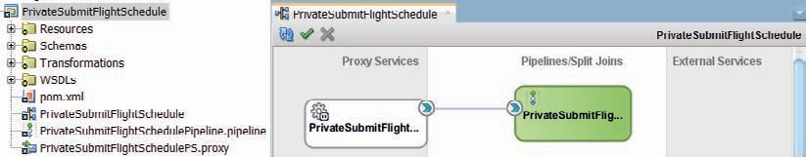

**FIGURE 7-1.** *PrivateSubmitFlightSchedulePipeline exposed as [local] proxy service*

##### Outline of FlightScheduleService

Open the *FlightScheduleService* project in the *FlightScheduleService***_step0** application that forms the starting point for the development of this project. It contains various artifacts, such as WSDLs, Schema definitions and a proxy service *FlightScheduleService*, based on the FlightScheduleService.wsdl and the interface with a single operation: *submitFlightSchedule*. The proxy service is currently not wired and can therefore not be deployed nor invoked.

Create a pipeline, called *FlightScheduleValidationPipeline*, based on the same WSDL as the proxy service. Wire the proxy service to this new pipeline.

Create another pipeline based on the same WSDL document, this one called

*ProcessingAndRoutingPipeline*.

Wire FlightScheduleValidationPipeline to *ProcessingAndRoutingPipeline*.

Open the *ProcessingAndRoutingPipeline*. Add a Route node to the pipeline. Drag a Routing activity inside the node. Configure the Routing activity to invoke the local proxy *PrivateSubmitFlightSchedule*, as shown in Figure 7-2.

The *PrivateSubmitFlightScheduleService* does not actually look at the request it receives—it just produces a hard-coded response. So whether we transform the request into the proper

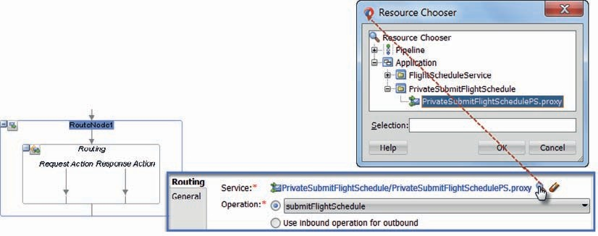

**FIGURE 7-2.** *Configuring the routing to the local (private) proxy service*

*PrivateSubmitFlightSchedule*

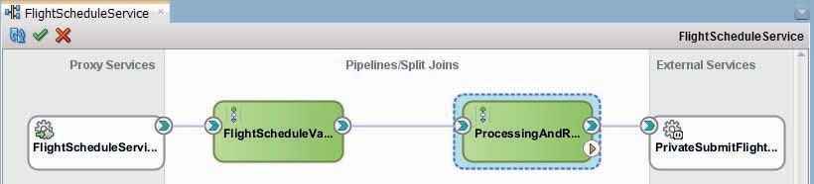

**FIGURE 7-3.** *The outline of the FlightScheduleService*

message format before sending it, will not make any difference. But of course the proper thing to do is add a *Replace* activity in the request action pipeline of the Routing activity to make sure

$body contains the input message stipulated by the private service. Use the XSLT templates in the folder Transformations. Use hard coded values for now for the three input parameter for the submitScheduledFlightRequestToprivateSubmitScheduledFlightRequest.xsl template; the values required for these parameters will be gathered using callouts in the next sections.

The overview of the *FlightScheduleService* should now look like Figure 7-3. Note how the call to the local proxy service is visualized and remember that we did not create the business service as our local intermediate to that local proxy.

Run the *FlightScheduleService* proxy service and verify that a response message is returned that is prepared in the *PrivateSubmitFlightSchedule*. This proofs that the end-to-end chain is working—even though it does not do anything useful yet.

### Implementing Validation

Processing a scheduled flight is not a trivial thing. First, the incoming message should be validated against the XSD Schema definition. Then a number of constraints that cannot be expressed in an XSD have to be checked. Subsequently, some of the values provided in the request message have to be verified against a list of allowable values. These values may also have to be converted to a different domain.

In order to provide our consumers with as complete a list of problems as possible with their request for a scheduled flight, we do not want to immediately abort processing in the validation pipeline upon the first issue we run into. Instead, we compile the results from each of the three steps into a list of processing results. If no issues were encountered, we can proceed to the next pipeline. If, however, one or more issues were found during XSD validation, constraint checking or domain value checking and mapping, we will not continue to the next stage but instead return a response that contains all the issues that were discovered.

In this section, we will implement the three validation stages as well as the mechanism for collecting all issues. The starting point is the *step1* application in the online sources.

#### Add XSD Validation

Open the *FlightScheduleValidationPipeline* editor. Add a pipeline pair—called Validations—and a stage in the request pipeline, called *SchemaValidation*.

Add a Validate activity to this stage. Configure this activity—as shown in Figure 7-4—to validate in Location *body* the expression

 $body/flig:submitScheduledFlightRequestMessage

against the *submitScheduledFlightRequestMessage* in the XSD file FlightScheduleService.xsd in the Schemas folder. Note that in order to be able to successfully use a namespace prefix such as flig in expressions, such a prefix has to be explicitly defined. While in the Expression Builder, click on the tab which reads *Namespaces*. Click on the green plus icon, to add a user defined namespace. In the popup that appears, set Prefix to flig and URI to saibot.airport/services/ flightschedule. Press OK to add this new namespace declaration. From this point on, the prefix flig: can be used in expressions anywhere in this stage.

Specify in the Validate activity that an error should be raised when validation errors are found.

Next, we add an error handler to the stage. We want to trap the validation error, save the validation results, and continue processing with the next stage in the pipeline.

Drag the error handler from the component palette to the *SchemaValidation* stage. Rename the stage in the error handler to *AddErrorToProcessingResults*. Add an Insert activity that will add the summary of validation errors to a variable. Configure this activity with this value:

 <fse:ProcessingResult xmlns:fse="saibot.airport/services/flightschedule">

<fse:ResultCode>{$fault/ctx:errorCode}</fse:ResultCode>

<fse:Description>{$fault/ctx:reason}</fse:Description>

<fse:ContextTrace>{$fault}</fse:ContextTrace>

</fse:ProcessingResult>

to be inserted as [the] first child of the processingResults variable.

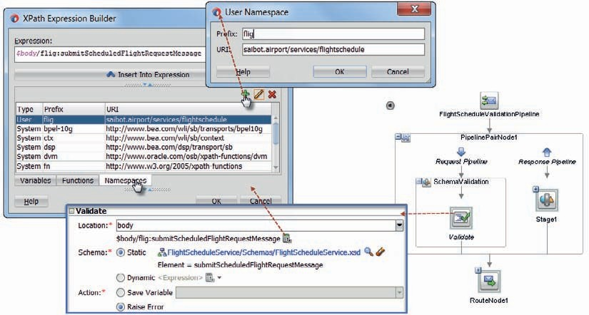

**FIGURE 7-4.** *Configuring the Validate activity to validate the*

*submitScheduledFlightRequestMessage; a User [defined] Namespace with prefix flig is defined*

Add the Resume activity to the error handler, to ensure that once the validation fault details have been added to the *processingResults* variable, the next stage in this pipeline will be executed.

The error handler is shown in Figure 7-5.

The *processingResults* variable that is updated in the error handler has to be initialized first. We cannot insert a child into an uninitialized variable. Therefore, add a stage called *Initialization* to the request pipeline, before the *SchemaValidation* stage. Add an Assign activity to this stage. In this activity, assign the value of

 <fse:ProcessingResults xmlns:fse="saibot.airport/services/flightschedule">

</fse:ProcessingResults>

to variable *processingResults*, thus initializing this variable.

##### Stop or Go

Before we add two more stages for additional validation activities, let’s first add a stage that determines if the request is suitable to be routed to the next pipeline or whether validation errors have been found and therefore processing should cease and the validation outcome should be reported.

Add a stage called *ContinueOrReturn* as the last in the pipeline, just before the Route node.

Add an *If Then* activity to this stage. This activity does what you expect it to do: depending on the outcome of a Boolean condition, one of two branches is executed.

Configure the If condition with

 fn:count($processingResults/*) gt 0

to determine whether or not any children have been added inside the variable *processingResults*.

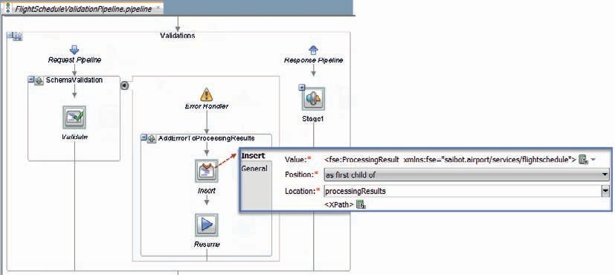

**FIGURE 7-5.** *The error handler for the SchemaValidation stage, resuming processing after*

*updating the processingResults variable*

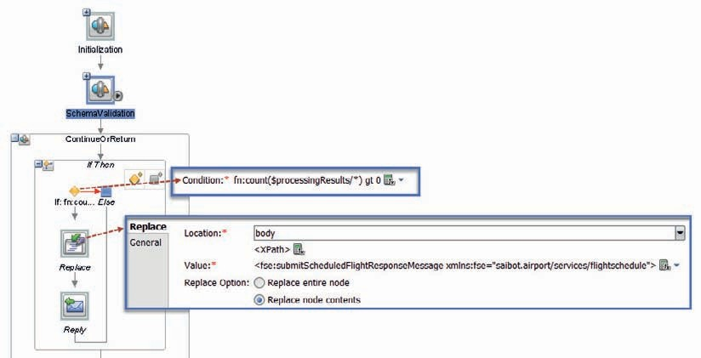

**FIGURE 7-6.** *The ContinueOrReturn stage that deals with processingResult if there are any*

Next, add a Replace activity to the *If*-branch. Configure this activity to replace the contents of the body variable with this expression:

 <fse:submitScheduledFlightResponseMessage xmlns:fse="saibot.airport/services/ flightschedule">

{$processingResults}

</fse:submitScheduledFlightResponseMessage>

This adds the value of variable *processingResults* to the response message.

Finally, add a Reply activity to the same *If*-branch, below the Replace step. Configure the activity to return with success. The stage is shown in Figure 7-6.

The logic we have now implemented ensures that when the Schema Validation finds errors, these errors are added to the $processingResults variable. When that happens, the if-then activity will trigger. The response is prepared in the $body variable—with the current contents from variable *processingResults*—and processing is halted with the sending of the response.

Run the Pipeline to try out this logic. The default message prepared in the tester contains some schema validation. Just press execute. Check the response message. Also verify the invocation trace, as shown in Figure 7-7.

Now we are ready to add two additional validation stages in this pipeline.

#### Add XQuery-Based Constraints Checking

Many of the constraints that apply to request messages cannot be expressed in XSD. This also holds true for the *submitScheduledFlightRequestMessage*. We require of this message for example that

* The start date is prior or equal to the end date.
* The start date is at least three days from today.

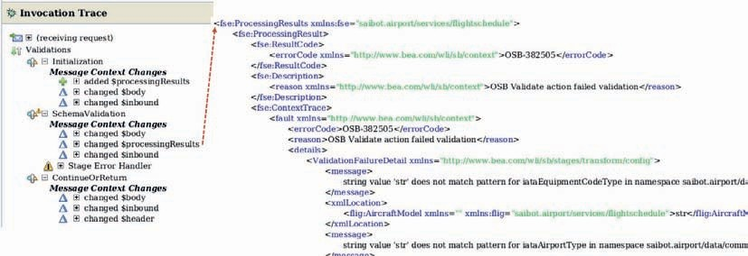

**FIGURE 7-7.** *Invocation Trace for the FlightScheduleValidationPipeline—showing validation*

*violation findings*

* + The element FiveMinuteBlock is an integer times five.
  + The element hour of the day is not empty.

These and similar constraints are not enforced by the Validate activity that we used in the previous section, because they cannot be specified in terms of the XSD definition.

The mediator component supports advanced validation using Schematron. In Service Bus, that option is not out of the box available to us. However, with XQuery we have a formidable tool at our disposal. We can create an XQuery function that inspects the XML contents of a variable and return a list of validation errors with zero, one or more errors. Using an Assign activity, we can invoke the XQuery function with the contents of the *submitScheduledFlightRequestMessage* and get a list of all (which could be none) validation errors.

Create a new XQuery file in a new folder called *Validations*. Call the XQuery file ValidateSubmitScheduledFlightRequest.xqy. Set the function name to *validateSubmitScheduledFlight*. Set a single source parameter, based on the *submitScheduledFlightRequest* element in FlightScheduleService.xsd. The target is based on Validation in Validation.xsd.

Add the following lines to the generated .xqy file:

 xquery version "1.0" encoding "utf-8"; (:: OracleAnnotationVersion "1.0" ::)

declare namespace fse="saibot.airport/services/flightschedule"; (:: import schema at "../Schemas/FlightScheduleService.xsd" ::) declare namespace ns1="saibot/validation";

(:: import schema at "../Schemas/Validation.xsd" ::) declare namespace ref="saibot.airport/data/reference"; (:: import schema at "../Schemas/reference.xsd" ::)

declare variable $submitScheduledFlightRequest as element() (:: schema-element (fse:submitScheduledFlightRequestMessage) ::) external;

declare function local:validateSubmitScheduledFlight($submitScheduledFlightReq uest as element() (:: schema-element(fse:submitScheduledFlightRequestMessage)

::)) as element() (:: element(*, ns1:Validation) ::) {

<ns1:Validation>

<ns1:Payload>{$submitScheduledFlightRequest/.}</ns1:Payload>

<ns1:ValidationErrorList>

{

(: Validations of required fields:)

if (empty($submitScheduledFlightRequest/fse:TimePlanningUnit/ ref:HourOfDay/text())) then

<ns1:ValidationError>

<ns1:code>1</ns1:code>

<ns1:message>Hour of Day is required</ns1:message>

</ns1:ValidationError> else ''

}

</ns1:ValidationErrorList>

</ns1:Validation>

};

local:validateSubmitScheduledFlight($submitScheduledFlightRequest)

At this point this XQuery function performs only a single validation: it checks if the Hour of the Day element does indeed contain a value. If it does not, a validation error is returned in the *ValidationErrorList* element. We will make the XQuery file a little bit more interesting a little later on.

First, add a stage to the pipeline called *CustomValidations*. In the stage, add an Assign activity.

Configure the activity to invoke the ValidateSubmitScheduledFlightRequest.xqy document and pass $body/flig:submitScheduledFlightRequestMessage as the input parameter. Assign the outcome from that call to a new local variable called *validationResults*.

When the Assign activity is executed, the variable *validationResults* has been set with a *ValidationErrorList* element that may contain zero, one or more *ValidationError* elements. And for each of these elements, we want to add an entry to $processingResults.

Whenever we want to do something for each of the elements in a list, we can make use of the For Each activity. Add such an activity to the stage, dropping it below the Assign activity.

Configure the activity according to Figure 7-8: the source of the For Each is the variable

*validationResults*. The expression used to retrieve elements from this variable is:

./val:ValidationErrorList/val:ValidationError.

The *Value Variable*—that is the variable populated in each iteration with the current element from the list—is called *ValidationError*. The *Index Variable* and *Count Variable* are automatically set by the Service Bus engine. We do not make use of these values in this situation.

Add an Insert activity inside the For Each. This activity is configured to add as a *First Child of*

variable *processingResults* this expression:

 <fse:ProcessingResult xmlns:fse="saibot.airport/services/flightschedule">

<fse:ResultCode>{$ValidationError/val:code}</fse:ResultCode>

<fse:Description>{$ValidationError/val:message}</fse:Description>

<fse:ContextTrace>{$ValidationError}</fse:ContextTrace>

</fse:ProcessingResult>

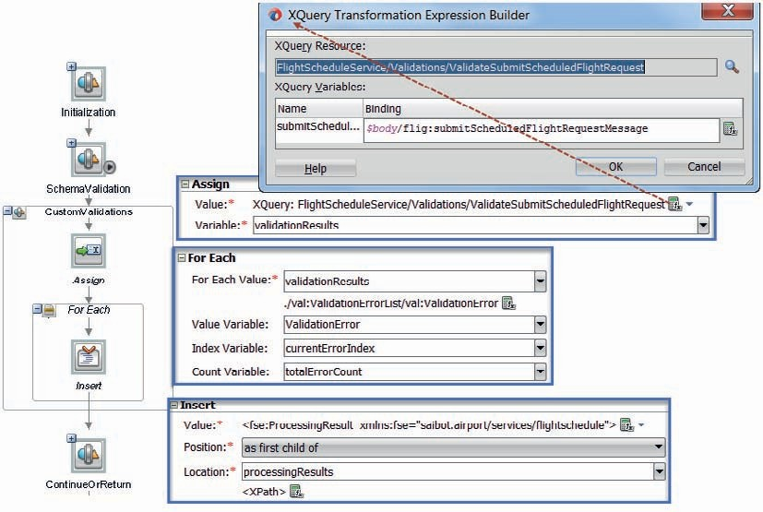

**FIGURE 7-8.** *Configuring the For Each activity to look over each and every ValidationError*

This means a ProcessingResult element is created for every validation error and added to

$processingResults.

The request side of the pipeline now looks as is shown in Figure 7-8. Now is a good time to run the pipeline—with a request message that does not contain a value for the Hour of Day element.

Verify that meaningful information about the missing data is included in the response message.

##### Create a Local XQuery Function with Additional Validations

To bring more structure to XQuery files, we can make use of functions that contain reusable logic. These functions can be invoked from other functions—to contribute to the overall result.

Return to the XQuery file ValidateSubmitScheduledFlightRequest.xqy. Create a new function using this code:

 declare function local:validateSubmitScheduledFlightDateAndTimeConstraints($submitScheduledFlightRequest as element() (:: schema-element(fse:submitScheduledFlightRequestMessage) ::)) as element() (:: element(*, ns1:ValidationErrorList) ::) {

(: Validations of date and time constraints for ScheduledFlight submission :)

<ns1:ValidationErrorList>

{

if (true() and ( xs:date($submitScheduledFlightRequest/fse:TimePlanningUnit/

ref:startDate) lt (fn:current-date() - xs:dayTimeDuration('P3D')))) then

<ns1:ValidationError>

<ns1:code>21</ns1:code>

<ns1:message>Start date should be more than three days from now</ns1:message>

</ns1:ValidationError> else ''

}

</ns1:ValidationErrorList>

};

This function takes a *submitScheduledFlightRequestMessage* element and verifies if the

startDate is at least 3 days from today. If it is not, a validation error is produced.

To enlist this function, add the following lines to function *validateSubmitScheduledFlight*:

 {for $validationError in local:validateSubmitScheduledFlightDateAndTimeConstraints($submitScheduledFlightRequest)/ ns1:ValidationError

return $validationError

}

This code should come just before the closing </ns1:ValidationErrorList> element. The result from the local function is a validation error list that may contain *ValidationError* elements. Each of these elements should be added to the final result of function *validateSubmitScheduledFlight*.

After making these changes rerun the pipeline with a request message in which the start date is not at least three days into the future.

##### Create an XQuery Library with More Validations

Local functions in XQuery files can be reused locally. It helps to structure an otherwise unwieldy XQuery function—but it does not contribute to reuse. We can, however, also create a library module with XQuery functions that can be reused across XQuery files.

From the New Gallery, create an XQuery Library. Set the name to TimePlanningUnitValidations.xqy. Set the function name to *validateTimeplanningUnit*. Set the target namespace to *validateTimeplanningUnit*. The source parameter is called *timePlanningUnit*. The result is again of type *ValidationErrorList*.

Complement the generated source, to the following code:

 xquery version "1.0" encoding "utf-8"; (:: OracleAnnotationVersion "1.0" ::)

module namespace ns3="airport.saibot/validations/dateAndTime";

declare namespace ref="saibot.airport/data/reference"; (:: import schema at "../Schemas/reference.xsd" ::) declare namespace val="saibot/validation";

(:: import schema at "../Schemas/Validation.xsd" ::)

declare function ns3:validateTimeplanningUnit($timePlanningUnit as element() ) as element() (:: element(*, val:ValidationErrorList) ::) {

(: Validations of date and time constraints :)

<val:ValidationErrorList>

{

if ( (not(empty($timePlanningUnit/ref:endDate))) and ($timePlanningUnit/ref:endDate lt $timePlanningUnit/ref:startDate) ) then

<val:ValidationError>

<val:code>11</val:code>

<val:message>End date should be empty or equal to or later than start date</val:message>

</val:ValidationError> else ''

}

{

if ( ( $timePlanningUnit/ref:FiveMinuteBlock mod 5 !=0 )) then

<val:ValidationError>

<val:code>15</val:code>

<val:message>The five minute block should be an integer number times 5</val:message>

</val:ValidationError> else ''

}

</val:ValidationErrorList>

};

This function performs two validations on a *TimePlanningUnit* element:

* + If the end date value is set, is the date equal to or later than the start date
  + Is the numerical value in the element *FiveMinuteBlock* an integer number times 5?

In order to make use of this function, we have to make two changes in the XQuery file

ValidateSubmitScheduledFlightRequest.xqy.

1. Add this line to import the library module:

import module namespace ns3='airport.saibot/validations/dateAndTime' at "TimePlanningUnitValidations.xqy";

1. Call the function in the library from function *validateSubmitScheduledFlight*:

{

for $validationError in ns3:validateTimeplanningUnit($submitSche duledFlightRequest/fse:TimePlanningUnit)/ns1:ValidationError

return $validationError

}

After making these alterations and saving all files, please run the pipeline once more. Define an end date in the request message that is set before the start date and make sure to set the *FiveMinuteBlock* to 42. Check the contents of the response message and ensure that all validation errors are properly reported.

#### Airline Checks and Mapping with Domain Value Map

The airline for which the scheduled flight is requested, is specified through the *carrier* element. This element is defined in the XSD document as a string. It is not further restricted in the schema. However, the values recognized for airlines by the business service are only the two letter IATA airline designators. This means therefore that we have to check:

* If the length of the airline value > 3 or <2; if so, it is incorrect.
* If the length of the airline value == 3 then it is probably an ICAO code and it should be mapped to an IATA code.
* If the length is two, it is probably an IATA code; we should ensure it is a valid IATA code.

To implement this validation, we need a new stage, a little if-then-else logic and this thing called a DVM or Domain Value Map.

##### Prepare the Stage AirlineValueMap

Add a stage called *AirlineValueMap* to the pipeline, between the stages *CustomValidation* and

*ContinueOrReturn*. Add an If..Then activity to the stage, with the condition set to

 fn:string-length($body/flig:submitScheduledFlightRequestMessage/flig:Carrier) lt 2 or fn:string-length($body/flig:submitScheduledFlightRequestMessage/flig:Carrier) gt 3

This condition traps values for the carrier element that are shorter than two or longer than three characters, neither of which is good.

Add a Raise Error activity to the Then branch, with the code set to FSE-10 and the message to “The carrier element has the wrong length—it can neither be a valid IATA code nor a correct ICAO code.”

We do not want this stage to cause the pipeline to abort because of this error, so we have to add an error handler to the stage. Inside the error handler, just like in the error handler for stage *SchemaValidation*, add an insert activity to add an entry for the error to variable *processingResults* and a Resume activity to continue on with the next stage.

Add another If..Then activity to the Else branch. Set the condition for this activity to

 fn:string-length($body/flig:submitScheduledFlightRequestMessage/flig:Carrier) = 3

When the value for the carrier element has three characters, we assume it is an ICAO code and we have to find the corresponding IATA designator. In the Then branch, we will use a domain value map to perform that feat.

##### Domain Value Map to Map ICAO Codes to IATA Designators

Mapping of values from one range of values (or domain) to another can be implemented in SOA Suite using a DVM or Domain Value Map. Such a DVM is an XML document that contains records for each point-to-point value mapping. A record contains one or more qualifiers used to identify the record (in the source domain) along with one or more values in the target domain. XPath functions are available that can be used in XPath and XQuery expressions and in both XQuery functions and XSL stylesheets to lookup an entry in a specific DVM and retrieve the associated mapped values. Domain Value Maps can be edited at run time using the out of the box SOA Composer console.

In the case at hand, we want to map from the three-character ICAO codes for airlines to the corresponding two-character IATA designators. If such a designator is not found, the request cannot be successfully processed because the carrier is unknown.

Create a new DVM called *ICAOToiataAirlineMapping* in the folder Validations. Specify three domains called ICAOAirlineCode, iataAirlineCode, and airline respectively. Create a few records, as shown in Figure 7-9. For example, mapping AFR to AF for Air France, AIC to AI for Air India Limited and DLH to LH for Lufthansa.

Add an Assign activity to the Then branch. Set the Value field to:

 **dvm:lookup('FlightScheduleService/Validations/ ICAOToiataAirlineMapping'**, 'ICAOAirlineCode', $body/flig:submitScheduledFl ightRequestMessage/flig:Carrier, 'iataAirlineCode', 'XXX')

Set the Variable to *iataAirlineCode*. This activity will use the DVM that was just created and look in the *ICAOAirlineCode* qualifier column with the value in the *Carrier* element in the *submitScheduledFlightRequestMessage* to locate the appropriate airline record. When found, the value in the *iataAirlineCode* column will be returned. If the record is not found—which means that the value in the Carrier element is not a known ICAO code—the default value “XXX” is returned, which clearly indicates the failure of the lookup.

Add an If..Then activity below the Assign, as is indicated in Figure 7-10.

Set the condition to $iataAirlineCode= ‘XXX’. This will determine if the value in the carrier element was not found as a valid ICAO code in the DVM. For that case, add a Raise Error activity (in the Then branch). Set an error code and a message indicating that the Carrier element does not contain a known ICAO code.

In the Else branch, add a Replace activity to enrich the request message with the retrieved IATA equivalent to the ICAO code in the Carrier element. Set the location to body and the expression to ./flig:submitScheduledFlightRequestMessage/flig:Carrier. The value should be

$iataAirlineCode and only the node contents should be replaced.

This stage requires an error handler, to prevent the Raise Error activities from ruining our carefully constructed $processingResults. Add the error handler at stage level. Specify the same Insert activity as in the *SchemaValidation* stage, to insert a new *ProcessingResult* element based on the contents of $fault as the first child of variable *processingResults*. Also add a Resume activity, to continue pipeline processing with the next stage.

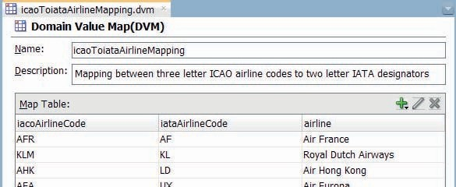

**FIGURE 7-9.** *Domain Value Map between ICAO airline codes and IATA designators*

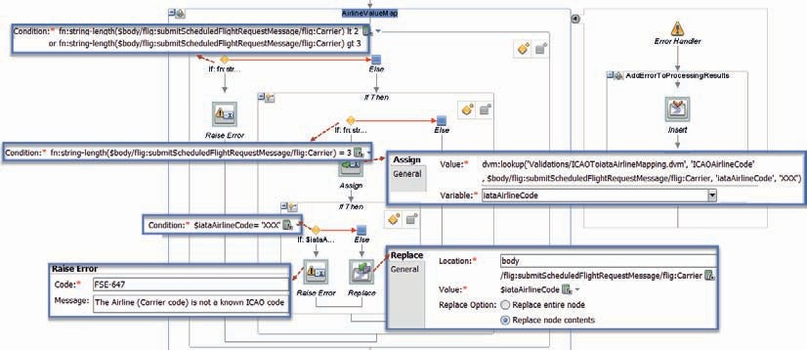

**FIGURE 7-10.** *The complete stage AirlineValueMap with the Assign using the DVM lookup*

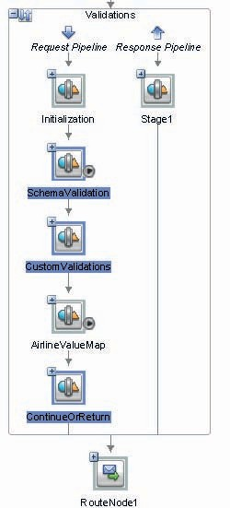

**FIGURE 7-11.** *The complete Validations Pipeline*

Now is a good time to run the pipeline (Figure 7-11) again. Provide a three letter (uppercase) value for the carrier element. If you use a value that occurs in the DVM, you should see the proper value of the corresponding IATA designator being assigned to the $iataAirlineCode variable. If your value is in fact a pretend ICAO code, this variable will have been assigned the value XXX and the error hander will have kicked in, once more.

### Using Callouts for Validation and Enrichment

The second pipeline in the *FlightScheduleService*—the *ProcessingAndRoutingPipeline*—can rely on the data it receives being valid. Not just in terms of the XSD definition but also the custom validations on start date, end date, and 5-minute time block as well as the IATA designator for the air carrier. It is now up to this pipeline to perform several enrichment steps that are to precede the final routing to the *PrivateSubmitFlightSchedule* local proxy service.

* + The number of flights has to be established that are to take place in the requested flight schedule.
  + The identifier of the allocated slot with which the flight schedule is to be associated must be retrieved.
  + The Financial Department has to approve of the requested flight schedule—based on the credit status, solvency, and safety status of the airline.

Service Bus has the concept of Callouts to invoke services, from any stage, prior to or after executing the routing activity. Callouts can invoke Java Classes, Pipelines, Local Proxy Services, and Business Services.

In this section, we will look at three types of callouts:

* + Java Callout to a custom Java Class, to calculate the number of flights
  + Service Callout to a Business Service, to find the slot with which to associate the scheduled flight
  + Service Callout to a Pipeline, to check if the airline is not blacklisted with the finance department

#### Java Callout to Execute Content-Based Logic

A Java Callout activity can be used to invoke a static method in a custom Java Class. This class can be deployed as part of the Service Bus project or to the classpath of the run-time WLS. XPath expressions are used to determine the values passed to this method as input parameter. The value returned from the Java code can be assigned to a stage level variable.

The Java Class we will create takes the start date and the end date for the requested flight schedule and—taking the weekdays into account—calculates the actual number of flights this request represents. This number has to be passed to the local proxy that processes the request.

##### Prepare for the Java Class to Be Called Out To

The Java Class receives the *TimePlanningUnit* element from the request message and it does so in the form of an XmlObject, a class from the Apache XmlBeans library. To work with such an object we need to add a library to the project, just like we did in Chapter 6 for working with the JEJB transport. The JAR file that contains the required definitions for the XmlBeans library ships with

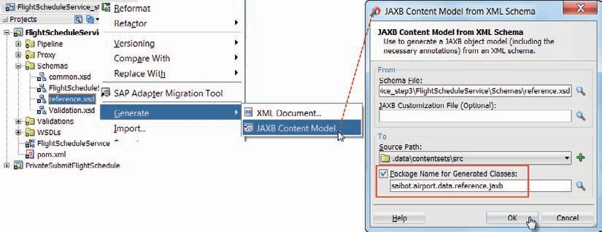

**FIGURE 7-12.** *Generating the JAXB Content Model for XSD document reference.xsd*

the SOA Suite. It can be found as com.bea.core.xml.xmlbeans_1.0.0.0_2-6-0.jar under MIDDLEWARE_HOME/Oracle_Home/oracle_common/modules. Add this JAR file to the *AircraftMovementService* project.

To conveniently work with the XML content in our Java code, we can leverage JAXB—the Java standard for binding XML to Java and vice versa. Right click on the reference.xsd document in the Schemas folder. Select the option Generate | JAXB Content Model. See Figure 7-12.

In the dialog that appears, set the Java package name for the generated classes to saibot

.airport.data.reference.jaxb. Accept the other defaults and press OK to have the JAXB object model generated.

Verify that the classes were indeed generated for the elements in the reference.xsd document.

Finally, create a new deployment profile called *JavaCalloutJar* of Profile Type JAR file for the project *FlightScheduleService*.

##### Implement Class ScheduledFlightProcessor

Create a new Java Class called ScheduledFlightProcessor, using the following code:

 package saibot.airport.flightscheduleservice; import java.io.ByteArrayInputStream;

import javax.xml.bind.JAXBContext;

import javax.xml.bind.JAXBElement; import javax.xml.bind.JAXBException; import javax.xml.bind.Unmarshaller;

import javax.xml.datatype.XMLGregorianCalendar; import org.apache.xmlbeans.XmlObject;

import saibot.airport.data.reference.jaxb.TimePlanningUnitType; public class ScheduledFlightProcessor {

public static int calculateNumberOfFlights(XmlObject timePlanningUnit) { int numberOfFlights = 0;

JAXBContext jc = null; try {

jc = JAXBContext.newInstance(TimePlanningUnitType.class); Unmarshaller unmarshaller;

String xml = timePlanningUnit.toString();

// this string starts with <xml-fragment xmlns:ref="saibot.airport/ data/reference" xmlns:flig="saibot.airport/services/flightschedule">

// the xml-fragment has to be replaced with ref:TimePlanningUnit xml = xml.replaceAll("xml-fragment", "ref:TimePlanningUnit"); unmarshaller = jc.createUnmarshaller();

byte[] bytes = xml.getBytes();

ByteArrayInputStream bais = new ByteArrayInputStream(bytes); TimePlanningUnitType tpu = (TimePlanningUnitType) ((JAXBElement)

unmarshaller.unmarshal(bais)).getValue();

XMLGregorianCalendar startDate = tpu.getStartDate(); if (tpu.getEndDate() == null) {

numberOfFlights = 1;

} else {

XMLGregorianCalendar endDate = tpu.getEndDate().getValue(); if (endDate.equals(startDate)) {

numberOfFlights = 1;

} else {

int diffInDays = (int)Math.ceil((endDate. toGregorianCalendar().getTimeInMillis() - startDate.toGregorianCalendar(). getTimeInMillis())/(1000*60*60*24));

// determine number of days per week

int daysPerWeek = tpu.getDaysOfWeek().getDay().size(); numberOfFlights = (diffInDays* daysPerWeek/7);

}

}

} catch (JAXBException e) { e.printStackTrace();

}

return numberOfFlights;

}

}

The class contains a single static method *calculateNumberOfFlights* that accepts an XmlObject. This object is expected to contain a *TimePlanningUnit* element. Using that XML content, an instance of class *TimePlanningUnitType* is retrieved. From this object, we can easily get hold of start date, end date, and the list of weekdays included in the flight schedule. The total number of flights is calculated and returned as an int value.

At this point, deploy the JavaCalloutJar profile—to create jar file JavaCalloutJar.jar in the deploy folder of the project. This jar file is needed for the configuration of the Java Callout. The contents of the jar file will also be deployed along with the Service Bus project when that is deployed.

##### Configure the Java Callout

Open the *ProcessingAndRoutingPipeline*. Add a Pipeline Pair. Change the name of the auto- created stage to *DeriveNumberOfFlights*. Add a Java Callout activity to the stage, and configure it as shown in Figure 7-13.

Select the JavaCalloutJar.jar in the deploy folder of the project. Select the

*calculateNumberOfFlights* method in the ScheduledFlightProcessor.

Set the XPath expression for the input parameter to:

 $body/flig:submitScheduledFlightRequestMessage/flig:TimePlanningUnit

Make sure to add the user defined namespace “**saibot.airport/services/ flightschedule**” and prefix: flig.

Set the name of the return variable to *numberOfFlights*. This means that the outcome of the

Java Callout is stored in $numberOfFlights.

At this point, you can run the *ProcessingAndRoutingPipeline* and see the Java Callout in action. Depending on the start date, end date, and the week days, the value for *numberOfFlights* is calculated.

###### NOTE

*Using a Java Callout is not the only way of executing custom logic implemented through Java in a Service Bus service. Creating a custom XPath function is another. Almost any static method can easily be registered as a function that can be used in XPath expressions in Service Bus. In the above example, we could easily have used such an XPath function in a simple Assign expression, rather than using a Java Callout. In fact, the logic currently implemented in the Java class could be handled using a very simple XQuery function without any custom Java code.*

Many aspects of Service Bus projects can be inspected and edited at run time—including XQuery functions, XPath expressions and other elements that drive the behavior of services. This does not apply to Java code invoked in Java Callouts. That should be a consideration when deciding on using a Java Callout. Heavy use of such callouts is not considered a good practice.

Custom XPath functions are deployed in a JAR file on the WLS server and require a server restart in order to be available to Service Bus projects. As such, they are highly reusable and (almost) part of the run-time infrastructure of the Service Bus.

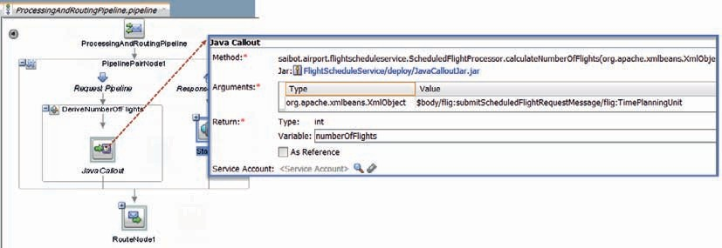

**FIGURE 7-13.** *Configuration of the Java Callout to the ScheduledFlightProcessor class*

#### Service Callout to a Business Service to Find the Allocated Slot

A Service Callout is an activity that invokes a service. Like a Java Callout, this activity can be used anywhere in a stage, both in the request pipeline or the response pipeline. Service Callouts are synchronous. That means that all other processing in the pipeline blocks until the callout has received its response. Service Callouts are used, for example, for validation and enrichment, logging, and auditing. A Service Callout can invoke a business service or local proxy service as well as a pipeline or split-join.

We will first look at a Service Callout to a business service to find the slot with which to associate the scheduled flight.

##### Create Business Service SlotService

The *SlotService* that was developed in Chapter 4 to record slot allocations in the database with future flights data, has been upgraded to also allow slot identifiers to be searched and retrieved. To that end, the interface of the *SlotService* has been extended with an operation *findSlot*. The *step3* source application contains a simple, almost mock implementation of the SlotService (that does not do any database interaction). Deploy and run the *SlotService* and invoke the *findSlot* operation to find out it has a mock-implementation that always returns the same slot identifier.

Open the overview editor for the *FlightScheduleService* project. Drag an HTTP technology component to the External Services swim lane. Call the business service *SlotService* and configure it to invoke the *SlotService*: select the WSDL for the *SlotService* from the Application Server and have it imported to the *FlightScheduleService* project along with the resources required because of dependencies or import the SlotService.wsdl file from the SlotService project. In that case, you have to configure the endpoint for the business service: http://host:port/flight/SlotService.

You can now run the newly added business service straight from the overview editor, to see if you can retrieve the slot identifier.

##### Add Service Callout to SlotService

Add a stage *RetrieveSlotIdentifier* directly under the stage *DeriveNumberOfFlights* that contains the Java Callout. Add a Service Callout activity to this stage.

Configure this activity to call out to the *findSlot* operation on the business service *SlotService*. Set the Configuration radio button to *Configure Body*. The body field under Request should be set to *findSlotRequestMsg* and the body under Response should be set to *findSlotResponseMsg*. These two settings indicate that new variables are created that hold the request message to be sent in the service callout, respectively, the response that will be received from the service callout.

Add an Assign activity in the Request Action of the Service Callout activity.

This should assign the value

 <soapenv:Body [xmlns:soapenv="http://schemas.xmlsoap.org/soap/envelope/"/>](http://schemas.xmlsoap.org/soap/envelope/)

to variable *findSlotRequestMsg*. Add a Replace activity underneath this Assign to update the contents of the variable with the request message to be sent to the *SlotService*.

The location for this Replace is variable *findSlotRequestMsg*. The Value is an XSLT Resource FlightScheduleService/Transformations/submitScheduledFlightRequestMessageTofindSlotRequestMessage

.xsl to which $body/flig:submitScheduledFlightRequestMessage is fed as the Input Document Expression.

Then, add an Assign activity to the Response Action. This activity retrieves the slot identifier from the Service Callout response and exposes it in a new variable called *slotIdentifier*.

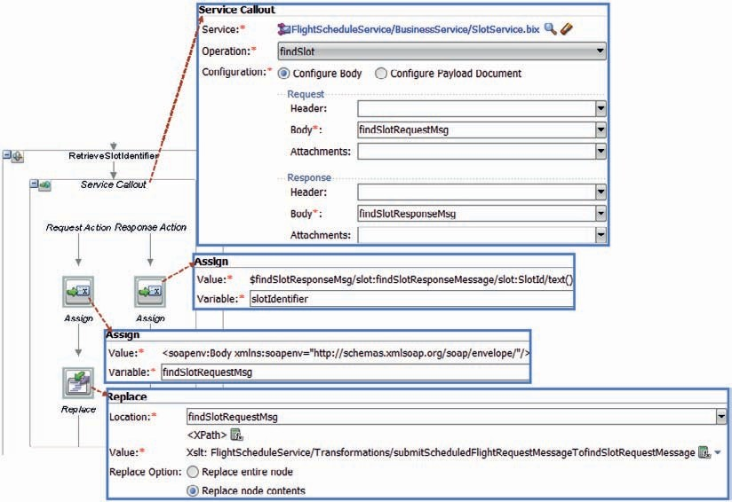

**FIGURE 7-14.** *Configuration of the Service Callout to the SlotService*

Use the following XPath expression to extract the slot identifier:

 $findSlotResponseMsg/slot:findSlotResponseMessage/slot:SlotId/text()

Make sure to define in the expression editor a new user defined namespace. Its prefix should be

*slot* and it is to be associated with namespace saibot.airport/services/slot.

At this point, the Service Callout is complete (Figure 7-14). It is visualized in the overview editor through a wire from the pipeline to the business service (Figure 7-15).

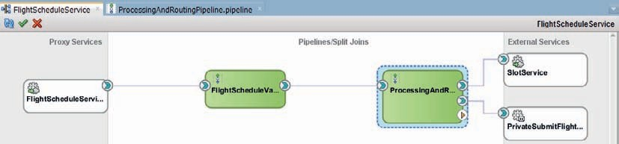

**FIGURE 7-15.** *Overview of Service Bus project with the wire to the SlotService based on the Service Callout*

You can run the *ProcessingAndRoutingPipeline* again to see in the trace how the slot identifier is retrieved through the Service Callout to the *SlotService*. A little later on we will use the

$slotIdentifier variable to complement the message routed to the

*PrivateSubmitFlightScheduleService*.

###### TIP

*At pipeline level, we can define the so called Shared Variables. These variables can shared across multiple pipelines—provided each pipeline defines these shared variable with the same name and the same type (supported types are String, Boolean, or XML data type). Sharing of variables works even across local proxies and through Split- Join services. The latter means that when pipeline A invokes a Split- Join service that invokes pipeline B, there can be a variable shared between A and B. However, this shared variable cannot be accessed inside the Split-Join service itself.*

#### Service Callout to a Pipeline within the Service Bus Project

A Service Callout can also be used inside a Service Bus project, to invoke a pipeline or Split-Join component. Pipelines are standalone, reusable containers of logic inside Service Bus projects.

A pipeline implements its own interface, defines its own variables, and is well encapsulated. Pipelines cannot be reused outside the project—unless they are exposed through a proxy service. Pipelines are defined in their own file. That means that several developers can each work on a different pipeline in a Service Bus project at the same time. Having multiple developers work simultaneously within the same pipeline is usually not a very good idea: they would be working on the same file.

We will now create a new pipeline based on a template. The logic of that pipeline has been implemented in a different project, perhaps by a different team. The pipeline was then published as a template—a file with extension .ptx. This makes it reusable in other Service Bus projects where local pipelines can be created that inherit the contents of the template. At run time, the pipeline that is based on a template will be deployed with a reference to the template, that itself also has to be deployed in the run-time server. Any change to that template is immediately inherited by all pipelines based on that template.

In this case, the project *FinancialDepartmentPipelines* contains the pipeline template *FinancialDepartmentAirlineCheckPipeline*. You can open the pipeline template, inspect it, and edit it. Let’s not make any changes right now.

##### Create Pipeline Based on a Template

Open the overview editor for the *FlightScheduleService*. In the center area, right mouse click and click on the option Insert | Pipeline in the context menu. Set the name of the new pipeline to *CheckAirlineWithFinancialDepartmentPipeline*. Check the checkbox *From Template*. Then select the *FinancialDepartmentAirlineCheckPipeline* template using the template browser (Figure 7-16), from either the local file system or the WebLogic domain.

On the second page of the Create Pipeline Service wizard, set the Service Type to WSDL and select the FinancialDepartmentAirlineCheck.wsdl file in the WSDLs folder in the *FinancialDepartmentPipelines* project. Click on Finish to generate the pipeline.

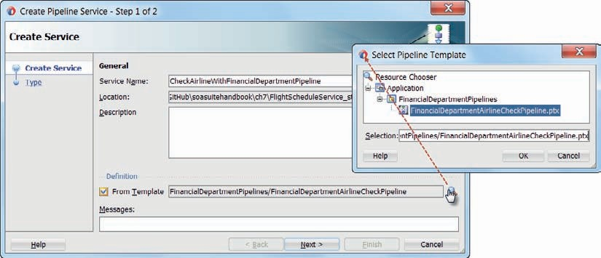

**FIGURE 7-16.** *Create a pipeline based on the FinancialDepartmentAirlineCheckPipeline*

*template*

The overview editor displays the new, not yet connected pipeline. You can edit the pipeline, even though it is based on a template. When you open the editor, you will see the pipeline definition with a pipeline pair and two activities. It is inherited from the template. Because no placeholders were added in the template definition, you cannot actually add or remove any stages or activities to or from the pipeline. You can, however, change the properties of the activities that are in the pipeline.

You can run the pipeline. Regardless of the values in the request message, it will run for approximately three seconds and return the string value “OK” as well as a unique identifier that represents the financial department’s approval stamp.

##### Create a Service Callout to the Pipeline

Open pipeline *ProcessingAndRoutingPipeline*. Add a stage *CheckAirlineWithFinancialDepartment*

just above the RouteNode1. Add a Service Callout activity to this stage.

Configure the Service Callout activity to invoke the *CheckAirlineWithFinancialDepartmentPipeline*. Define variables *checkAirlineRequest* and *checkAirlineResponse* to be used for the callout request and response message respectively, as is shown in Figure 7-17.

Add an Assign activity in the Request Action of the Service Callout, and assign the following expression to the variable *checkAirlineRequest*:

 <soapenv:Body [xmlns:soapenv="http://schemas.xmlsoap.org/soap/envelope/">](http://schemas.xmlsoap.org/soap/envelope/)

<fin:checkAirlineRequestMessage xmlns:fin="saibot.airport/services/financial">

<fin:Carrier>

<ref:IATACode xmlns:ref="ref:saibot.airport/data/reference">{$body/flig:su bmitScheduledFlightRequestMessage/flig:Carrier}</ref:IATACode>

</fin:Carrier>

</fin:checkAirlineRequestMessage>

</soapenv:Body>

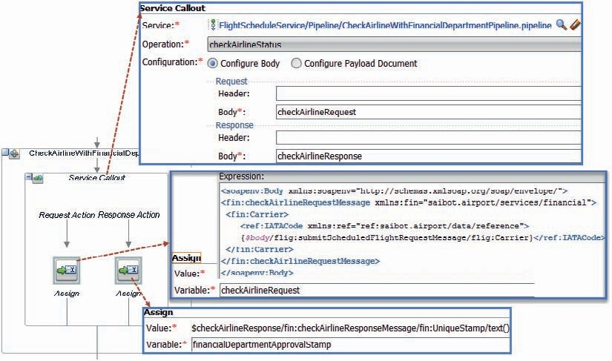

**FIGURE 7-17.** *Configure the Service Callout activity to invoke the*

*CheckAirlineWithFinancialDepartmentPipeline*

Also add an Assign activity to the Response Action. This activity retrieves the financial approval stamp from the response message and stores it in the variable *financialDepartmentApprovalStamp*. Set the Value field to

 $checkAirlineResponse/fin:checkAirlineResponseMessage/fin:UniqueStamp/text()

This XPath expression takes the value from the *UniqueStamp* element that will be set by the FinancialDepartment when they approve of the airline. Make sure that a user defined namespace is set up for namespace saibot.airport/services/financial with prefix fin.

The project as it currently stands is shown in Figure 7-18.

You can now run the *ProcessingAndRoutingPipeline* and from the flow trace see not only the number of flights calculated and the slot identifier retrieved but also the blessing from the financial department begotten and stored in $financialDepartmentApprovalStamp. The three parameters can now be used to provide the appropriate input to the XSL stylesheet that we use for the transformation of the message sent from the final Routing activity to the *PrivateSubmitFlightService*.

It does take an uncomfortable long time to arrive at the final result though. Apparently, some of the processings in either the *SlotService* or the financial department’s pipeline—or both, as it turns out—is somewhat slow. We will address this slowness to some extent using parallelization through split-join a little bit later on.

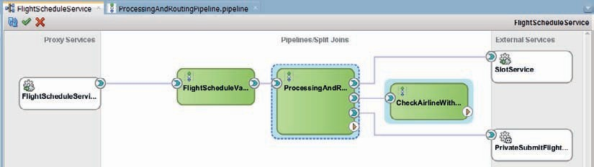

**FIGURE 7-18.** *Overview of the entire FlightScheduleService including the callout to the*

*CheckAirlineWithFinancialDepartmentPipeline*

##### Update the Template and See the Change Trickle Down

The *CheckAirlineWithFinancialDepartmentPipeline* is created based on a Template. The link between this pipeline and the original template is retained—until such time as we sever it. This can be done as shown in Figure 7-19 by right clicking on the pipeline and choosing the option Service Bus | Break Template Link.

If we do not break the link, this pipeline and all other pipelines based on the same template, will inherit any change made to the template.

Open the template pipeline FinancialDepartmentAirlineCheckPipeline.ptx in project *FinancialDepartmentPipelines*. Drag an If..Then activity to the SetAirlineStatus stage in the response pipeline and drop it above the existing Assign activities. Set the condition to

 $body/*[1]/*:Carrier/*:IATACode/text()='XX'

This tests for the condition that the IATACode is set to XX. Copy the first Assign activity and paste it in the Then branch. Modify it to make it apply the value “NOK” to the variable called *status*. Move the first two Assign activities—that assign values to $status and to $uniqueApprovalStamp— to the Else branch.

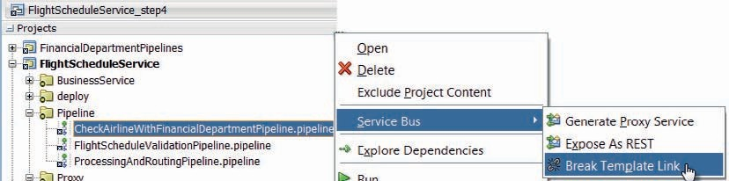

**FIGURE 7-19.** *Breaking the link between a pipeline and the template is was created from*

The template is now changed—to return a value of NOK for airline XX. This change is immediately inherited by any pipeline based on the template. Run pipeline *CheckAirlineWithFinancialDepartmentPipeline* in the *FlightScheduleService*. Provide a value of XX for the carrier and see the value of NOK returned.

### Add a Template-Based Logging Pipeline

In the previous section, we have seen a first example of a pipeline template. Such a template is a predefined pipeline that new pipelines can be cloned or—better yet—inherited from. A template contains stages, activities, error handlers, variables, and other elements found in any regular pipeline. When a new pipeline is defined based on a pipeline template, the pipeline already includes all the stuff from the template. Some of these elements in the template can be locked: not to be changed in derived pipelines (unless the link is broken). Others can be open for editing. Template developers can predefine stages that are placeholders for template consumers to add elements to. Through these placeholders, the template designer guides the pipeline developer through a number of predefined and documented steps.

Pipeline templates are very useful for boosting productivity and stimulating the use of best practices for Service Bus service design. Templates can be used to capture and share design patterns. They can also be used to easily distribute reusable pieces of configurable logic.

In this section, we will first create a template for a logging pipeline. The template predefines a number of elements that perform logging in the way Saibot Airport considers desirable practice. By simply including a pipeline based on this template as the first step in each Service Bus project following the proxy service, developers ensure that they adhere to the logging guidelines. Some aspects of the logging pipeline have to be configured for the specific project—such as the logic to determine if the service request was processed successfully and the actual contents to include in log entries.

We will then use this pipeline template in the *FlightScheduleService* to quickly add logging functionality. As we have seen before: any change in the pipeline template, applied even after the template has been used to create new pipelines from, is inherited by each derived pipeline—as long as the link to the template has not been broken.

#### Create the Pipeline Template with Logging Capabilities

Open the project *CommonPipelines*. This project is the container for reusable pipelines. Right click on the project node. Click on New | Pipeline Template in the context menu (Figure 7-20).

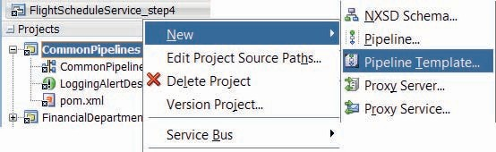

**FIGURE 7-20.** *Create a new Pipeline Template*

The Create Pipeline Template wizard appears. Enter *LoggingPipelineTemplate* as the name for the new template. Press Next. Select SOAP 1.1 as the Service Type. Press Finish to have the template generated.

The Pipeline Template editor opens. It is very similar to the normal pipeline editor—with some differences. The background, a grid, makes it obvious that the pipeline editor is in a special (template) mode. The component palette contains a special section, titled Template Placeholders.

These components—nodes, stages, actions, route, conditional, operational—are used to create a placeholder in the template where the actual pipeline instance derived from the template can have zero, one, or multiple elements included of the type indicated by the placeholder. The template developer will typically add documentation on the placeholder to explain what type of activity is expected at that point in the template.

Figure 7-21 shows the implementation we will subsequently add to the currently empty template.

Add a Route component with a Routing activity to the pipeline template. We expect pipelines based on this template to be injected in existing wires from Proxy Services to regular pipelines.

Our pipeline template exposes the Any service type interface and should also contain the Routing action to connect to the first regular pipeline. Also add a Pipeline Pair above the Route node. This is where the real logging action will take place.

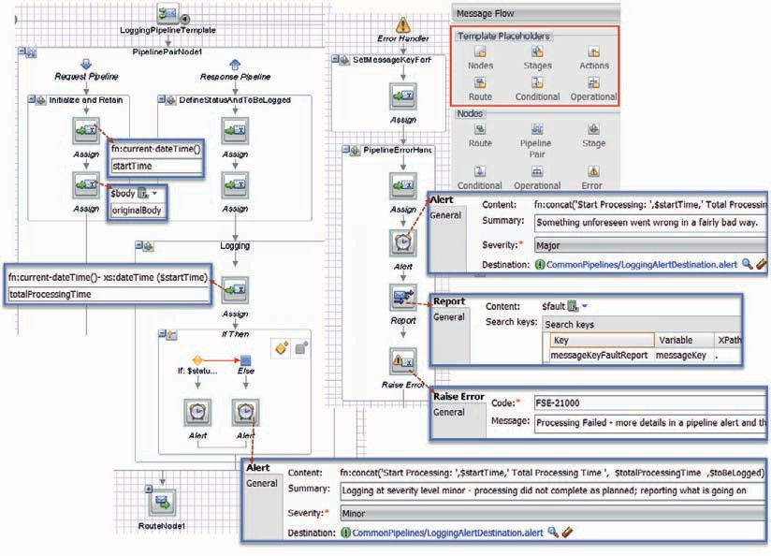

**FIGURE 7-21.** *The request and response pipelines for the LoggingPipelineTemplate*

The routing action should not be locked of course: the pipelines based on the template have to be configurable for the specific routing that applies in the services where they are included.

Change the name of the stage in the Request Pipeline to *Initialize and Retain*. Change the stage name in the Response Pipeline to *DefineStatusAndToBeLogged*. Add a second stage to the Response Pipeline, called *Logging*.

Add an Assign activity to stage *Initialize and Retain*. Set the value to *fn:current-dateTime()*. Set the variable to *startTime*. Add a second Assign activity that will retain the original request body for future use. The value should be *$body* and the variable is *originalBody*. Lock both activities, by right clicking them and selecting Lock Action from the context menu. These activities should not be modified by the developers creating pipelines based on this template.

Add an Assign activity to stage *DefineStatusAndToBeLogged*. This activity sets value “OK” in variable *status*. It is up to pipeline developers to override the configuration of this activity and set their own logic to derive the value of $status. Based on the value assigned to status—either OK or some other value—the Logging stage will produce logging at severity level normal (all is well) or minor (something is not well). Add a second Assign activity in this stage. This one assigns a value to variable *toBeLogged*. Anything this variable contains is used in logging messages in the *Logging* stage. The default value used for $toBeLogged is the expression $body/*[1]—or the contents of the response message. It is likely to be overwritten in concrete pipeline instances based on the template.

Add an Assign activity to stage *Logging*. It calculates the total processing time, using expression

 fn:current-dateTime()- xs:dateTime ($startTime)

and assigns the result to variable *totalProcessingTime*.

Then add an If..Then activity in stage *Logging*, below the Assign activity. Set the condition to

 $status='OK'

Add an Alert activity to both the Then and the Else branch. Both can refer to the, *LoggingAlertDestination,* Alert Destination that is prepared in the project. Set the Alert’s severity to Normal in the Then branch and to Minor in the Else branch. Set appropriate Summary values. Use the same Content for both Alert activities:

 fn:concat('Start Processing: ',$startTime,' Total Processing Time ',

$totalProcessingTime ,$toBeLogged)

Here we see the $startTime that was created in the request pipeline, the $totalProcessingTime that was calculated earlier in the stage and $toBeLogged that was defined in the previous stage.

All activities in the *Logging* stage should be locked; they are not intended for customization by the pipeline developers.

We have now reached the situation shown in Figure 7-21. Next, add an error handler to the pipeline *LoggingPipelineTemplate*. This handler will kick in if a fault occurs. The pipeline will report all fault details in both a message report and a pipeline alert and then raise a generic fault to be returned to the service invoker.

Create two stages in the error handler: *SetMessageKeyForReport* and *PipelineErrorHandler*.

The first one should contain a single Assign activity (that the pipeline developer should customize). The activity assigns a value to variable messageKey that is used by the error handler as the key under which a Message Report is created. Only developers of pipeline instances can determine what a meaningful message key is for the current service. Use “yourKey” as the default value to be overridden by the pipeline developer.

Copy the Assign activity and one of the Alert activities from the *Logging* stage to the error handler. Change the Alert activity’s severity to Major. Also change the Summary.

Add a Report activity. Set the content to $fault. Define one search key called *messageKeyFaultReport*. Its value is taken from variable *messageKey* using the XPath expression . (a single period).

The last activity in the error handler should be a Raise Error activity. Have it set a generic error code and message. All activities in the stage *PipelineErrorHandler* should be locked: pipeline developers working on children of this template have no business making changes to these action.

#### Add a Logging Pipeline to the FlightScheduleService

Open the overview editor for the *FlightSchedulerService*. Drag the pipeline component from the palette to the central area. The Create Pipeline wizard appears. Set the Service Name to *LoggingPipeline*. Check the checkbox *From Template*. Then browse for the *LoggingPipelineTemplate* in the *CommonPipelines* project.

Click Next. The Service Type is WSDL. Browse for the FlightScheduleService.wsdl, because we want this pipeline to expose exactly the same interface as the Validation pipeline currently invoked by the proxy service. Uncheck the checkbox for exposing the new pipeline as a proxy service. Press Finish to have the pipeline created. It is added as a standalone pipeline component in the overview editor.

Double click the *LoggingPipeline* to open the editor. The gray background indicates that this is not a regular pipeline, but instead one derived from a template. When you click on any of the activities in the *Logging* stage or the *PipelineErrorHandler* stage, you will see the effect of earlier locking these actions during template development: the activities can be inspected but not edited.

To make the *LoggingPipeline* useful, a number of activities do have to be edited. First, configure the Routing activity to make it route to pipeline *FlightScheduleValidationPipeline*. In the overview editor, the wire has been added. Delete the wire from the proxy service to *FlightScheduleValidationPipeline*. Then create a wire from the proxy to the *LoggingPipeline*, as shown in Figure 7-22.

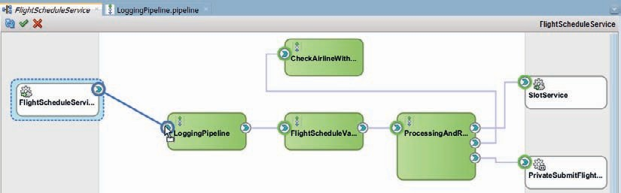

**FIGURE 7-22.** *Rewiring the proxy service to the LoggingPipeline that intercepts requests and*

*routes them through*

Return to the *LoggingPipeline* editor, where we have to configure a number of activities.

Click on the first Assign activity in stage *DefineStatusAndToBeLogged*. Set the Value—the expression used to derive the value of variable status—to the following XQuery expression:

 let $errorCount := fn:count($body/flig:submitScheduledFlightResponseMessage/ flig:ProcessingResults/flig:ProcessingResult)

return if ($errorCount = 0) then 'OK'

else 'NOK'

Define user namespace saibot.airport/services/flightschedule with prefix flig.

Next, edit the second Assign activity in the same stage, the one that assigns a value to variable *toBeLogged* that determines what will be visible in the pipeline alert. Use the following expression for the Value:

 if ($status= 'OK') then

fn:concat('Successful processing; assigned flight id: ', $body/flig:submitSche duledFlightResponseMessage/flig:FlightSchedule/flig:FlightId)

else

$body/flig:submitScheduledFlightResponseMessage/flig:ProcessingResults

In case of a successful scheduled flight registration, only the identifier of that flight is reported. In case of unsuccessful processing, all process results are reported.

##### Test the FlightScheduleService with LoggingPipeline

With these simple configuration steps, the new *LoggingPipeline* is embedded in the *FlightScheduleService*. Any request the service handles is processed by the pipeline and will surface somehow in pipeline alerts and whatever channels the *LoggingPipelineTemplate* uses now or in the future.

Run the *FlightScheduleService* and submit a request message that you expect will be processed successfully. The only evidence from the *LoggingPipeline* will be visible in pipeline alerts. Note: If instead of running the proxy service you run the *LoggingPipeline*, you can check the flow trace for details on the actions by the *LoggingPipeline*. Run either the proxy service or the *LoggingPipeline* with a request message that will fail during validation.

Open the Enterprise Manager FMW Control. Click on the node SOA | service-bus in the Target Navigation frame. On the Dashboard, set the Alerts dropdown to Pipeline Alerts. The Alert History appears (Figure 7-23) and should contain two pipeline alerts for the last two requests. The last one (that failed) at level Minor and the one before that at severity Normal.

Click on the alerts to verify if the Description contains the information that was defined in the

$toBeLogged variable.

Right click on the Service Bus drop-down link above the dashboard link. Select the option *Message Report* from the drop-down menu. On the overview page that appears, click on the Search button to retrieve all [recent] message reports. Note: If your request to the *FlightScheduleService* caused the *ProcessingAndRoutingPipeline* to abort, then the error handler in the *LoggingPipeline* will have kicked in and a Message Report is produced. In that case, the pipeline alert is created at severity Major. If the request did not make it passed the validation pipeline, then the alert is of severity level Minor and it did not trigger the error handler in the *LoggingPipeline*.

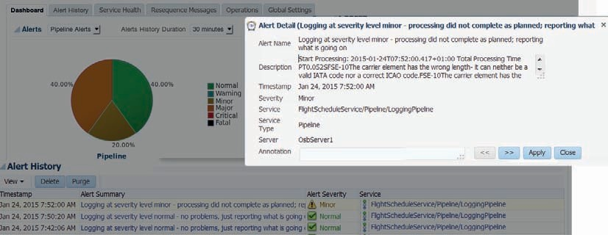

**FIGURE 7-23.** *Alert details produced from the inherited Logging Pipeline Template*

###### NOTE

*At this point, we can make additional changes in the LoggingPipelineTemplate in project CommonPipelines and see how these changes would automatically appear in the*

*FlightScheduleService. We can also create pipelines in other services based on the LoggingPipelineTemplate—to further demonstrate the reuse potential of pipeline templates.*

**Reaching Out from a Pipeline with Routing, Service Callout and Publish Activities** There are several activities that can be used to reach out from a pipeline to a business service, a local proxy service, a Split-Join component, or a pipeline. Service Bus developers can use routing, service callout and publish. Even though they essentially do the same thing, there are some distinctions you should be aware of.

Routing is used as the last node in a pipeline. It is the bridge between the request pipeline and the external component that continues processing the contents of $body and

$header. The routing activity will receive the response and trigger the response pipeline. A pipeline can contain only a single routing activity. This activity is synchronous: Service Bus will wait for the Route call to finish before continuing to process.

The threading model of the Service Bus consists of different threads being used for the request and the response pipeline. Routing is done by a Transport Provider that may or may not use the request thread to wait for the provider’s response. The latter case means that the transport is blocking and this applies to the EJB transport and the JCA Database Adapter.

The HTTP transport is nonblocking, which means that the request thread is released as soon as the transport provider has sent the request. The answer from the synchronous business service is handled by a newly allocated response thread.

A Service Callout can be used like Routing to callout to local proxy service, pipeline, business service, and split-join. A pipeline can contain multiple Service Callout activities, both in the request as well as in the response pipeline. Service callouts are synchronous. *The pipeline processor will block the thread until the response arrives asynchronously. The blocked thread then resumes execution of the pipeline. An important purpose of a Service Callout is to retrieve values for variables that can later be used in pipeline actions to perform business logic.* That means that while the Service Callout is being processed, nothing else can happen in the pipeline in terms of processing the current request.

The Publish activity is also used to invoke a local proxy service, pipeline, business service, and split-join. This activity can be used multiple times in a request and a response pipeline. Calls by Publish can be synchronous or asynchronous. Publish action is used for request-only scenarios where you don’t expect a response back. The exact nature of the Publish action depends upon the target service you are invoking. For example, with the Quality of Service (QoS) defined as “best effort” (the default setting), Publish is a true fire and forget and the thread will not be blocked.

A Publish Table activity can be used when the service to invoke has to be selected at run time. Switch-style condition logic is used to determine at run time which of the predefined services are to be invoked. Additionally, Dynamic Publish activities are used to invoke a single service; at run time is determined through an XQuery expression which service that should be.

### Parallel Processing Using Split-Join

A pipeline can contain many activities. Some of these are sequential by necessity, because one builds on the results of another. Activities have to wait on their predecessor in such cases.

However, it is not uncommon to have activities that could be processed in parallel, because they do not depend on each other in any way. Especially when these activities interact with external services whose response time determines the duration of the activity—and no local resources are involved—we can speed up the overall processing by executing these unrelated activities simultaneously.

Service Bus provides the Split-Join component, which allows us to implement such parallelism. It comes in two flavors: static and dynamic. In the static case, each parallel thread performs its own task and the number of parallel activities is known beforehand. In the dynamic case, the same set of activities is performed on multiple elements that are identified in a for..each loop. The iterations of this loop can (to some degree) be executed in parallel.

In the next two sections, we will first use a static Split-Join service to do a reimplementation of the *RoutingAndProcessing* pipeline that leverages the fact that its three key stages are actually unrelated and are good candidates for parallel execution. The second section introduces the *MultipleFlightScheduleService* that is capable of handling multiple flight schedule requests in one go. This service will use a dynamic split-join to process these requests in parallel.

#### Implementing the Aggregator Pattern through a Static Split-Join

The aggregator design pattern describes how multiple *individual messages are collected and retained through individual service calls until all required information is available to process and ultimately publish a single message distilled from the individual messages.*

The implementation of this pattern—where we retrieve results in parallel from various back end systems and subsequently aggregate the results together—can be done easily in a Service Bus project using the Split-Join component. Figure 7-24 shows how we could leverage this pattern in the *ProcessingAndRoutingPipeline* for the three sequential actions slot retrieval, calculation of the number of flights, and the airline check.

In the overview editor for the *FlightScheduleService*, create a Split-Join component—either by dragging it from the component palette or from the context menu Insert | Split Join.

The Create Split-Join Service wizard appears. Set the name to *ParallelEnrichmentSplitJoin*. Click Next. Select the ParallelFlightEnrichmentService.wsdl in the WSDLs folder. Operation *enrichFlightSchedule* in binding execute_bind is selected. Uncheck the checkbox for exposing the split-join as a proxy service. Click Finish to create the Split-Join service.

Double click on the Split-Join component to start editing it. The editor is similar to the pipeline editor—but quite different as well. Split-join is a different beast—as the component

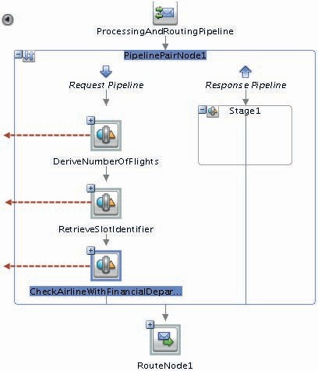

**FIGURE 7-24.** *Three sequential actions in the ProcessingAndRoutingPipeline that are candidate*

*for parallel invocation*

palette should tell you; when you check the .flow source file, you will see that this component uses BPEL as its definition language.

We want to have several enrichment operations executed in parallel. Therefore, add a Parallel component from the component palette and drop it between Receive and Reply, as shown in Figure 7-25.

Set the names of the two predefined scopes in this parallel flow to the same names used for the stages in the *ProcessingAndRoutingPipeline*: *DeriveNumberOfFlights* and *RetrieveSlotIdentifier*. Add a third scope, called *CheckAirlineWithFinancialDepartment*.

##### Implementing the Three Parallel Scopes

Add a Java Callout assign operation to the scope *DeriveNumberOfFlights*. Configure the method in the same way as when we implemented the Java Callout in the *ProcessingAndRoutingPipeline* (see Figure 7-13): invoke method *calculateNumberOfFlights* in class *ScheduledFlightProcessor* available in Jar file JavaCalloutJar.jar. Set the value expression of the argument to $request.in/ bind:TimePlanningUnit. This refers to the request message received by the Split-Join service. In a pipeline we would use $body instead of $request.in. For the Return value, click on the green plus icon and generate a new global variable *numberOfFlights* of type integer.

Next, drag the Invoke Service component to the scope *RetrieveSlotIdentifier*. Configure this action (as shown in Figure 7-14) to call the operation *findSlot* on the business service *SlotService*. For the request variable, create a local variable called *findSlotRequestMsg*. For the response variable, create a global variable *slotIdentifier*.

Add an assign action prior to the Invoke Service. Configure this action to assign the value

 <soapenv:Body [xmlns:soapenv="http://schemas.xmlsoap.org/soap/envelope/"/>](http://schemas.xmlsoap.org/soap/envelope/)

to $findSlotRequestMsg.in.

Add a replace action, following the assign. Have it operate on location *findSlotRequestMsg.in*, replacing only the node contents. Use the XSLT resource submitScheduledFlightRequestMessageTofindSlotRequestMessage.xsl in folder Transformations on *$request.in*.

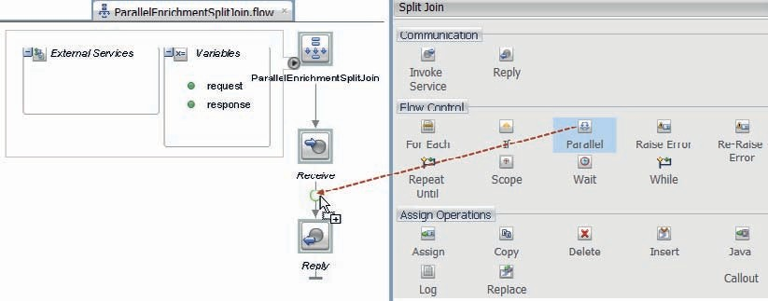

**FIGURE 7-25.** *Initial implementation of the ParallelEnrichmentSplitJoin component*

Moving to the third scope: *CheckAirlineWithFinancialDepartment*. Add another Invoke Service action and configure it as shown in Figure 7-17: Have it invoke the *FinancialDepartmentPipeline* and specifically the *checkAirlineStatus* operation. Create a local variable *checkAirlineRequest* for the Request variable and a global variable *checkAirlineFinanceResponse* for the Response Variable.

Add an assign action to the scope preceding the service invocation. The Variable is set to checkAirlineRequest.in. The expression used for setting the variable is:

 <soapenv:Body [xmlns:soapenv="http://schemas.xmlsoap.org/soap/envelope/">](http://schemas.xmlsoap.org/soap/envelope/)

<fin:checkAirlineRequestMessage xmlns:fin="saibot.airport/services/financial">

<fin:Carrier>

<ref:IATACode xmlns:ref="ref:saibot.airport/data/reference">{$request.in/ bind:Carrier}</ref:IATACode>

</fin:Carrier>

</fin:checkAirlineRequestMessage>

</soapenv:Body>

Here we include the *Carrier* element from the request message sent to the Split-Join service in the request message for the *FinancialDepartmentPipeline*.

##### Complete the Split-Join Service

All three scopes are defined—in a way that is very similar to the sequential stages in the *ProcessingAndRoutingPipeline*. The results from the scopes are stored in three global variables. What is left for us to do is create an Assign action that constructs the response message—in global variable $response, and not in $body as we are used to in pipelines. Add an Assign action, outside the parallel container and above the Reply action. The expression

 <flig:EnrichmentDetails xmlns:flig="saibot.airport/services/flightschedule">

<flig:SlotId>{$slotIdentifier.return/ns1:SlotId/text()}</flig:SlotId>

<flig:NumberOfFlights>{$numberOfFlights}</flig:NumberOfFlights>

<flig:FinancialDepartmentApprovalStamp>

{$checkAirlineFinanceResponse.out/ns3:UniqueStamp/text()}

</flig:FinancialDepartmentApprovalStamp>

</flig:EnrichmentDetails>

is to be assigned to variable $response.out (the wrapping body and *enrichScheduleFlightResponseMessage* element are added automatically). Here we construct the SOAP Body with the required response message, injecting the three global variables that have been assigned values by the three parallel scopes.

At this point, you can run the Split-Join service to see if it produces the desired result. Simply right click, either in the project navigator, the Split-Join editor, or the overview editor.

**Reorganize the ProcessingAndRoutingPipeline to Utilize the Split-Join Service** The real benefit from the *ParallelEnrichmentSplitJoin* will only emerge when we replace the current logic in the *ProcessingAndRoutingPipeline* with a call to the Split-Join service. That is easily done.

Open the *ProcessingAndRoutingPipeline* for editing. Add a new stage

*InvokeParallelEnrichmentService* as the first in the request pipeline. Add a Service Callout

activity to this stage. Configure it to invoke the *ParallelEnrichmentSplitJoin* service, specifically the operation *enrichFlightSchedule*, as shown in Figure 7-26.

Set the Configuration radio button to Configure Body. Define body variables *parallelEnrichmentRequest* and *parallelEnrichmentResponse* for the Request and Response, respectively.

Next, add an Assign activity to the request pipeline in the Service Callout. This assign has to copy $body to the variable *parallelEnrichmentRequest*.

Disable the three stages *DeriveNumberOfFlights, RetrieveSlotIdentifier*, and

*CheckAirlineWithFinancialDepartment*.

###### TIP

*Disabling and enabling stages or activities in a Service Bus pipeline can be done from the context menu on the relevant stage or activity in the pipeline editor. When disabled, a node is completely ignored by the run-time engine, as if the node does not exist at all.*

Add a new Replace activity in the Request Action of the Routing activity and disable the current one (or update the current one with new settings). This [new or edited] Replace activity acts on Location body. It replaces the node contents, using an XSLT resource (submitScheduledFlightRequestToprivateSubmitScheduledFlightRequest.xsl). The three input

parameters for this transformation—*numberOfFlights*, *financialDepartmentApprovalStamp,* and

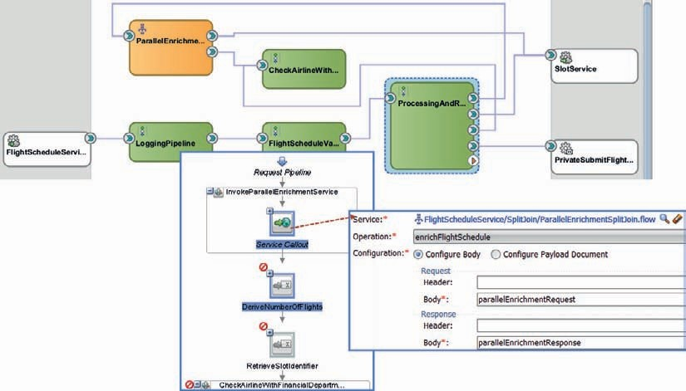

**FIGURE 7-26.** *Configuring the Service Callout to the Split-Join component*

*slotIdentifier*—are now to be configured using the following binding expressions, all based on the response from the Split-Join service:

 $parallelEnrichmentResponse/*[1]/flig:NumberOfFlights/text()

$parallelEnrichmentResponse/*[1]/flig:FinancialDepartmentApprovalStamp/text()

$parallelEnrichmentResponse/*[1]/flig:SlotId/text()

At this point you can try out the newly configured *ProcessingAndRoutingPipeline* with the callout to the Split-Join service, either by running the pipeline directly or any of the pipelines that precedes it or even the proxy service. Check what has happened with the overall response time: has it gone down now that we do multiple things in parallel using the Split-Join service?

#### Dynamic Split-Join for Parallel Processing of Multiple Scheduled Flights

In the previous example, we used a Split-Join service to perform three distinct tasks in parallel. Another common situation is where a message contains a number of details that should each be processed in the same way. This could apply to order items in an order, line items in an invoice or passengers on a flight boarding plan. Split-join can also be used in these cases—where the same operation has to be performed on a number of elements. The number is unknown at design time. The processing of each item is unrelated to each other item—therefore the processing can be performed in parallel—provided enough threads are available.

This section, we will look at this dynamic application of split-join. We will implement a new service interface *MultiFlightScheduleService*. This service is the versatile cousin of the *FlightScheduleService* that can process multiple requested scheduled flights in a single service request. Each scheduled flight request can be processed independently of the others—and this could be done in parallel to speed up the overall process.

##### Create Split-Join and Expose a Proxy Service for It

Open the overview editor for the *FlightScheduleService*. Either using drag and drop from the component palette or using right mouse click and Insert | Split Join, add a Split-Join component. Set the name to *MultiFlightScheduleSplitJoin*. Press Next to advance to the second page.

Select MultiFlightScheduleService.wsdl in the WSDLs folder as the interface for this split-join. Select operation *submitMultiFlightSchedules*. Have the split-join exposed through a Proxy Service called *MultiFlightScheduleServicePS*, to be created in the *Proxy* folder.

Press Finish to have the split-join created. Double click the split-join to edit its definition.

A request and response variable have already been created and the request and reply steps are also already present. Create a new global variable *tempResponse* based on the *submitMultiScheduledFlightsResponseMessage* element in the FlightScheduleService.xsd file. We will collect all intermediate results—gathered during parallel processing of the flight schedule requests—into this variable.

Add an Assign operation below the Receive activity. Configure the assign to assign this value

 <flig:submitMultiScheduledFlightsResponseMessage xmlns:flig="saibot.airport/ services/flightschedule"> <flig:SubmittedFlightScheduleResults></flig:Submitte dFlightScheduleResults> </flig:submitMultiScheduledFlightsResponseMessage>

to variable *tempResponse*.

Add a For..Each action below the Assign. This action is where the parallel processing will take place. Set the Execution Mode of the For..Each to Parallel. Call the counter variable name *counter*.

Set the Counter Start Value to *number(1)*. Set the Final Counter Value to

 count($request.in/bind:SubmittedFlightSchedules/bind:SubmittedFlightSchedule)

Add an Assign, an Invoke Service and an Insert action inside the For..Each scope. The assign will set the request message to be used in the Invoke Service and the insert will take the response from the service invocation and add part of it to the *tempResponse* variable.

Configure the Invoke Service to call the *submitFlightSchedule* operation on the *FlightScheduleValidationPipeline*, as shown in Figure 7-27. Create and set local Request Variable *submitFlightScheduleReq* and Response Variable *submitFlightScheduleRes* for this action.

Next, configure the preceding assign activity to set variable *submitFlightScheduleReq* with the expression

 $request.in/bind:SubmittedFlightSchedules/bind:SubmittedFlightSchedule[$counter]

This means that in each iteration, the next *SubmittedFlightSchedule* element from the request message received by the split-join is used for the subsequent service call to *FlightScheduleValidationPipeline*.

Configure the insert action with the value:

 <bind:SubmittedFlightScheduleResult>

<bind:Carrier>{$submitFlightScheduleReq.in/bind:Carrier/text()}</bind:Carrier>

<bind:FlightNumber>{$submitFlightScheduleReq.in/bind:FlightNumber/text()}</ bind:FlightNumber>

<bind:SubmissionOutcome>

<bind:FlightSchedule> <bind:FlightId>{$submitFlightScheduleRes.out/ bind:FlightSchedule/bind:FlightId/text()}</bind:FlightId> <bind:SlotId>{$submi tFlightScheduleRes.out/bind:FlightSchedule/bind:SlotId/text()}</bind:SlotId>

</bind:FlightSchedule>

{$submitFlightScheduleRes.out/bind:ProcessingResults} </ bind:SubmissionOutcome>

</bind:SubmittedFlightScheduleResult>

Set *as first child of* as the Position and the XPath expression *./*[1]* and variable *tempResponse* as the (target) location (see Figure 7-27).

This means that in each iteration, variable *tempResponse* is extended with an additional

*SubmittedFlightScheduleResult* element.

Add a final assign activity after the For..Each and before the Reply. Assign the value

$tempResponse to variable response.out to copy the final result to the response message returned from the Split-Join service.

Figure 7-28 shows the overview for the *FlightScheduleService* project, with the pipelines, the two Split-Join components, the two exposed proxy services, and the two business services—and all their interdependencies—including the logging pipeline that will be added in the next section. Each of these components can be run from within JDeveloper.

You can now run either the proxy service or the split-join itself. Feed a request message with two or more *SubmittedFlightSchedule* elements and see the response with entries for each of them. Try out a request message with a combination of correct *SubmittedFlightSchedule* elements

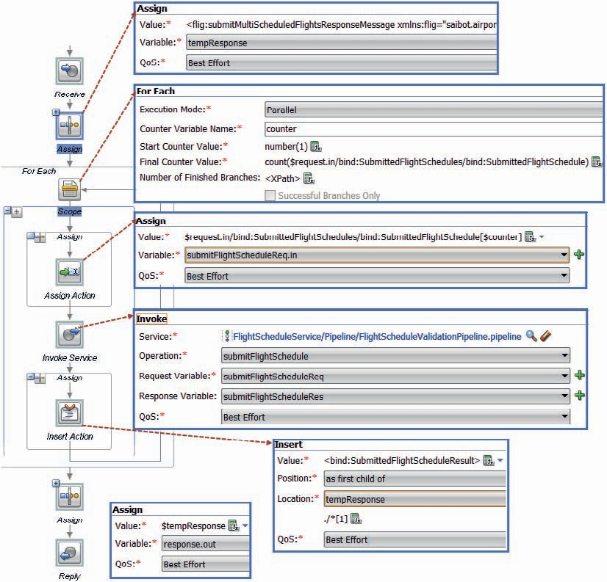

**FIGURE 7-27.** *The Split-join for parallel processing multiple flight schedules using a For..Each activity*

and elements that will fail validation. The response will contain a combination of

*SubmissionOutcome* elements and *ProcessingResults* entries.

Note that the response time is not the sum of the processing time of each *SubmittedFlightSchedule*. Thanks to parallel processing, the total response time should be considerably lower than that—depending on the number of threads the Service Bus has at its disposal for doing the work in parallel.

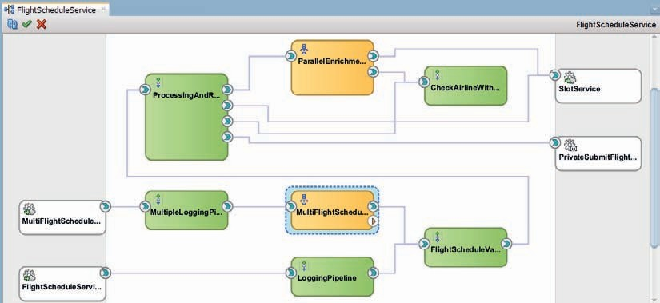

**FIGURE 7-28.** *Overview over the FlightScheduleService project*

###### NOTE

*An alternative to the dynamic split-join in case of one-way processing: post each element on a queue and do the processing in a second Service Bus service that listens to that queue. This is a nice approach when the processing part is reusable (and can be exposed as a separate service). This decoupled approach will also help to throttle the number of threads used to process elements in parallel and it allows the Split-Join component to complete more rapidly.*

##### Add Logging Pipeline

As a final step in this chapter, we will now reuse the logging pipeline template to also insert logging in the *MultipleFlightSchedule* service processing. Create a new pipeline in the *FlightScheduleService* project. Call the pipeline *MultipleLoggingPipeline* and associate it with the *LoggingPipelineTemplate* in project *CommonPipelines*. The pipeline should implement the same interface implemented by the *MultipleLoggingPipeline* and the *MultiFlightScheduleServicePS* proxy service, as defined in the MultiFlightScheduleService.wsdl.

Edit the new pipeline and configure the Routing activity to invoke the *MultiFlightScheduleSplitJoin*. Rewire the proxy service *MultiFlightScheduleServicePS* to this pipeline.

At this point, you can run the proxy service. The multiple flight schedule requests will be processed and some basic logging is performed, including a pipeline alert that tells you the time it took to process the request.

To tailor the output in the new logging pipeline, double click on the *MultipleLoggingPipeline*. Specify the expression that determines whether we should log at normal or minor severity level.

Open the first Assign activity in the *DefineStatusAndToBeLogged* stage in the response pipeline.

Set the expression to

 let $errorCount := fn:count($body//flig:ProcessingResults/ flig:ProcessingResult)

return if ($errorCount = 0) then 'OK'

else 'NOK'

This specifies that as soon as the response from processing multiple submitted flight schedules contains even a single *ProcessingResult* element, the status of the overall request is set to NOK. As a result, logging takes place at severity level Minor.

You can edit the second Assign activity to define the value of variable $toBeLogged—the message actually contained in the Pipeline Alert.

##### Modular Design with Service Bus

Service Bus has several levels of granularity at which functionality can be encapsulated. The most fine-grained level is the stage, which is easily identifiable in the visual editor and can have its own variables and error handling. A stage is not invoked—it is executed when within the request or response pipeline its turn has arrived. Stages are not reusable.

The pipeline is the next level of encapsulation granularity. Pipelines can contain multiple stages, have their own variables that are global throughout the pipeline and can have their own error handling. When a pipeline is based on a template, it inherits the template’s functionality. Shared variables can be shared across pipelines within the same project. Pipelines are reusable within the Service Bus project. Pipelines are invoked through the service interface they expose. That interface can be exposed as proxy service to external consumers as well. Note that Pipelines are very similar to Mediator or BPEL components in SOA composite applications.

Private proxy services that are invoked over the local transport offer the next level of encapsulation. These services are reusable across Service Bus projects within the same run-time environment. The local transport ensures efficient, low-overhead calls can be made to these services, that allow transaction and security context to be shared. Shared variables can be shared between pipelines in the calling project as well as the called, private service project.

Public proxy services are the highest, coarsest grained level of reusable functionality in the Service Bus. Any pipeline can invoke a public proxy service, either a local one or a remote one. In both cases, nothing is shared between the calling and the called service—no variables and no security or transaction context, unless the transport protocol used has explicit support for such propagation.

When designing services and their implementation, these levels of encapsulation should be considered. For example, from the perspective of reuse, testing, team development, deployment, debugging, and continuous delivery.

### Summary

Service Bus is the lean and mean machine that is very good at processing messages quickly and efficiently, and without too much fuss. Earlier chapters demonstrated fairly simple Service Bus projects with minimal VETRO activity. This chapter makes clear that a Service Bus pipeline can do much more than just a little transformation. Implementing composite services is very well possible too. Callouts, error handling, if..then..else logic, for-loops and such make a pipeline into a little program that can perform quite complex tasks. Multiple pipelines can be linked together, to form a larger process constructed from fairly encapsulated reusable pieces.

Determining how to organize the logic in a Service Bus project and what granularity to use for stages, pipelines, and local proxies is both important and something of challenge. Deciding what to do in Service Bus projects and when to engage an SOA composite application is even more important. To keep the Service Bus lean and mean, we probably should refrain from implementing too much complexity and composition in Service Bus projects—even when that can be done.

Pipelines can be based on pipeline templates. These templates—as we have seen—provide inheritable chunks of logic that can be fine-tuned in each realization of a pipeline based on the template. The logging pipeline template that we discussed contains generic functionality—best practices as laid down by the Saibot Airport competence center on SOA Suite—that can easily be applied in pipelines across many Service Bus projects. These pipelines each customize and complement the contents from the template to the specific context in which they are used. When the pipeline template is modified and deployed, all derived instances will inherit these changes automatically without redeployment.

The Split-Join service can be used as another type of reusable component that can be called from either pipelines, proxy services, or other Split-Join services. The split-join is similar to a Pipeline. However, it uses a different syntax and set of activities (based on BPEL). Its main purpose in Service Bus is to provide of parallel processing capabilities that are used to speed up processing of messages.

The next chapter will demonstrate how composite services can also be implemented in SOA composites. We will see how the BPEL component is another great tool for implementing complex message processing, XML oriented logic, and service orchestration.





CHAPTER

# 8

## Composite Services with SOA Composites Using the BPEL Component

he previous chapter demonstrated how composite services can be implemented through Service Bus projects, using Pipelines and Split-Join components. We welded several of these components together to realize the *FlightScheduleService—*using activities to

**T**

validate messages, do parallel processing on parts of messages, and to call out to custom Java classes and local and remote web services.

The BPEL component that can be used in SOA composites is also very well and probably even better equipped for the implementation of such composite services. Orchestrating service calls, manipulating XML messages, performing flow logic with if-then-else and for-loops, handling exceptions as well as performing parallel processing are the sweet spot for this component. A BPEL component has many characteristics in common with Service Bus Pipelines and Split-Join components. In addition to orchestrating synchronous services, BPEL is also good at asynchronous interactions as well as longer running (stateful) conversations. These latter two subjects—that are both not the strong suit of Service Bus*—*are addressed in later chapters.

BPEL (Business Process Execution Language) is a standard, defined by OASIS, and supported by many IT vendors. BPEL is a language for creating a piece of service and process logic—logic that exposes a service interface and that typically orchestrates multiple service calls. At the same time, BPEL has many of the traits of general-purpose programming languages, as we will see in this chapter and the next.

A BPEL process can be fairly long-running, can contain state, and can receive incoming messages in addition to the original request that instantiated the process. In addition, BPEL can perform its orchestration as part of a single global (XA) transaction. This chapter introduces BPEL and the development of BPEL service components.

In this chapter, we will revisit the *FlightScheduleService* and the *MultiFlightScheduleService* that were introduced in Chapter 7. These services take a single one or multiple of these requests for actually planning a flight that is the implementation of a slot. We will implement them again, this time using a SOA composite application and the BPEL component, as well as many of the same artifacts used in the previous chapter, for example, for transformation and Domain Value Mapping.

The sources for this chapter provide several stages in the development of this service (from the starting point *step0* through *step7* with the final result). Each step is both the end result of the previous stage as well as the starting point for the next. This chapter covers a lot of ground. It does not provide screenshots or detailed explanations for every step along the way. You are encouraged to take a close look at the steps in the source code to get a good understanding of how the end result is arrived at.

### Using BPEL to Create the Bare Bones FlightScheduleService

This section discusses the initial creation of the *FlightScheduleService*, using a BPEL component. At first it will be a hollow shell: the service interface is exposed and the barest of implementations is provided. Later on we will add more details to this implementation. Start this section from the *step0* sources.

#### Quick Introduction to BPEL

BPEL is a programming language for implementing process flows and composite (or orchestrated) services. The program created with BPEL is called a (BPEL) process. This term reflects the fact that BPEL was initially positioned to implement business processes. Over the years, business processes

have predominantly become the domain of BPMN (and for Oracle of the BPM Suite)*—*see Chapter 19, with BPEL being used more in a similar way as Service Bus pipelines: service oriented programs that manipulate XML, invoke business services and perform logic around those. BPEL is therefore a fine candidate for implementing composite services. One major difference with Service Bus pipelines is BPEL’s natural ability to interact with asynchronous services, as we will discuss in Chapter 12, and to capture state during longer running processes.

BPEL is a standard maintained by OASIS and supported by all major players in the IT industry, including Microsoft, Oracle, IBM, Software AG, Adobe, and SAP. A BPEL program—referred to as a *BPEL process definition*—can be run by a BPEL engine, just like a Java program can be run by a Java Virtual Machine and a PL/SQL program by the Oracle RDBMS. BPEL is one of the first-class citizens for component implementation included in the SCA standard, along with Java, Spring, PHP (SOAP) web services, and C++. Services implemented using BPEL can easily be configured in SCA components and linked with references provided by other SCA components.

A BPEL process is often published as a web service. It then has an associated WSDL document with XSD definitions and one or more operations on a *portType* that can be called through SOAP messages. Note that we will later discuss other ways to call and communicate with BPEL components.

A typical BPEL process contains the following items:

* + Calls to services. A service in this sense can be a task performed by a human staff member, hiding behind the service interface of a workflow engine, or an automated Web Service,

although for the BPEL process, the distinction is not important.

* + Specific BPEL activities, including data manipulation (calculation and transformation of variables associated with the process) and flow logic, including decision point (if-then-

else and switch/case, iteration, parallelism, wait).

* + Event handlers and fault (or exception) handlers.

In SOA Suite 12c*,* BPEL components often work closely together with other service components in a composite application, such as Mediator, and Business Rule service components, to facilitate interaction with other services and provide complex, externalized decision logic. Human Task components are also frequently wired to BPEL processes for the manual handling of activities in potentially complex workflows. Another regular partner for BPEL components is the Notification Service for sending messages to human users via email, SMS, and instant messaging (internally connected to the User Messaging Service, or UMS).

Its a good fit with business processes notwithstanding, BPEL primarily provides a powerful way for implementing composite services that do not necessarily directly relate to an automated business process. Of course, services can be implemented using a variety of technologies.

Especially when a service component has to invoke multiple services—either external to the composite application or provided by other service components inside the composite, and potentially asynchronous and long-running—BPEL is typically a good way to implement the component. This holds especially true when over the course of the component’s lifetime some state is built up in variables and process flow logic is involved to loop or conditionally branch.

A BPEL component has the capability to receive additional messages, beyond the first invocation that initiated the component instance, and respond to them. This allows clients to interact with the process—for example, to check on its progress, provide additional information, or get a hold of intermediate results.

#### First Steps with the FlightScheduleService and with BPEL

Open project *FlightScheduleService* in application *FlightScheduleServiceSOA*. This is a SOA composite project. It currently exposes the *FlightScheduleService—*based on the same WSDL and XSDs we used in Chapter 7. This service is to be invoked with details about a flight schedule that is the implementation of an existing slot allocation. The scheduled flight should be registered, once it has been validated and enriched. Upon successful registration, the assigned Saibot Airport flight identifier is to be returned, along with a tentative gate assignment.

The initial implementation will simply accept the request message and return a hard-coded response. No validation, enrichment, or onwards processing is performed yet. It will be a first taste of BPEL.

##### Implement the Minimal FlightScheduleService

Open the composite editor for the *FlightScheduleService*. From the component palette, drag the BPEL component and drop it in the Components section, to add the component to the SOA composite.

The editor for creating a BPEL process appears, as shown in Figure 8-1. Call the BPEL component *FlightScheduleProcessor*. Set the namespace to saibot.airport/services/flightschedule/ private/FlightScheduleProcessor. Select the Template *Base on a WSDL* and select the FlightScheduleService.wsdl in the WSDLs folder. Note that the Port Type is automatically set. Set the Service Name to *FlightScheduleProcessor* and uncheck the checkbox *Expose as a SOAP service*. Press OK to complete the creation of the BPEL component.

The BPEL component is added to the composite overview and to the underlying composite

.xml file. Wire the exposed service to this new component. This means that when the composite is deployed and the *FlightScheduleService* is invoked, the request message is passed to the BPEL engine to process using the *FlightScheduleProcessor*. It is up to this BPEL component to perform

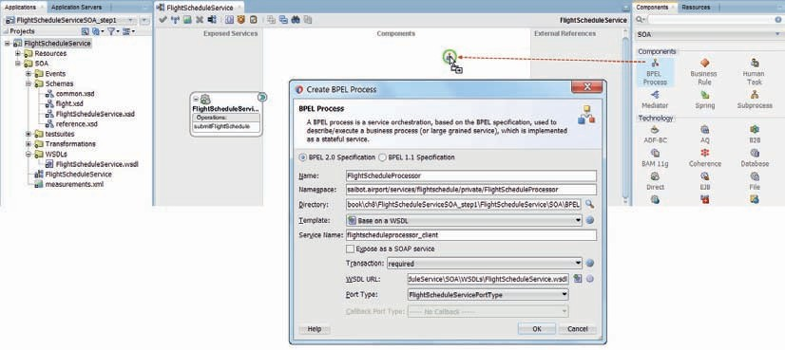

**FIGURE 8-1.** *Add a BPEL component to the FlightScheduleService SOA composite application*

*to provide the implementation of the FlightScheduleService*

the required logic and come up with a meaningful response message that will travel from the BPEL engine over the SCA fabric to be returned to the service consumer.

Double click the BPEL component to bring up the editor. You will see something similar to Figure 8-2*—*and not all that different from the Service Bus Split-Join editor discussed in Chapter 7.

The BPEL process should be read from top to bottom. It contains a single, largely sequential flow that starts with the *receive* activity. This activity gets handed the incoming request message, initiates a new instance of the BPEL process, and assigns the request message to a global variable*—*default name is *inputVariable*. This variable was created automatically*—*based on the request message for operation *submitSchedule* as defined in the FlightScheduleService.wsdl document.

At this moment, the only other activity is a Reply activity. This activity takes the value from one of the variables in the BPEL process*—*by default called *outputVariable* and based on the response message defined in the FlightScheduleService.wsdl document*—*and returns it to the caller as the response message.

Note the component palette with activities that can be added to the BPEL process. Many are similar to the activities available in Service Bus pipelines, used for messaging validation and processing, for service callouts and for typical programming operations such as iterations, conditional logic, and exception handling.

All interactions between a BPEL process and the outside world*—*both incoming and outgoing*—*are regulated through Partner Links, such as the *FlightScheduleProcessor* partner link shown on the left in Figure 8-2.

###### NOTE

*Interactions through the Event Delivery Network (see Chapter 15) are the exception to this statement: these do not take place through Partner Links.*

Partner Links represent service interfaces that are either implemented by or accessed from the BPEL process. The definition of exactly which interface is associated with a Partner Link is defined

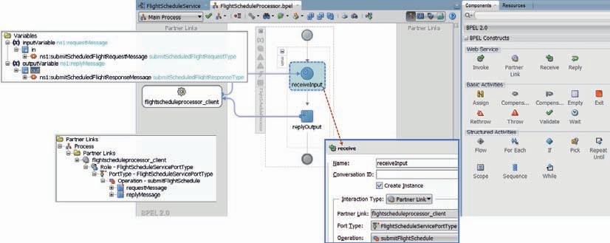

**FIGURE 8-2.** *The default implementation of a BPEL process based on a synchronous service*

*definition*

in a wrapper WSDL document. In this case that is FlightScheduleServiceWrapper.wsdl*—*generated by JDeveloper when the BPEL component was first created, based on the FlightScheduleService. wsdl and implementing the *FlightScheduleServicePortType*.

A *PartnerLinkType* specifies “role” elements. Each role element introduces a role that either the BPEL process or the external partner can assume in their mutual interaction: service consumer or service provider. That role is linked to a *portType* that the partner playing the role should implement. These roles associated with *portTypes* are a BPEL specific extension to vanilla WSDL documents.

If the BPEL process is asynchronous, the partner link type contains two role elements: The partner is initially the consumer of the service, sending a SOAP message to the BPEL process and subsequently the receiver of the response message sent to the callback interface. Asynchronous services are discussed in Chapter 12.

Both the Receive and the Reply activity are associated with the *submitFlightSchedule*

operation on the *FlightScheduleProcessor* partner link.

Although you could already deploy the SOA composite and test the service, what is still lacking from the BPEL process is an activity that assigns a value to the *outputVariable*. At this moment, the response message would be empty.

##### Add an Assign Activity to Provide Content for the Response Message

In BPEL, the Assign activity is used to manipulate variables. Add an Assign activity from the component palette and insert it between the Receive and Reply activity. Set the name of the activity to *setHardcodedReply*. This name has no relevance for the BPEL engine*—*it is only used for human readability when working in the design time, or when looking at the audit trail at run time.

Double click on the Assign activity to bring up the editor. On the right-hand side, you will see the variables that can be manipulated in the current scope. On the left is a similar list that shows all available variables from which data can be used to help construct the data to be applied to the target. We can draw direct mappings from the left to the right, to have values copied over to the target variables.

Alternatively, we can assign static values or entire XML fragments and we can use expressions to produce the values of (elements of) target variables. These expressions can enlist advanced XPath functions that can do both XQuery- and XSLT-based transformations, deal with binary content or map from native formats to XML or vice versa. Assign rules can also remove elements from the target variable or rename or recast them (both local name and namespace). Check the documentation for some details on all the many intricacies of the Assign activity and the copy rules.

For now, set hard coded values for all elements in the *FlightSchedule* node in the

*outputVariable*, by dragging literals to the relevant target elements.

###### TIP

*BPEL differs from Service Bus pipeline in this area in several ways: in BPEL, variables have to be predefined before they can be used in an Assign activity. Additionally, the Assign activity in BPEL is used both for the initial assignment of a value to a variable as well as for manipulating and replacing the current value of a variable, unlike Service Bus that has separate activities for this—assign and replace*

*respectively. In both cases, variables contain XML structures—although BPEL also supports simple types such as String and Integer.*

##### Deploy and Test

Deploy the SOA composite *FlightScheduleService* to the Integrated WLS, in exactly the same way as first introduced in Chapter 5. A test call to the service exposed by this composite can be made from a tool like SoapUI, from the test tab in the EM FMW Control and from with JDeveloper, using the HTTP Analyzer. If you open the *Application Servers* window and expand the node for the IntegratedWebLogicServer all the way down to IntegratedWebLogicServer | SOA | DefaultServer | default | FlightScheduleService [1.0] | FlightScheduleService (ws), you can right click on this node and select *Test WebService* on the context menu. Figure 8-3 illustrates this.

###### NOTE

*The [1.0] for the SOA composite application is an indication of the version of the composite. Multiple versions could be deployed at once, all of them running in parallel (also see Chapter 21). This is a distinction between Service Bus and SOA composites: the Service Bus does not have any concept of versioning at all.*

The HTTP Analyzer will appear. This is a tool integrated in JDeveloper for making test calls to HTTP services, including SOAP and REST services. Since the HTTP Analyzer is invoked in the context of the *FlightScheduleService*, it opens with the correct WSDL and Service URL (endpoint) and presents a form where the values for the elements of the request message can be set, see Figure 8-4. The XML content can be directly edited on the tab labeled HTTP Content.

To see what happened during the execution of the service request in the composite instance, we can inspect the SOA composite flow trace and the detailed BPEL audit flow in the EM FMW Control. The latter allows us a step by step audit trail of exactly what went on in the BPEL process instance, see Figure 8-5.

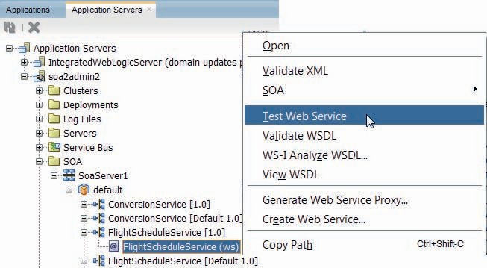

**FIGURE 8-3.** *Invoking a service exposed by a deployed SOA composite from within JDeveloper*

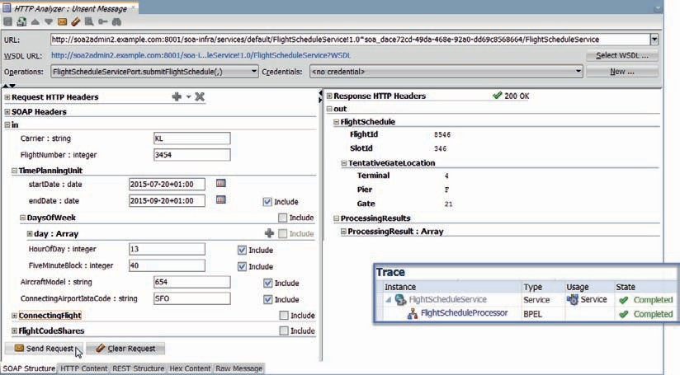

**FIGURE 8-4.** *Test call to the FlightScheduleService SOA composite’s exposed service interface*

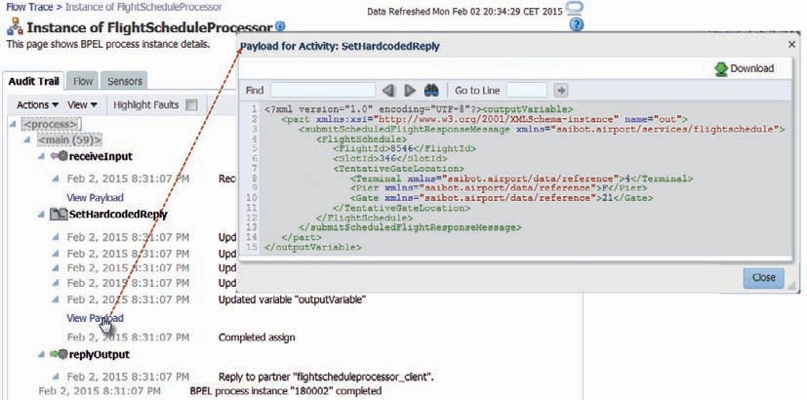

**FIGURE 8-5.** *The message flow trace and the audit trail for the BPEL process instance*

###### NOTE

*We can also make use of debugging the SOA composite and the BPEL component to closely inspect exactly what goes on inside.*

*The Flow tab provides a graphical report on the BPEL process instance, illustrating in the same language as used in the BPEL design editor how a particular instance progressed.*

### Implementing Validation

**on Requested Flight Schedules**

Processing a scheduled flight is not a trivial thing. First, the incoming message should be validated against the XSD Schema definition. Then a number of constraints, that cannot be expressed in an XSD, have to be checked. Subsequently, some of the values provided in the request message have to be verified against a list of allowable values. These values may also have to be converted to a different domain. This was the situation in Chapter 7—where we dealt with the challenges in a Service Bus pipeline—and it is again the situation now as we will use a BPEL component to implement the desired logic.

In order to provide our consumers with as complete a list of problems as possible with their request for a scheduled flight, we do not want to immediately abort processing upon the first issue we run into. Instead, we compile the results from each of the three steps into a list of processing results. If no issues were encountered, we can proceed to the next phase of the BPEL process: enrichment. If, however, one or more issues were found during XSD validation, constraint checking, or domain value checking and mapping, we will not continue to this next stage but instead return a response that contains all the issues that were discovered.

In this section, we will implement the three validation stages as well as the mechanism for collecting all issues. Start this section from the *step1* sources.

#### Prepare the Multiphase BPEL Process Structure

A BPEL process contains activities. In the most basic case, these activities are organized in a single sequential flow. The BPEL language provides the Scope activity, an important element in structuring processes. A scope is a container that contains one or more activities. A scope can also define local variables—private to the scope—and define scope level fault handling and compensation logic (to deal with failed transactions) as well as scope level event handlers. Unlike a Sequence activity in BPEL, a Scope is more therefore than just a container or package of related activities.

Scopes are quite useful when developing large BPEL processes in a structured fashion. Scopes can be nested to any level. They allow clustering of related activities with meaningful labels, making the BPEL process diagram much easier to understand. You can open or collapse scopes in the visual BPEL editor, which allows you to focus on details where you need to and stick to a high-level overview where that is more appropriate. Scopes also help with a top-down design of the BPEL process.

We want to execute three types of validations, and each of these three may result in a fault. However, these faults should not cause the process instance to completely abort but instead have to lead to an update of a variable that contains processing results. This leads inevitably to a process design with a scope for each of these three validation steps. Additionally, it makes sense to make an explicit distinction between the validation phase of the process and the processing and routing phase. In Service Bus, we used separate pipelines for this high-level service

implementation structure and used stages for the more fine-grained organization. In BPEL we have more options. Scopes, unlike Service Bus stages, can be nested—so we can use top level scopes for one level of organization and a deeper level for more fine grained structure. Additionally, we can use a subprocess—either inline or stand-alone—to be called from the main BPEL process, as a means of structuring the BPEL process.

For now, let’s just work with scopes—top level and nested.

Open the BPEL editor and add two top level scopes, called *Validations* and *ProcessingAndRouting*. Open the *Validations* scope and add four nested scopes, called *SchemaValidation*, *CustomValidation*, *AirlineValueMap,* and *ContinueOrReturn,* respectively, as seen in Figure 8-6.

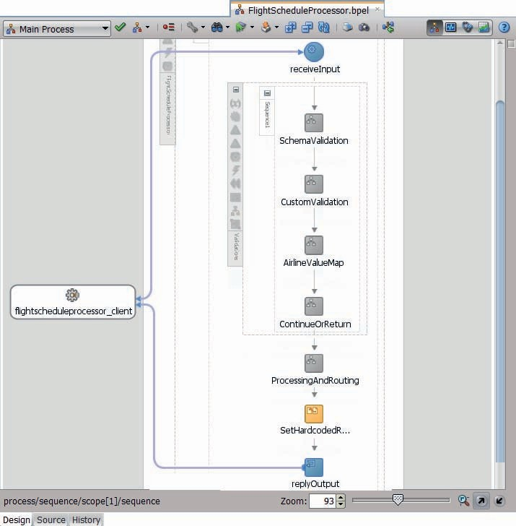

**FIGURE 8-6.** *FlightScheduleProcessor with two top level scopes and four nested scopes*

###### TIP

*A scope must contain at least one activity in order to be valid. New scopes will therefore be marked with an alert icon as long as they do not have that first activity. To make a scope valid without having to implement its functionality, we can use the BPEL activity called Empty. This activity does what you would expect it to do: nothing. By giving this activity a logical name that describes what the eventual activity*

*in that spot should do, it can be used to design the structure of the process early on. At a later stage, the real activities doing the actual work can replace these empty activities.*

When the scopes are created, they will automatically contain a *sequence* activity. A sequence contains one or (usually) multiple BPEL activities that are executed sequentially. A sequence can be named and it can be expanded or collapsed in the visual editor, just like a scope. Unlike a scope, a sequence does not have its own variables or handlers—all it has are the sequentially executed activities. Sequences are frequently used for grouping activities inside containers, such as Scope and Flow, which can contain only a single [direct] child activity.

#### Add Schema Validation

Instructing the BPEL engine to perform validation of the contents of a variable against the underlying XSD schema is straightforward: there is an activity called Validation for precisely that purpose. Drag a Validation activity from the component palette to the *SchemaValidation* scope. Double click the activity. On the *General* tab, add variable *inputVariable* as the variable whose content should be validated against the XSD definition. This will make the BPEL engine perform the *Schema Validation*. When a violation is detected, the BPEL engine will throw a bpelx:invalidVariables run-time fault.

You can deploy the SOA composite and invoke the *FlightScheduleService* with a request message that contains a violation of the XSD, for example, by using a one-digit numerical value for the *AircraftModel* element. An HTTP 500 response will be the result, containing a SOAP Fault that reports on the validation error.

We do not want the process to abort, however. Therefore, we have to add fault handling to the

*SchemaValidation* scope.

#### Fault Handling for Scope SchemaValidation

The main process activity, as well as every scope in a BPEL process, can have a *faultHandler* associated with it that contains one or more Catch activities that can each handle a specific type of fault (or all faults) when it occurs in the scope they are defined against—or in one of that scope’s descendants or nested scopes. Each fault type in a BPEL process is identified through its fully qualified name. Catch activities specify the fault type they want to catch through that name. A Catch activity for a fault that has associated data can specify a *faultVariable* that will be initialized with the fault’s data when the Catch is activated. We will use this for the *invalidVariables* fault that is thrown when a validation error occurs.

The variable used as the fault variable needs to have been defined earlier in the scope or on some higher level. It needs to be based on a message type—not a simple or complex XML element—in one of the WSDL documents associated with the application.

In addition to fault-specific Catch elements, we can add a catchAll—similar to “when others” in PL/SQL and “catch(Throwable exception)” in Java. When no fault-specific Catch is around to take care of the current fault, this all-purpose safety net steps in to handle it. We can find out the name of the fault that our catchAll is dealing with using the Oracle BPEL-specific XPath function bpelx:getFaultAsString(), which we can use, for example, to assign the name of the fault to

a local variable.

##### Add Fault Handler to Scope SchemaValidation

Click on the Add Catch icon in the *SchemaValidation* scope’s icon bar as shown in Figure 8-7. The Catch editor appears. Enter *handleValidationFault* as the documentation only name of this Catch. Select the predefined *invalidVariables* fault for the Fault Name. Type *validationFault* as the user defined name for the Fault Variable; that is the variable into which the BPEL engine will store the fault when it occurs. From that variable will we be able to read some details about the fault inside the Catch.

Click on OK to close the Catch editor. Next, create the variable called *validationFault* at scope level. This variable is of type Message Type. It is to be based on the message *RunTimeFault* in the RunTimeFault.wsdl document that is available in the type browser.

It is our objective to be able to return a response message that contains the processing results from this and other validation stages in the BPEL process. To that end, we have to create a global variable to which each validating scope can add its findings.

Create a global variable—at process level—called *processingResults*. This message should be based on type *processingResultsType* in FlightScheduleService.xsd. The scopes can insert *ProcessingResult* elements into this variable if they have found violations of some sort. Add an Assign activity – immediately after the receiveInput activity - to initialize the variable with a literal XML snippet. The value to assign to processingResults is

 <processingResults xmlns:def="saibot.airport/services/flightschedule" [xmlns:xsi="http://www.w3.org/2001/XMLSchema-instance"](http://www.w3.org/2001/XMLSchema-instance) xsi:type="def:processing ResultsType"></processingResults>

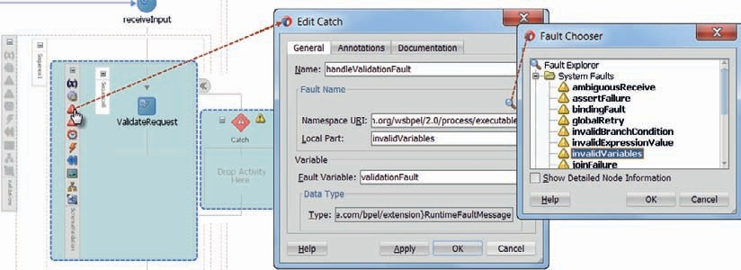

**FIGURE 8-7.** *Add Catch (fault handler) to scope SchemaValidation, handling fault*

*invalidVariables*

Return to the Catch in scope *SchemaValidation*. Add an Assign activity. This activity has to create a *ProcessingResult* element inside the global variable *processingResults*.

First, drag the Literal icon to the *processingResults* variable. In the editor, specify the literal value as:

 <fse:ProcessingResult xmlns:fse="saibot.airport/services/flightschedule">

<fse:ResultCode>SBT-011</fse:ResultCode>

</fse:ProcessingResult>

Next, wire the *summary* element in the *validationFault* variable to the *Description* element under the *ProcessingResult* node. Right click on the copy rule that is created and check the option *insertMissingToElement*. This ensures that the *Description* element gets created in the target variable.

Finally, wire the *in* node under *inputVariable* to the *ContextTrace* element in the

*processingResults* variable. Check option *insertMissingToElement* for this copy rule too.

The Assign activity should now look as is shown in Figure 8-8. Close the editor.

You can now deploy the SOA composite and invoke the *FlightScheduleService*. The response message will not yet contain any indication of validation errors though. Only in the BPEL audit trace in the Enterprise Manager FMW Control will you be able to verify that the fault handler was triggered and variable *processingResults* was set. In the next section, we will ensure that the response message is set appropriately.

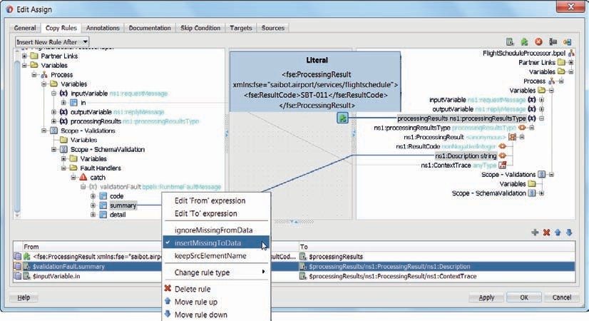

**FIGURE 8-8.** *Assign activity that populates variable processingResults based on the validation*

*findings*

#### Return Processing Results upon Validation Failure or Continue

As the last step in the top level scope *Validations*, we will determine if all validations were passed successfully and we can therefore move on to the second top-level scope *ProcessingAndRouting*, or if one or more validation issues were encountered and the process should therefore terminate and return the processing results to the service consumer.

##### Implement Scope ContinueOrReturn

Open scope *ContinueOrReturn*. Add an If activity to the scope. We will configure this activity with a condition to check if variable *processingResults* contains any *ProcessingResult* entries. If it does, clearly one of the validating scopes has reported an issue and we cannot proceed with processing the flight schedule request.

Set the name of the If activity to *IfValidationErrors.* Set the condition to

 count($processingResults/ns1:ProcessingResult) > 0

This condition will evaluate to true when at least one *ProcessingResult* has been added to global variable *processingResults*.

The process will enter the If branch if a validation error was reported. In that case, the outputVariable on which the response message is based should be updated, the response should be sent, and the process should be terminated.

Add an Assign activity to the If branch. Double click this activity to edit it. Set the name to UpdateOutputVariable.

Map a literal value to the out part in outputVariable. Set the literal value to

 <fse:ProcessingResults xmlns:fse="saibot.airport/services/flightschedule"/>

The copy rule should be of type append, meaning that this literal should be appended to the contents of the out part of the *outputVariable*.

Add a second copy rule—also of type append—that maps the *ProcessingResult* element in variable *processingResults* to the *ProcessingResults* element in the *outputVariable*.

Add a reply activity to the If branch, right after the assign activity. Link this activity to the [FlightScheduleProcessor] partner link. Select the *outputVariable* as the one to provide the data for the response message.

This activity will send the response, but that does not prevent the BPEL process from continuing. If we would not forcibly interrupt the process, it would continue onwards and send another reply. That second reply would be the only one that consumers receive as it supersedes the first one. That is not what should happen. Add a Terminate activity underneath the Reply. This will ensure that the BPEL process stops and nothing is done after the reply has been sent.

The *else* branch is simple and straightforward: nothing has to happen in that case and we can move on to the second top level scope. However, the *else* branch must contain at least one activity, so add an Empty activity.

An alternative implementation could be: move all subsequent processing to the *else* branch. In that case, both the Empty activity in the *else* branch and the Terminate activity in the If branch would not be necessary. The result would be somewhat different: instances of the SOA composite that ran into validation errors would be marked as *aborted* when the Terminate executes or as *completed* in the alternative implementation.

The scope *ContinueOrReturn* should now look as in Figure 8-9.

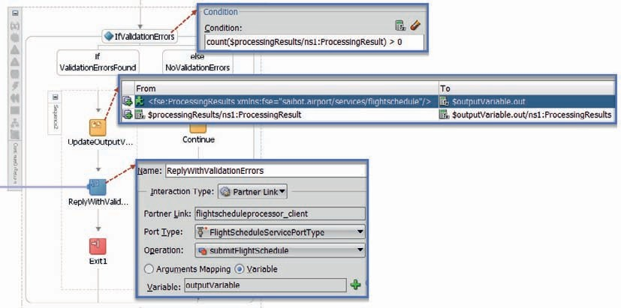

**FIGURE 8-9.** *The If activity that determines whether validation errors were reported and acts*

*accordingly*

**Test the FlightScheduleService with Validation and Premature Termination Inside** Deploy the *FlightScheduleService* composite. Then invoke the service from either the HTTP Analyzer, the EM FMW Control test page, or any other tool. Send a request message that does not satisfy the XSD definition.

This time this call should result in a response message that contains the *ProcessingResults* element with contents that explains what the problem was with the request message. The flow trace in the EM FMW Control as well as the BPEL audit trail (Figure 8-10) should make clear which path was taken. The SOA composite instance is listed in the console as *aborted* because of the terminate that ended the instance.

#### Implement Custom Validations Using XQuery

The BPEL process *FlightScheduleProcesor* now has a mechanism for performing validations in a scope, handling validation errors at that scope level, and adding them to the global *processingResults* variable. The *ContinueAndReturn* scope inspects that variable and determines whether to continue or to report back the processing results and subsequently abort the process instance.

We next will implement the *CustomValidation* scope, to do the more advanced validations of the request message and report any violations in the same way. We can make good use of the XQuery functions that we used in Chapter 7 in an Assign activity in the Service Bus pipeline. This time, we will create a BPEL Assign activity that sets the value of a local scope variable using the contents of the request message and these XQuery files. The outcome is used to update the global variable *processingResults* in case of errors.

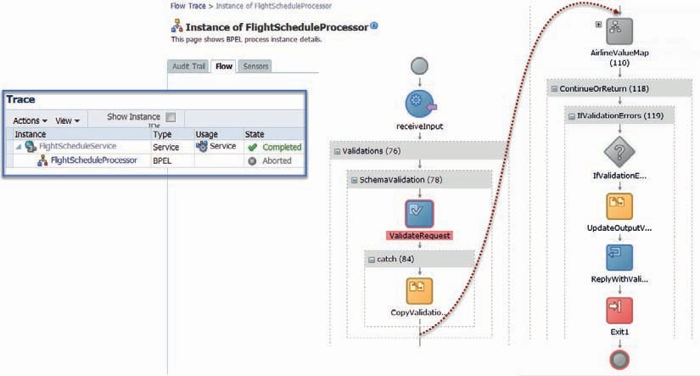

**FIGURE 8-10.** *The Audit Trail of a BPEL process instance that ran into Schema Validation*

*issues—through Fault Handling at the SchemaValidation scope, through two more Validation scopes to the If-branch in the ContinueOrReturn scope, terminating the process instance*

##### Add Assign Activity to Perform Custom Validation Using XQuery Function

The XQuery documents ValidateSubmitScheduledFlightRequest.xqy and TimePlanningUnitValidations

.xqy were introduced in Chapter 7. These files are in the Validations folder of the current *FlightScheduleService* project. They perform several custom validations on the requested flight schedule that go beyond the XSD validation. The XQuery-based validation is invoked with the submitScheduledFlightRequest and it produces a *Validation* element as defined in Validation.xsd. Check for more details in Chapter 7.

Create a scope level variable in scope *CustomValidation* that is called *validationResults*. The variable is based on the same Validation type that is returned by the XQuery function.

Next, add an Assign activity to scope *CustomValidation*. Call the activity *ValidateScheduledFlightWithXQuery*. Open the editor and drag an expression to variable *validationResults*. Set the expression to

 ora:processXQuery10('../Validations/ValidateSubmitScheduledFlightRequest.xqy', 'submitScheduledFlightRequest',$inputVariable.in)

This expression stipulates that the main function in XQuery document ValidateSubmitScheduledFlightRequest.xqy is invoked and that the contents of part *in* for *inputVariable* is passed as the value for the input parameter *submitFlightScheduleRequest* of the XQuery function. The result from this call—an instance of Validation—is stored in variable *validationResults*.

This means that additional validation errors have to be reported in variable *processingResults* when after the Assign activity executes, variable *validationResults* contains one or more ValidationError elements.

###### TIP

*In addition to using an Assign activity with the processXQuery function, we can also make use of the XQuery Transform activity which you will find in the component palette in the section Oracle Extensions | Transform, along with the activity XSLT Transform. When the number or complexity of the assign rules increases or the same set of assign rules is used multiple times, it may be interesting to resort to a transformation.*

##### Add If Activity to Handle Any Validation Errors

Add an If activity labeled *IfCustomValidationError* with its condition set to

 count($validationResults/ns3:ValidationErrorList/ns3:ValidationError) > 0

which is a test for the existence of any *ValidationError* elements.

Add an *Empty* activity to the *else* branch—since in that case (no *ValidationError* elements and therefore nothing to report) the process can simply proceed.

In the If branch, we have to loop over all *ValidationError* elements and add a *ProcessingResult* element for each one of them. BPEL provides us with three iterating activities—For Each, While, and Repeat Until. The first one will do nicely in our case, so add a For Each activity to the If branch. Double click the For Each to bring up the editor, as is shown in Figure 8-11. Set the name to *ProcessAllValidationErrors*. Set the Counter Name to *counter*. This is the local index variable that inside the For Each keeps the iteration count.

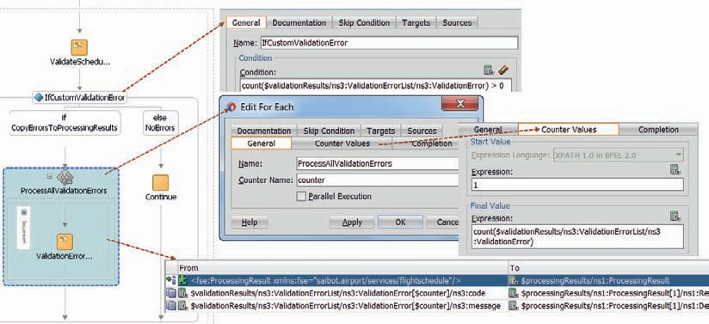

**FIGURE 8-11.** *Configuration of the For Each activity*

Notice the check box labeled *Parallel Execution*. This little checkbox represents a serious piece of functionality, similar to what we saw in the dynamic split-join case of the previous chapter. When the activities performed in each iteration involve for example calls to external resources or other actions that make sense to carry out in parallel, this checkbox is how to unleash that power.

Now open the Counter Values tab. Because of the condition on the If activity, we know there is at least one *ValidationError*. That means we can configure our iteration to start at 1 and continue for as many times as there are *ValidationError* elements. In other words, set the Expression for *Start Value* to 1 and for *Final Value* to

 count($validationResults/ns3:ValidationErrorList/ns3:ValidationError)

Finally, add an Assign activity to the scope inside the For Each activity. Create a first copy rule of type *InsertBefore*, mapping a literal value to $processingResults/ns1:ProcessingResult. The literal value creates a new *ProcessingResult* element as the first one under the root:

 <fse:ProcessingResult xmlns:fse="saibot.airport/services/flightschedule"/>

Next add rules to insert values for *ResultCode* and *Description* to this node. Both rules have their

*insertMissingToData* option set. The first copy rule copies

 $validationResults/ns3:ValidationErrorList/ns3:ValidationError[$counter]/ ns3:code

to

 $processingResults/ns1:ProcessingResult[1]/ns1:ResultCode

And the second one in a similar vein

 $validationResults/ns3:ValidationErrorList/ns3:ValidationError[$counter]/ ns3:message

to

 $processingResults/ns1:ProcessingResult[1]/ns1:Description

Figure 8-11 shows what scope *CustomValidation* should look like, after adding the *Assign* that does XQuery validation, the *If* that checks for any validation errors and the *For Each* that adds a *ProcessingResult* for every validation error reported by the XQuery-based validation.

##### Try Out the Two-Stage Validation in FlightScheduleService

Deploy the *FlightScheduleService* SOA composite. Then invoke *submitSchedule* operation in the service, for example from the HTTP Analyzer. Make sure to include several violations of the rules—both in terms of XSD and additional rules—to see the effect of the two scopes each performing their own validation.

This could look like Figure 8-12.

Checking in the EM FMW Control’s BPEL audit trail clearly visualizes the flow that was taken through the BPEL process instance.

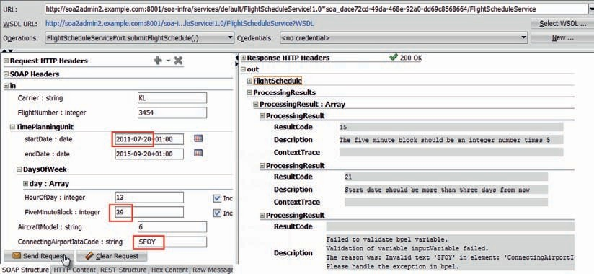

**FIGURE 8-12.** *Testing the FlightScheduleService with incorrect data produces the expected*

*processing results*

#### Airline Checks and Mapping with Domain Value Map

The following will sound familiar from Chapter 7. The airline for which the scheduled flight is requested, is specified through the *carrier* element. This element is defined in the XSD document as a string. It is not further restricted in the schema. However, the values recognized for airlines by the business service are only the two letter IATA airline designators. This means therefore that we have to check:

* + If the length of the airline value > 3 or < 2; if so, it is incorrect.
  + If the length of the airline value == 3 then it is probably an ICAO code and it should be mapped to an IATA code.
  + If the length is two, it is probably an IATA code; we should ensure it is a valid IATA code.

To implement this validation, we need a new stage, a little if-then-else logic and this thing called a DVM or Domain Value Map. In Chapter 7, the DVM was first introduced and specifically the DVM to map from ICAO to IATA codes was introduced. This DVM will be reused in the

BPEL process.

##### Map ICAO Code to IATA Code Using a Domain Value Map

Open scope *AirlineValueMap*. Create a scope level variable of type string called *iataCode*. This will be our target for the mapping of the ICAO airline code.

Add an If activity with a condition to check for an incorrect length of the incoming carrier element. In the *else* branch, add another If activity that checks if the length of the carrier element happens to be 3. In that case, it may well be an ICAO code and we will try to map the value to the corresponding IATA airline code. Add an Assign activity—called *MapAirlineCode*—to the If branch of this second If activity, as is shown in Figure 8-13.

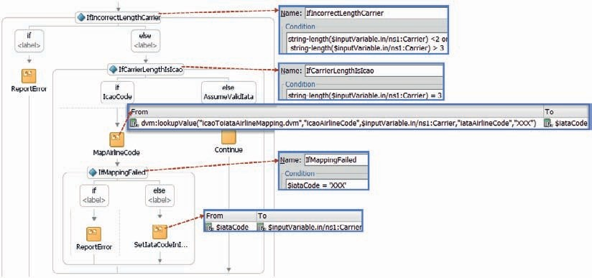

**FIGURE 8-13.** *Scope AirlineValueMap with If (incorrect length) and nested If (length equals*

*three) activities*

Configure a single copy rule mapped to variable $iataCode that uses the following expression

dvm:lookupValue('icaoToiataAirlineMapping.dvm', 'icaoAirlineCode',

$inputVariable.in/ns1:Carrier, 'iataAirlineCode', 'XXX')This instructs the BPEL engine to read the DVM file, locate in domain *icaoAirlineCode* the value contained in the Carrier element in the request message and return the corresponding *iataAirlineCode*. When the value from the request message cannot be found in the DVM document, the value XXX is returned to indicate that apparently the input was not a valid *icaoAirlineCode*. Add an If activity after *MapAirlineCode* that tests for the string ‘XXX’ in variable $iataCode. In the if-branch, we face the situation that the three character carrier value could not be (domain value) mapped to a valid IATA code.

We now need to report a *ProcessingResult*—shown in Figure 8-13 through the *ReportError* activities—in case the carrier length was neither 2 nor 3 and in case the carrier element with length 3 could not be mapped to an IATA code. If the length was 2, we ideally should test for the existence of the value as a valid IATA code, but we will save that for another time.

Instead of adding assign activities in many different places in the BPEL process to update variable $processingResults and perhaps perform additional error reporting activities such as logging, we will introduce in the next section an inline subprocess to capture that logic in a reusable unit that can be called from different places in the BPEL process.

### Reusable Logic through Inline Subprocess

An inline subprocess can best be thought of as a callable scope. It is a scope that is not part of the normal process flow, but rather a unit of encapsulated logic that can be called zero, one or multiple times from anywhere within the BPEL process—even recursively from within itself. It is in

effect very similar to a private member function in a Java class or a procedure in the body of a PL/ SQL package.

An inline subprocess can define arguments to be passed in. These can be passed by reference, which means the subprocess can alter their values as well. Additionally, the inline subprocess can access all global process variables. The inline subprocess is a scope which as such can define local variables and nested scopes, use partner links, and have event handlers etcetera.

An inline subprocess is created from a normal scope that is promoted using the context menu option *Convert to subprocess*. At that time, at the location in the BPEL process where the scope used to be, a call to the subprocess can be inserted. Later on, such calls can be added in other places as well. Of course the subprocess can be further refined after its initial creation.

###### TIP

*In addition to the Inline Subprocess, the BPEL component also supports stand-alone Subprocesses. These are defined in a separate file (with extension .sbpel) and appear as components in their own right in the composite overview. They can be called from multiple other BPEL components (but only from BPEL components). They cannot access global elements of these calling BPEL processes, unlike the Inline Subprocess. However, for every other intent and purpose, they act as if merged into the calling process.*

*An important advantage of the stand-alone subprocess, apart from its ability to be reused across multiple BPEL process components,*

*is the fact that because the subprocess has its own definition file, developers can work in parallel on subprocesses.*

Start this section from the *step2* sources.

**Create Inline Subprocess to Report a Validation Error**

An inline subprocess can easily be created from a scope. Create a scope called *ReportError* in the If branch of the *IfIncorrectLengthCarrier* activity. Copy the Assign activity *CopyValidationFaultToProcessingResults* from the Fault handler on scope *SchemaValidation* to this new scope *ReportError*.

Select the scope and click on the icon *Convert to a Subprocess*—or select that option from the context menu, as shown in Figure 8-14.

The dialog box appears to create the Inline Subprocess. Provide a name—such as *ReportMessageToProcessingResults*—and a label and comment (for documentation purposes). Press OK to create the inline subprocess.

The scope *ReportError* has been replaced with a Call Activity that invokes the new subprocess. In order to inspect and further edit the subprocess, you have to select it from the drop-down list in the upper left-hand corner, as shown in Figure 8-15.

Click on the global scope for the subprocess. Next, click on the *variables* icon that displays as an x between parentheses: (x). Specify three variables for the subprocess—for message code, message summary and description, each of type string.

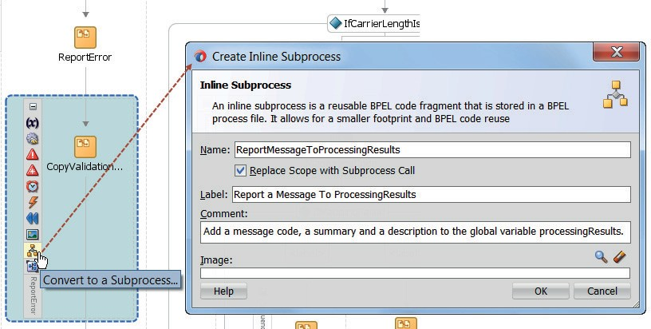

**FIGURE 8-14.** *Convert a Scope to an inline Subprocess and a call to the Subprocess*

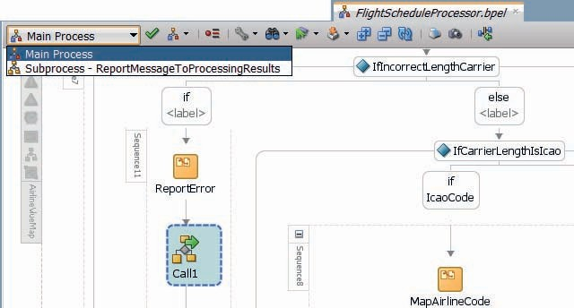

**FIGURE 8-15.** *Toggling the BPEL editor to one of the inline subprocesses*

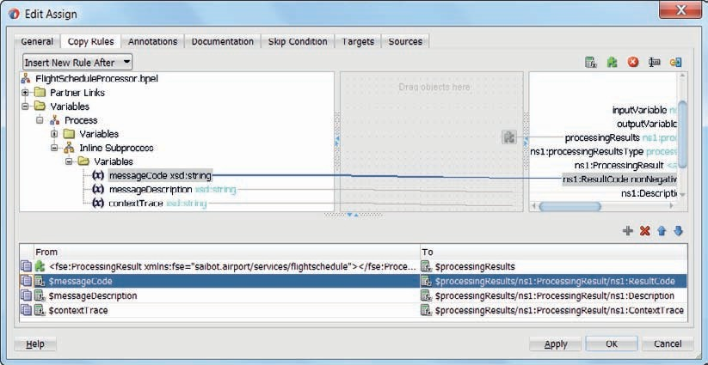

**FIGURE 8-16.** *Create the ProcessResult element using the values from the input variables*

*to the subprocess*

Edit the Assign activity. Take the values from the three (input) variables of the subprocess to provide the values for the new *ProcessResult* element, as illustrated by Figure 8-16.

Set the flag *insertMissingToData* on each of the three copy rules, to have all elements in the nested XML structure specified in the target XPath expression constructed if they do not exist, instead of throwing a *selectionFailure* fault if the XPath expression does not return exactly one element. Note that the first copy rule should be of type insertBefore rule in order to prevent overwriting previous errors.

#### Call the Inline Subprocess from Scope AirlineValueMap

Return to the main process and to the call activity that replaced the scope. Edit the call activity. Specify the values for the three input variables, as “FSS-32,” concat(‘Incorrect length for Airline Carrier: ‘, $inputVariable.in/ns1:Carrier) and string($inputVariable.in) respectively. See Figure 8-17 for an example. Copy these values by value—because it is not our intention to have the subprocess manipulate these values.

Next, copy the call activity and paste it in the *IfMappingFailed* branch of scope *AirlineVaueMap*, also shown in Figure 8-17. Here it will call the subprocess to report an incorrect length for the carrier element. Update the values passed to the subprocess accordingly.

You may also want to use the call activity in the fault handler in scope *SchemaValidation* and in the *For Each* activity *ProcessAllValidationErrors* in scope *CustomValidation*.

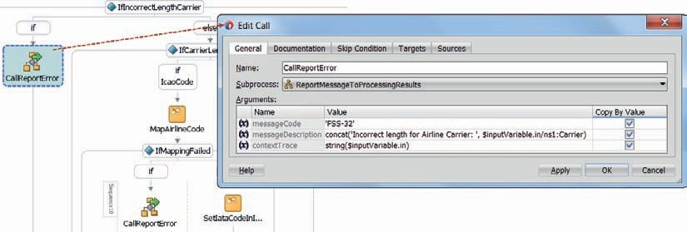

**FIGURE 8-17.** *Configuration of the Call activity that calls the inline subprocess*

#### Testing the FlightScheduleService with the Subprocess to Handle Airline Mapping Errors

Deploy the *FlightScheduleService* composite. Invoke the service with a perfectly valid flight schedule request message, with a three letter airline carrier that exists in the DVM. Note how the response does not mention any processing results. When you check the BPEL process audit trail or flow overview, you will find how the DVM produced the two letter IATA code for the carrier.

Now provide either a carrier value of less than two or more than three characters length or with a three character value that does not exist as a source value in the DVM. In the response you will find at least one *ProcessResult* this time. In the EM FMW Control console, you will see how the inline subprocess is invoked to write the processing result element, see Figure 8-18.

Common next steps are both the addition of new functionality to or the refinement of existing functionality in the subprocess as well as the creation of more calls to the subprocess in various spots in the main process.

### Using Embedded Java for Validation and Enrichment

The second top level scope in the *FlightScheduleProcessor*—the *ProcessingAndRouting* scope— can rely on the data it receives as being valid. Not just in terms of the XSD definition but also the custom validations on start date, end date, and five minute time block as well as the IATA designator for the air carrier. It is now up to this scope to perform several enrichment steps that are to precede the final registration of the flight schedule:

* The number of flights has to be established that are to take place in the requested flight schedule.

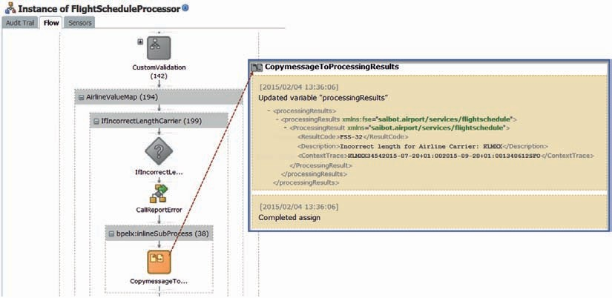

**FIGURE 8-18.** *The call to the inline subprocess is presented inline in the BPEL audit trail and*

*flow overview*

* + The identifier of the allocated slot with which the flight schedule is to be associated must be retrieved.
  + The Financial Department has to approve of the requested flight schedule—based on the credit status, solvency, and safety status of the airline.

BPEL processes can perform various types of call outs. Through Partner Links, the process can invoke both other components within the SOA composite as well as adapter bindings and references to external services. Similar to Java Call Outs in Service Bus, BPEL process can also use the Embedded Java activity.

In this and the next two sections we will look at three types of interactions:

* + Embedded Java activity calling to a custom Java class to calculate the number of flights.
  + Partner Link that connects to a reference to an external service to find the slot with which to associate the scheduled flight.
  + Partner Link that connects to another service component in the SOA composite to check if the airline is not blacklisted with the finance department.

Start this section from the *step3* sources. First add three nested scopes to scope *ProcessingAndRouting* for these three tasks: *DeriveNumberOfFlights* , *RetrieveSlotIdentifier,* and *CheckAirlineWithFinancialDepartment*. For now, these scopes are sequential. A little bit later on we will see how easy it is in a BPEL process to organize these scopes into parallel activities. Also add variables numberOfFlights (int) and slotIdentifier (string) to scope *ProcessingAndRouting*.

#### Embedded Java Activity to Execute Content-Based Logic

We can embed Java snippets in special activities inside BPEL process components—at a more granular, tighter integrated, less formal (no service interface), typically more specialized level than using partner links to other components or even external services. We do this with the Oracle- specific BPEL extension activity Exec. This activity contains a snippet of Java code that is executed by the JVM that executes the BPEL process—in the same JTA transaction context as the BPEL process and without any context switches.

Embedding Java like this is primarily useful for advanced validation and manipulation of BPEL variables, and for auditing and debugging purposes. One usage is to fill the metadata attributes in the instance table in the dehydration store with functional data to be able to correlate composite instance IDs with meaningful instance data. This can be handy for error recovery.

The Java snippet can use a number of special built-in methods that facilitate integration with the BPEL process instance. These methods, for example, allow direct read and write access to BPEL variables. Java exceptions thrown and not handled in the Embedded Java activity are converted to BPEL faults and can be dealt with in the BPEL process in the normal way.

The Embedded Java snippet can do JNDI lookup operations that make it possible to invoke EJBs from within the Exec activity. Note that although this is possible, it is certainly not the recommended way to interact with EJBs from within composite applications, except sometimes for the SOA Suite’s own API.

It sounds too good to be true: the power of Java in the best-performing, transaction-preserving way. Wow! Well, although it seems pretty good, it is very tightly coupled. Before you get too excited about the ability to use Java inside BPEL, remember why we do not use Java for all the functionality of our composite applications. We strive for decoupled, reusable components that bring us business agility. Embedding small or even large chunks of Java code inside BPEL processes threatens this ambition: The code is not reusable at all, and it is difficult to develop, test, and subject to version control, as it is pretty much hidden inside the BPEL process. However, for relatively localized and fairly small operations, it can be quite powerful.

###### TIP

*The SCA Spring component can be used to embed Java-based logic in an SOA composite application in a more explicit way that is to be*

*preferred as it is more aligned with the SCA specification. More on this component is in Chapter 10.*

*In our current case, we want the embedded Java code to take the start date and the end date for the requested flight schedule and—taking the weekdays into account—calculate the actual number of flights this request represents and write that number to a BPEL process variable.*

**Create Java Code That Does the Job**

Our first step will be to create a stand-alone Java application—well, Java class—that has the logic we need to embed later on. We have no easy way to test the Embedded Java—only by deploying the composite and testing it, can we test the Java logic in a very indirect way. It is a best practice to have as little Java code inside the Exec tag—only the direct interaction with the BPEL process and a call to a custom class that does the actual work. Note that this custom class has to be explicitly imported in the BPEL process. The same applies to other classes used in the Java code in the Exec activity.

Create Java class *FlightScheduleProcessor*—in package saibot.airport.flightscheduleservice— with a static public method *calculateNumberOfFlights*, as shown below. The method takes the string representation of a start date and end date as well as the *numberOfDaysPerWeek* on which flights will be executed and it returns the number of (days with) flights in that period.

 public class FlightScheduleProcessor {

public static int calculateNumberOfFlights(String startDateString, String endDateString, int numberOfDaysPerWeek) {

DateFormat formatter = new SimpleDateFormat("yyyy-MM-dd"); int numberOfFlights = 0;

if (endDateString == null||endDateString.length()==0) { numberOfFlights = 1;

} else {

if (endDateString.equals(startDateString)) { numberOfFlights = 1;

} else {

try {

Date startDate = formatter.parse(startDateString); Date endDate = formatter.parse(endDateString);

long dayDiff = getDateDiff(startDate, endDate, TimeUnit.DAYS); numberOfFlights = (int)(dayDiff* numberOfDaysPerWeek/7);

} catch (ParseException e) {

}

}

}

return numberOfFlights;

}

public static long getDateDiff(Date date1, Date date2, TimeUnit timeUnit) { long diffInMillies = date2.getTime() - date1.getTime();

return timeUnit.convert(diffInMillies,TimeUnit.MILLISECONDS);

}

}

When you add a main method to this class or create a test class, you can test the *calculateNumberOfFlights* outside the context of the BPEL process or the SOA Suite. There is nothing yet in this class that indicates that soon it will be integrated into a BPEL component.

##### Embed the Java Logic in the BPEL Process

We have the Java code working on its own; we can now leverage it from an Exec activity in the BPEL process and integrate it with the BPEL variables in that process.

Open the BPEL process *FlightScheduleProcessor* and add two import elements as direct children of the process root element. These elements make the Java classes XMLElement and *FlightScheduleProcessor* available for use in embedded Java activities:

 <import location="oracle.xml.parser.v2.XMLElement" [importType="http://schemas.](http://schemas/) oracle.com/bpel/extension/java"/>

<import location="saibot.airport.flightscheduleservice. FlightScheduleProcessor" [importType="http://schemas.oracle.com/bpel/extension/](http://schemas.oracle.com/bpel/extension/) java"/>

Add an Embedded Java activity to the BPEL process and set its name to

*CalculateNumberOfFlights*. Next, set the Code Snippet of this activity to the following snippet:

 XMLElement flightNumberElement = (XMLElement) getVariableData("inputVariab le", "in", "/ns1:submitScheduledFlightRequestMessage/ns1:FlightNumber");

String flightNumber = flightNumberElement.getTextContent(); XMLElement startDate = (XMLElement) getVariableData("inputVariable",

"in", "/ns1:submitScheduledFlightRequestMessage/ns1:TimePlanningUnit/ ns2:startDate");

XMLElement endDate = (XMLElement) getVariableData("inputVariable", "in", "/ ns1:submitScheduledFlightRequestMessage/ns1:TimePlanningUnit/ns2:endDate");

XMLElement daysOfWeek = (XMLElement) getVariableData("inputVariable", "in", "/ns1:submitScheduledFlightRequestMessage/ns1:TimePlanningUnit/ ns2:DaysOfWeek");

int numberOfDaysPerWeek = daysOfWeek.getElementsByTagName("day"). getLength();

int flightCount = FlightScheduleProcessor.calculateNumberOfFlights(startDa te.getTextContent(), endDate.getTextContent(),numberOfDaysPerWeek);

addAuditTrailEntry("Java Embedding - Calculated number of flights for flightnumber "+ flightNumber +" as "+ flightCount);

setVariableData("numberOfFlights", flightCount);

In the first line, the built-in method *getVariable* is used to retrieve a specific element from one of the variables in the BPEL process. More specifically: an XPath expression is used to access the *FlightNumber* element *in* for the *in* message part of the *inputVariable*. The result is an XMLElement—that is stored in a local Java variable defined in the snippet. The next line retrieves the actual value from that element.

The same *getVariableData* is used to retrieve the values for *startDate*, *endDate,* and *daysOfWeek*. The latter holds zero, one or more children and *numberOfDaysPerWeek* is set with that number of child elements.

Finally, the call is made to the public static method *calculateNumberOfFlights* on class *FlightScheduleProcessor*. Inside this class, as we have seen, the context of the BPEL process is no longer available.

Method *addAuditTrailEntry* is another built-in operation that can be used in embedded Java snippets, to add entries to the audit trail that can be inspected in the EM FMW Control (as well as through the APIs). Finally, through *setVariableData*, the actual number of flights is pushed back to the BPEL process context and set on scope variable *numberOfFlights*.

##### Run the Composite with Embedded Java Inside

With the code in place, we can deploy the composite application. The custom Java class is deployed along with the application, and any libraries you would add to the project would also have been deployed along with the composite.

Invoke the *FlightScheduleService*, perhaps with a little variation in the start date and end date values. You will not see an effect of the calculated number of flights in the response message.

However, when you inspect the audit trail (Figure 8-19), there will be evidence of the Java activity and the additional audit trail entry.

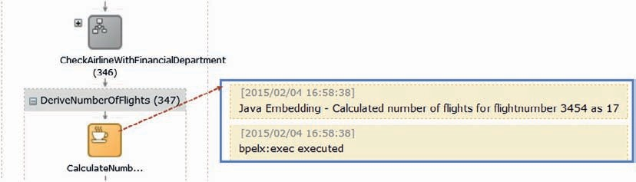

**FIGURE 8-19.** *Evidence in the flow trace of the execution of the Embedded Java activity*

###### TIP

*BPEL processes can send signals out through so-called BPEL sensors. These signals inform the world of the progress in the process. Sensors can be targeted at a database table, a JMS queue or topic, BAM (Business Activity Monitoring) or a custom Java class. Note that such a custom Java class is called and notified; it cannot respond to the process and it cannot manipulate its data or impact its flow.*

*Composite sensors by contrast—first introduced in Chapter 4— are defined at the composite level rather than the level of a BPEL component, and do not support custom Java actions.*

### External Callouts or Invoking Services from a BPEL Process

Calling out to web services or other components is the most natural thing for a BPEL process. The Invoke activity is used for making such calls. And just like the Receive and Reply are associated with a partner link, so is the Invoke. The partner link represents the service interface that the invoke calls out to—without bothering the invoke activity with details about transport or location.

Start this section from the *step4* sources.

#### Invoke the SlotService from the BPEL Process

The *ProcessingAndRouting* scope contains the scope *RetrieveSlotIdentifier*. In this scope, we will add the invoke activity that will indirectly—through the partner link and the reference binding— interact with the same *SlotService* that the Service Bus pipeline in the previous chapter did a Service Callout to.

##### Create Reference for SlotService

Open the SOA composite overview editor. Right click in the External References zone and select Insert | SOAP or drag the SOAP component to this area, as shown in Figure 8-20. The *Create Web Service* editor appears. Enter the name—*SlotService*—and the WSDL URL (for the *SlotService* exposed on the Service Bus), presumably: http://localhost:7101/flight/SlotService?wsdl. After entering this value—or browsing for it using the icon—the wizard will auto-select the Port Type.

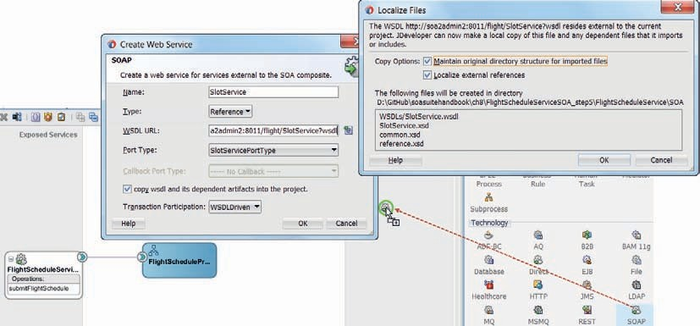

**FIGURE 8-20.** *Add a reference binding for the external SlotService*

The little check box marked *copy wsdl and its dependent artifacts into the project* is actually quite important. It determines whether the project will have design time dependencies on the live service and its artifacts or will be stand alone. Both options have their merits: only being able to do development work on the composite when the *SlotService* is deployed and the server is up and running can be quite cumbersome. Then again, locally creating copies of all service artifacts—including some that are truly shared artifacts—and running the risk that these go out of synch with the real service definition is not attractive either. In a later chapter, we will discuss the MDS (Meta Data Services) that provides a solution to many of these challenges.

Let us for now check the checkbox and create a stand-alone reference to the *SlotService*.

Press OK to create the reference binding.

The *SlotService* reference is added to the composite, in the External References swim lane. The SlotService.wsdl document is added to the WSDLs folder and it references SlotService.xsd that is created in the root of the project. Also created in the project root are common.xsd and reference

.xsd—which are duplicates from files already available in the project. We need to reorganize things a little. Delete common.xsd and reference.xsd in the root folder. Move SlotService.xsd to a new folder called *LocalizedExternalResources*. Edit the import statements in SlotService.xsd to have them reference the common.xsd and reference.xsd files in the Schemas folder.

Finally, to prevent problems with multiple instances of the XSD documents at build time, you also need to edit the composite.xml file. Edit the *reference* element for the *SlotService*: remove the *location* attribute on the binding.ws element and add a property called endpointURI to reference to the endpoint for the *SlotService*:

 <reference name="SlotService" ui:wsdlLocation="WSDLs/SlotService.wsdl">

…

<property name="endpointURI" type="xs:string">http://localhost:7101/ flight/SlotService?wsdl</property>

</binding.ws>

</reference>

Next, create a wire from the *FlightScheduleProcessor* BPEL component to the new SlotService reference. This will create a new partner link definition in a newly created file SlotServiceWrapper.wsdl, clearly associated with SlotService.wsdl. Note that this will make the partner link available inside the BPEL process, to for example connect *Invoke* activities to.

##### Add Invoke Activity in BPEL Process

Open the editor for BPEL component *FlightScheduleProcessor*. Open the scope *RetrieveSlotIdentifier* and add an Invoke activity. Wire this activity to the *SlotService* partner link, as demonstrated in Figure 8-20.

The invoke activity editor appears. Set the name of the activity to *InvokeSlotService*. Select operation *findSlot* on the *SlotServicePortType*. On the Input tab—where the variable or arguments mapping for the call out to the *SlotService* is configured—set the radio button to Input Variable and click on the green plus icon to have a new local variable created that will contain the data to pass to the *SlotService*. Accept the default name for this variable, as shown in Figure 8-21.

###### TIP

*A local variable is defined at the scope level. It can only be accessed inside the scope. As soon as the scope is completed, the local variable is removed from memory. Local variables in BPEL are very similar to private variables in Java methods. It is good practice to define variables as local if they only are used within a certain scope.*

Do the same thing on the Output tab: have a local variable created to hold the result returned from the *SlotService*. Click OK to complete the configuration of the invoke activity.

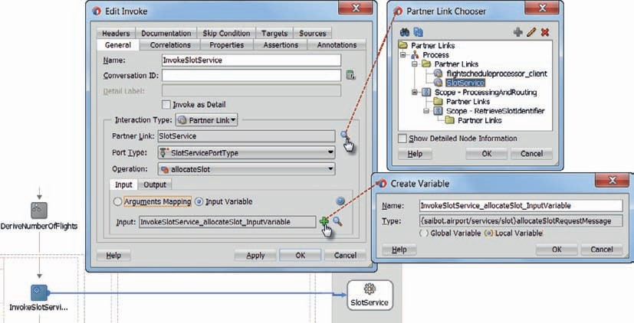

**FIGURE 8-21.** *Configure the invoke activity including new default local variables for the input to*

*and output from the SlotService*

Next, add two assign activities to the current scope, one to go just prior to the invoke activity and one to immediately follow the invoke activity. This is a common pattern: these assign activities will copy from the process variables to the local input variable and from the local result variable to the process variables. You can use Sequence activities to group these together.

Configure the first assign activity to set the *Carrier*, *TimeplanningUnit,* and *AircraftModel* elements from the *inputVariable*—that holds the request message that was sent to the *FlightScheduleService*—to the variable created locally to provide the input to the *SlotService*.

Configure the second assign activity to copy the *SlotId* element returned from the *SlotService*

and stored in the local output variable to the *slotIdentifier* variable.

With these steps, we have extended the *FlightScheduleProcessor* with the callout to the *SlotService*: first we created the reference binding at SOA composite level and wired the reference to the BPEL component (which created the partner link). Next, we created and configured the invoke activity, wired it to the partner link and configured assignments to and from the local variables.

##### Test FlightScheduleService with the Call to the SlotService Inside

It is easy to deploy and test the *FlightScheduleService* composite once more. The Flow will show (Figure 8-22) how this time, right after the embedded Java activity is executed, the invoke activity does its thing. The returned SlotId is 4592.

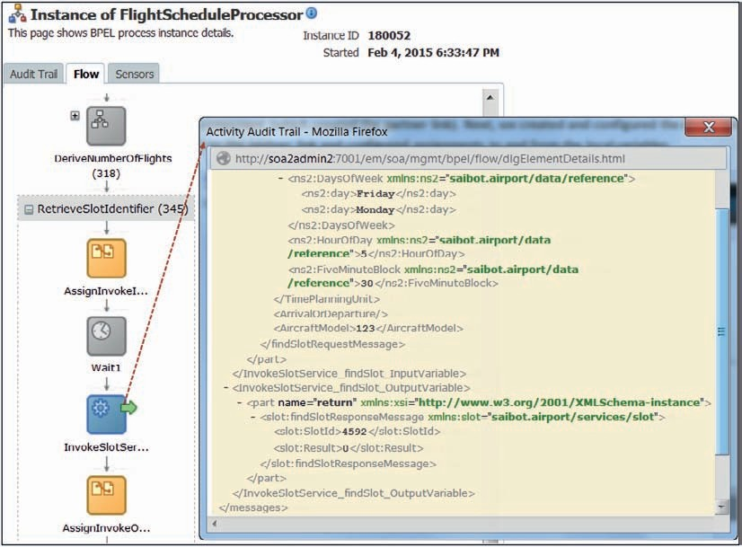

**FIGURE 8-22.** *BPEL process flow that visualizes the InvokeSlotService activity*

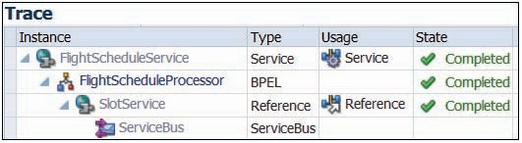

**FIGURE 8-23.** *Message flow trace after calling the FlightSchedule service that invokes the*

*SlotService*

All we can see from the flow is that the Invoke does something. From the BPEL process definition we know that the invoke calls a partner link that is based on and wired to the SlotService reference binding in the SOA composite. The SOA composite message flow trace in Figure 8-23 reveals that this reference resolves to a service exposed on the Service Bus. This trace does not reveal the name of the particular proxy service. Detail trace information about what goes on inside the Service Bus can for example be generated using pipeline alerts. This information is not available from this flow trace though.

##### Dependencies from BPEL Component

In this chapter, we create a BPEL component based directly on the external service interface *FlightScheduleService*—WSDL plus XSD—exposed by the SOA composite. It is certainly convenient—as we can simply wire the exposed service directly to the BPEL component.

However, there is a drawback: the BPEL component has a direct dependency on the external WSDL and XSD as a result. The variables and activities in the BPEL components lean on the WSDL and XSD definitions. That means that when there is a change in the external service interface, this change may have a direct impact on BPEL process—and a much larger impact than *should* be the case. Often, BPEL components have a lot of activities that work on payloads (as defined in XSDs) so changes to XSDs can be disruptive to BPEL components.

The same is true in the other direction: we want to have the freedom to change the implementation of the BPEL process without having to worry about disrupting the external service interface. Additionally, it is convenient to have a separate BPEL component for each operation in the external service interface—which of course means that no single BPEL process implements the same WSDL as the SOA composite exposes.

To eliminate this direct dependency, we could determine to use a Mediator between the exposed service and the BPEL component, as is shown in Figure 8-24. The BPEL component would have its own WSDL and XSD that are of course very similar to interface definitions of the exposed service and of the Mediator. The transformation in the Mediator is therefore almost trivial (completely auto-mapped). Yet, when the external interface changes, there is no immediate impact on the BPEL component. Depending on the changes in the service definition, several strategies can be used to revise the SOA composite to provide the implementation. These may or may not include modifying the BPEL component. By decoupling we have ensured at least we have this choice.

|  |
| --- |
| Something similar can be said about the outgoing partner links of a BPEL component.  These can be wired directly to the external references—such as the *SlotService*—and outbound adapter bindings of the SOA composite. That is easy enough. However, this too causes the BPEL component to be directly dependent on the WSDL and XSD of the external service or adapter binding. That means that even a small change in these definitions may break the BPEL component and have a far larger impact than should be the case.  The BPEL component can be insulated from such direct effects by using a Mediator component between the BPEL component and the outbound dependencies. The Mediator implements the internal interface that the BPEL component is designed for, using SOA composite specific definitions. The Mediator translates to and from whatever external service is enlisted to provide the implementation of the external need of the BPEL component. When we decide to use a different external provider, this does not affect the BPEL component, but only requires an update of the Mediator. |
|  |
| **FIGURE 8-24.** *The BPEL component decoupled from both the service interface and the external references* |

### FinancialDepartmentAirlineCheck from the BPEL Process

The *FlightScheduleServiceSOA_step5* application contains a second project, called *FinancialDepartmentProcesses*. This project contains a SOA composite and the single component in the composite application is a BPEL process called *FinancialDepartmentAirlineCheckProcess*. This component implements the service interface *FinancialDepartmentAirlineCheckService*, as specified in the WSDL document with that name. The interface has a single operation: *checkAirlineStatus*.

In this section, we are going to take this BPEL component and turn it into a Component Template that we publish to be reused across different projects. Note that unlike a Service Bus pipeline template, there is no lasting relationship between the template and components derived from the template. Using an SOA component template is more like a complex copy and paste operation than an inheritance definition.

Next, we will create a new BPEL component in the *FlightScheduleService* composite, based on this template. The new component is wired to the existing *FlightScheduleProcessor* component and invoked from the last remaining empty scope *CheckAirlineWithFinancialDepartment*. This in turn completes the *ProcessingAndRoutingScope*.

Start this section from the *step5* sources.

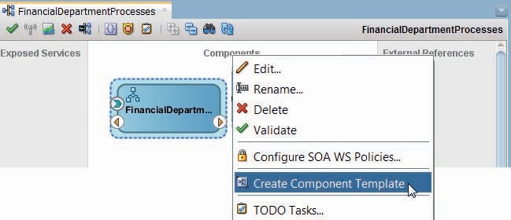

**FIGURE 8-25.** *Starting to create a component template from a BPEL process component*

#### Turn BPEL Component into Component Template

Open composite overview editor for the *FinancialDepartmentProcesses* project. Right click the BPEL process component. From the context menu, select option *Create Component Template*, as shown in Figure 8-25.

The Create Component Template wizard appears, to collect your input about the template (Figure 8-26). You can specify the name, the description, and (optionally) the palette icon. This is

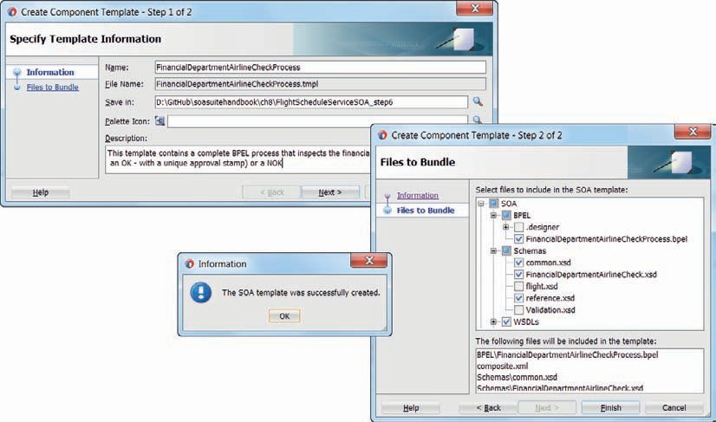

**FIGURE 8-26.** *The Component Template creation wizard*

important because this information will be presented in the component palette and has to allow other developers to decide whether or not to reuse this template.

Press Next to go to the second step of the component template creation. In this step, the wizard lists all files in the project and allows you to decide which ones to include in the template. All files you select here will be bundled as part of the template and will be copied to an SOA composite target project when the template gets used in that project.

Press Finish to complete the creation of the template. The template bundle is now created and saved on your local file system (from which it can be uploaded to a central share or into Subversion, Git or some other source code management system). Templates can also be stored in MDS (see Chapter 21).

In JDeveloper, from the main menu Windows | Preferences, you can bring up the SOA | Templates preferences page. On this page, you can specify which locations can contain SOA templates—not just component templates but also SOA composite application templates and BPEL scope (activity) templates.

###### NOTE

*Given the low reuse potential of this FinancialDepartmentAirlineCheckProcess, it is not a logical candidate at all to create a template of. Typically, templates will contain the outline of a process according to the development guidelines in an organization, with predefined scopes and embedded logging and fault handling. They will generally have to be completed with the specific functionality required of the component based on the template.*

*In this case, the template serves as a container for quickly injecting a number of artifacts into an SOA composite.*

#### Create and Wire the BPEL Process Based on Component Template

Open the SOA composite overview editor for the FlightScheduleService. Open the SOA Templates tab in the Components palette. It should list the *FinancialDepartmentAirlineCheckProcess* template. Drag the template from palette and drop in the Components section, as shown in Figure 8-27.

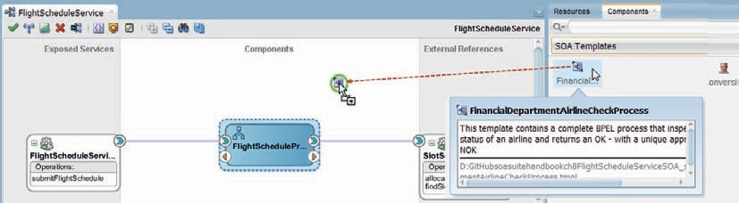

**FIGURE 8-27.** *Use SOA Component Template to add a predefined BPEL component to the*

*FlightScheduleService*

Another editor manifests itself—one that helps you create an SOA component from a Component Template, see Figure 8-28. Set the name of main component (note that from one template, multiple components can be created) to *FinancialDepartmentAirlineCheckProcess*. Review the list of template entries: these are the artifacts that are about to be added to the project.

Click on Next to review the conflicts: artifacts in the template bundle that already exist in the target project. For each of the conflicts, we need to decide whether to retain or overwrite the current project artifact. In the current case, choose *skip* for each conflict—which means that in each case the existing resource is retained. Click on Finish to complete the creation of the component based on the template.

Create a wire between the *FlightScheduleProcessor* and the new BPEL component

*FinancialDepartmentAirlineCheckProcess*.

#### Invoke the Financial Department Check of the Airline

Open the editor for the BPEL component *FlightScheduleProcessor*. Open the scope *CheckAirlineWithFinancialDepartment*. Remove the *Empty* activity from the scope and add an *Invoke* activity. Wire this activity to the new partner link for the *FinancialDepartmentAirlineCheckProcessor* component, as Figure 8-29 shows.

###### TIP

*It may feel more natural to have the outgoing partner links displayed on the right side of the BPEL diagram. Using the option Display | Move To Opposite Swim Lane, you can manipulate the position where a partner link is shown.*

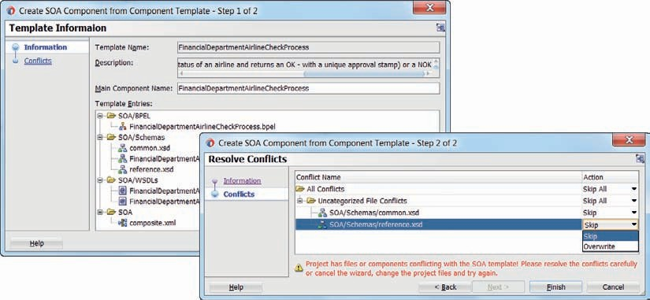

**FIGURE 8-28.** *Creating an SOA Component by importing a Component Template*

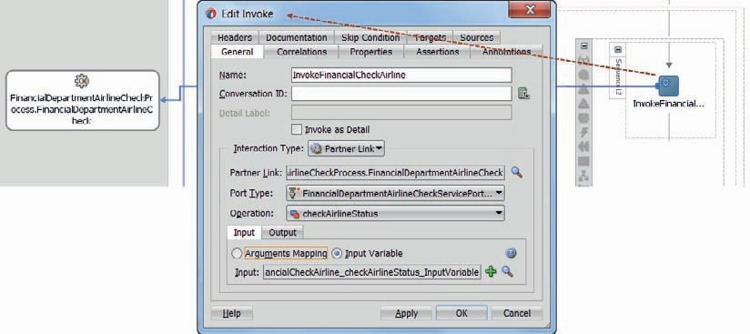

**FIGURE 8-29.** *Wire invoke activity to partner link for the*

*FinancialDepartmentAirlineCheckProcessor component*

Configure the invoke activity, including two local variables for the input and output to the second BPEL component.

Next, in scope *ProcessingAndRouting*, create a scope level variable called *checkAirlineFinanceResponse*, based on the *checkAirlineResponseType* in the FinancialDepartmentAirlineCheck.xsd schema definition.

Then, add assign activities to scope *CheckAirlineWithFinancialDepartment*, one before and one after the invoke activity. As before, the first assign has to set the input variable for the invoke activity. The second assign takes the output and stores it in the new variable *checkAirlineFinanceResponse*. The scope now looks as is displayed in Figure 8-30.

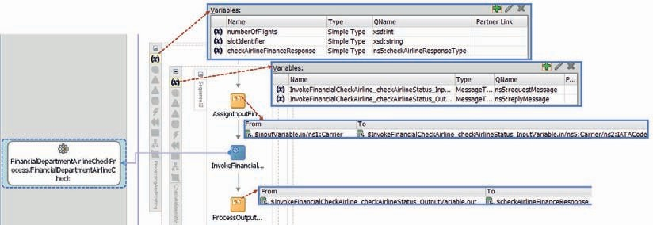

**FIGURE 8-30.** *Scope CheckAirlineWithFinancialDepartment with the invoke and associated*

*assign activities*

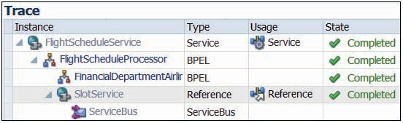

**FIGURE 8-31.** *Composite message flow through two BPEL process components and one*

*reference binding*

#### Deploy and Test

Deploy the SOA composite and invoke the *FlightScheduleService* once more. Depending on the request message and specifically the carrier code, the airline check with the financial department returns either an OK or NOK status.

Note that the message flow trace for the entire composite visualizes the additional step that was introduced with the new BPEL component that performs the financial department’s airline check, see Figure 8-31.

### Reorganizing Scope ProcessingAndRouting with Parallel Activities

At this moment, scope *ProcessingAndRouting* has three sequential scopes. However, just as we concluded in the previous chapter leading to the decision to introduce a Split-Join component, these scopes could also be executed simultaneously. They do not depend on each other; results from one scope do not influence the other scopes. By configuring the scopes to be executed in parallel, we allow the BPEL engine to assign system resources in a more flexible an potentially efficient way. For example, in situations where one scope has to wait long for an asynchronous response, the engine can speed up the overall processing time by running a second scope while the first one is waiting.

The BPEL language comes equipped with the Flow activity. This activity contains one (not useful) or more parallel branches. One fact you have to aware of: one BPEL instance is executed by at most one thread. That means there is never real parallelism, even with this Flow activity: only when the first branch that was started is blocked (waiting for an asynchronous response or just waiting) can the thread be assigned to the second parallel branch. Branches cannot actually execute at the same time, but one branch’s wait time can be used to allow another branch to run.

Ideally, each branch writes to a separate variable. When the Flow is complete, the contents from these variables-per-branch could be combined into a single global variable.

The property *nonBlockingInvoke* can be set on a partner link to specify that an invoke of that partner link should not be blocking. This property will cause a new thread to be created for each invocation of the partner link, which will then callback to the main thread once it has completed, resulting in true parallelism: the newly spawned thread is the one waiting for the synchronous response, not the main one that can continue to spawn additional thread to make invokes from. This does mean your process instance may consume many threads which reduces the scalability of the application.

Our current scopes do not make asynchronous calls or have other long-running activities. The semi-parallelism offered by the Flow-activity is therefore not going to be of any serious help in our current situation. However, we will still take a brief look at how to use the Flow activity. We may extend the scopes at a later moment in a way that will make them suitable for more serious parallel behavior. And by using the flow, we are sending both the engine and the fellow developers a message about the mutually independent nature of the scopes.

Start this section from the *step6* sources.

#### Introducing the Parallel Flow Activity to the ProcessingAndRouting Scope

Open scope *ProcessingAndRouting* in the *FlightScheduleProcessor*. Add a Flow activity to the scope. Initially it contains two parallel sequences. Add a third sequence. Drag each of the three scopes—*DeriveNumberOfFlights*, *RetrieveSlotIdentifier,* and *CheckAirlineWithFinancialDepartment*—to one of the parallel Flow sequences, see Figure 8-32.

###### TIP

*It is very easy to restructure a BPEL process. Activities can easily be moved around from one scope to another and new activities can be added anywhere in the process.*

There is no additional configuration required.

When you next deploy and run the *FlightScheduleService*, you will not notice any difference. The visual flow looks a little bit different from before. By adding Wait activities of, for example,

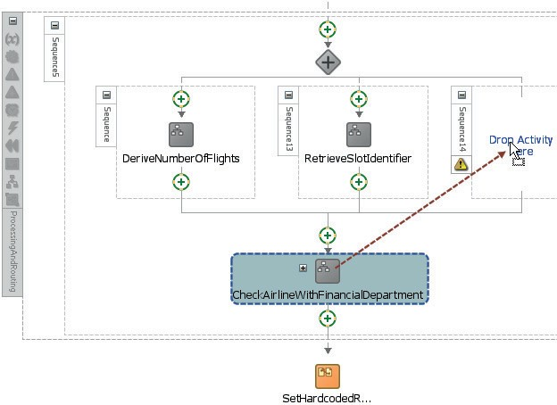

**FIGURE 8-32.** *Three parallel scopes within the Flow activity*

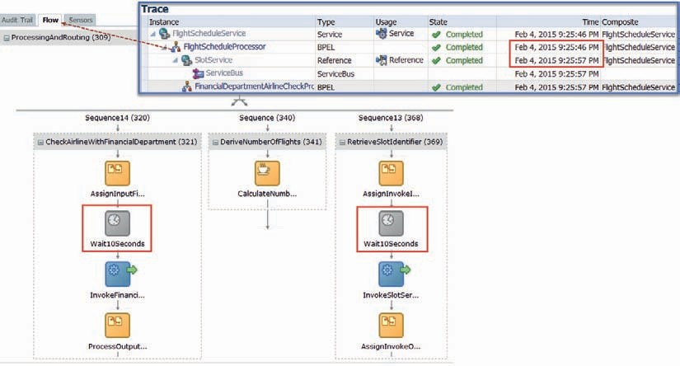

**FIGURE 8-33.** *BPEL Flow in the EM FMW Control—showing the parallel processing of a Flow*

*activity with two 10-second-long Wait activities*

10s to each of these three scopes, we can see the effect of the parallel flow very clearly—as visualized in Figure 8-33. Instead of the overall processing taking longer than 20 seconds—which would have been the case when no parallel scope processing would take place at all, the response is received in about 11 seconds.

### Summary

This chapter introduced the BPEL component in SOA composite applications. With BPEL, we have a language at our disposal that is very good at calling services—synchronous or asynchronously—and processing XML data. BPEL also provides many of the features expected from any programming language—including iterations, fault handling, conditional logic as well as parallel processing.

Additional features we have encountered are the embedded Java activity, the callable inline subprocess, and the use of a component template to rapidly create a new BPEL component.

Creating a composite service that receives a request message and performs a number of actions before producing a response, potentially interacting with multiple local components or remote services, is quite straightforward with the BPEL component. Still to come in later chapters are asynchronous interactions, long-running BPEL process instances, event consumption, compensation, interaction with human actors, and correlation.

There are many similarities between BPEL processes and Service Bus pipelines. This chapter implemented the same *FlightScheduleService* with BPEL that we developed in Chapter 7 using Service Bus pipelines. When we start discussing how to implement true, long-running processes using BPEL, the difference between Service Bus and BPEL will become more apparent.





CHAPTER

# 9

## Coherence Integration to Reduce Load and Speed Up Response

he service implementations we have seen until now have no memory: they are stateless. Once they are done, they are done. They don’t store intermediate state in memory, in the database, or in any other medium other than for purposes of monitoring (e.g., by recording

**T**

audit trails). Ask them a question and they will process the request and usually (except for one- way operations) prepare a response. And next time for the same request, they will go through exactly the same motions again. However, there are many situations where the same question is indeed asked from a service quite frequently, in fact, much more frequently than the response is likely to change.

A simple example would be the current dollar to euro conversion ratio (set once per day at Saibot Airport) or the weather forecast (set per hour) or the status of a flight. During the day, for each scheduled flight, the status may be asked for thousands of times. By the application that powers the web portal and from the application that runs all the information terminals and by the many hand held devices used by security staff, cleaning super visors, baggage handlers, and so on. For every request about the flight status, the service will still access the enterprise resources that hold the flight details, even though this puts a load on the back-end system, adds time to the request processing, and usually returns the same value as upon the previous round trip. The status of the flight does not change very often. However, the service is stateless and has no memory.

Enter Coherence. Coherence is part of the Fusion Middleware infrastructure. It provides an in-memory multinode grid that can be accessed through a Java API, RESTful APIs, and the JCA

Coherence adapter. Additionally, Coherence is the foundation for the out-of-the-box Result Cache feature on Service Bus business services.

Coherence can be used as the (shared, cross cluster) memory for services. A service can easily store a result on the Coherence grid and reuse that result for more quickly handling a future request, provided the stored result is still deemed valid and fresh enough. Values that do not have to be recalculated or retrieved again from back-end systems can be made available much faster for service consumers and obviously reduce the load on the enterprise resources that would otherwise have had to cough them up.

This chapter shows how Coherence can be integrated into SOA composites through the Coherence adapter. Using the example of the flight status, it shows how a typical pattern emerges: put data in the cache when first queried and either expire the cache after a set time or refresh the cache when the value changes in the underlying system. With Service Bus, we will see that the first approach is available declaratively for any business service using Result Caching.

###### TIP

*This chapter is fairly technical in nature. It does not introduce new functional behavior in the SOA Suite, but merely describes*

*nonfunctional aspects. As such, you could easily skip the chapter for now and return to it later.*

**Introducing Cross Instance Shared Memory Using Coherence**

As a first step, we will create a new SOA composite with a simple BPEL process that creates a single string response for a single string request. Producing the response takes 5 seconds— because of a Wait activity in the BPEL process. Into this SOA composite, we introduce two BPEL

subprocesses that together with a Coherence cache act as the shared memory across instances of the composite. Using Coherence, the subprocesses are capable of recording a value associated with a certain key and retrieving a previously registered value.

This cache does not just exist across instances of the same SOA composite, it is also available across different SOA composites, across different applications—including Service Bus and custom Java applications—and across cluster nodes.

#### Create Slow SOA Composite

Create a new SOA Application with project, both called *QuickAndSlowHello*. Choose the Template Composite with BPEL Process. Set the name of the BPEL process to *QuickAndSlowProcess*. Select *Template Synchronous Service* and accept all defaults.

 Add the following type definition in the XSD document QuickAndSlowProcess.xsd.

<complexType name="intermediateResultType">

<sequence>

<element name="result">

<complexType>

<sequence>

<element name="ValueOne" type="string"/>

<element name="ValueTwo" type="string"/>

</sequence>

</complexType>

</element>

</sequence>

</complexType>

We will use this definition to define the payload of the calculated result that is to be stored in and retrieved from the cache.

Open the BPEL editor for the *QuickAndSlowProcess*. Add a global variable called *intermediateResult*, based on the intermediateResultType that was just added to QuickAndSlowProcess.xsd.

Add a scope *ComputeValue* between the request and reply activities. Add an assign activity to this scope, in which the following XML literal is assigned to variable *intermediateResult*:

 <intermediateResult xmlns=" <http://xmlns.oracle.com/QuickAndSlowHello/> QuickAndSlowHello/QuickAndSlowProcess">

<result [xmlns="http://xmlns.oracle.com/QuickAndSlowHello/QuickAndSlowHello/](http://xmlns.oracle.com/QuickAndSlowHello/QuickAndSlowHello/) QuickAndSlowProcess">

<ValueOne>Bonjour</ValueOne>

<ValueTwo>Goedendag</ValueTwo>

</result>

</intermediateResult>

Also add a wait activity to the scope, configured to wait for 5 seconds. This activity represents the long time it may take to access back-end systems and process some result. In the next section, we will be able to retrieve the value from the cache instead of having to recreate it—thereby shaving off almost 5 seconds from the over-all processing time. Although in real life this nonsensical wait would of course never be introduced, it is an easy way to demonstrate the effect of introducing a Coherence cache.

Add a second Assign activity, below the scope. In this activity, set the result element in the payload message part of the *outputVariable*.

 concat('Result for input ',$inputVariable.payload/client:input,' was calculated as ', $intermediateResult/client:result/client:ValueOne)

Figure 9-1 shows the extremely simple BPEL process as it currently stands.

Deploy the SOA composite and make a test call from the HTTP Analyzer. After a considerable waiting time of at least 5 seconds, the response should become available.

If you execute the same request again—and again, and again—the response time will not vary substantially: it will be a little over 5 seconds for every call, because on each occasion, the intermediate result has to be recalculated—at a cost of a little more than 5 seconds.

#### Speed It Up with Cache Support

SOA composites as well as Service Bus applications can make use of Coherence as a caching infrastructure embedded in the SOA Suite. Using the Coherence Adapter, composites can easily interact with this infrastructure. The contents of the cache can be shared across all instances of all SOA composites and Service Bus projects, and across all cluster nodes.

##### Retrieve from Cache

Add the file Cache.xsd to the *Schemas* directory in the *QuickAndSlowHello* project. This schema defines types for key used for storing objects in the cache and for the cached object itself.

Open the SOA composite editor. Drag the Coherence Adapter from the component palette to the External References swimlane, as shown in Figure 9-2. The Coherence Adapter editor opens.

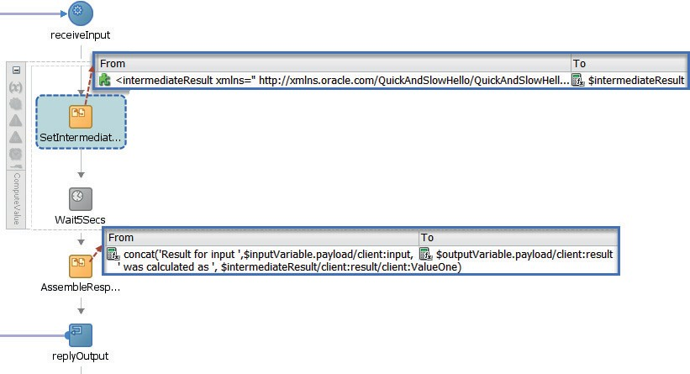

**FIGURE 9-1.** *The initial BPEL process that primarily waits for 5 seconds*

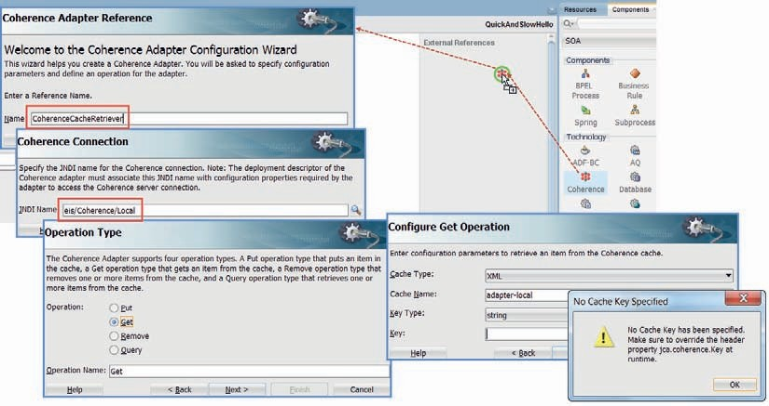

**FIGURE 9-2.** *Adding the Coherence Adapter binding to read from an external cache*

Set the name of the adapter binding to *CoherenceCacheRetriever*. Set or select the JNDI name of the Coherence connection to eis/Coherence/Local. This name corresponds with one of the connections configured in the Coherence Adapter deployment in the Integrated WebLogic Server. Select *Get* as the operation type and the operation name.

In step 4 of the wizard, set *Cache Type* to XML. Set the *Cache Name* to adapter-local. This cache is preconfigured—ready to use for straightforward situations where no special configuration is required. Set the Key Type to String and leave the Key field empty. Press Next. A popup appears with a message, instructing us on setting the value for the key at run time using the JCA header property jca.coherence.Key. Acknowledge the message and continue.

###### NOTE

*Check in the WebLogic Admin Console whether the Coherence Adapter deployment is active. Initially its status can be New or Prepared. In those case, select the Coherence Adapter application deployment and click on the Deploy button.*

In the next page of the wizard—*Specify Schema*—select element *CacheResult* from the Cache.xsd document as the schema element (for objects to retrieve from the cache). Click Next and click Finish. The Coherence Adapter reference is created.

In order to clearly separate the cache interaction from the logic of our main BPEL process and to also make that cache interaction reusable across processes, we create a BPEL subprocess, as visualized in Figure 9-3. Drag a BPEL subprocess component to the central area in the composite editor. Call the subprocess *CacheRetriever*. Set the namespace to saibot.airport/ services/generic/soacomposite. Click OK to have the subprocess created.

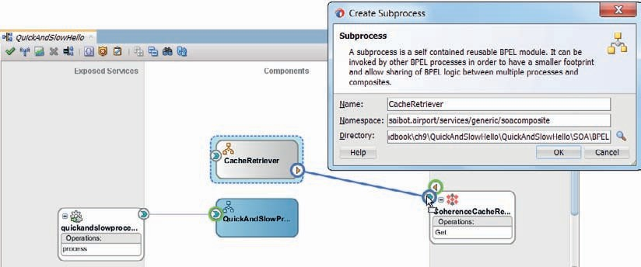

**FIGURE 9-3.** *Create a BPEL subprocess as a separate unit of (reusable) logic*

Wire the subprocess to the *CoherenceCacheRetriever* adapter binding. Open the subprocess by double clicking the icon.

Create global variables *key* and *cacheResult*, based on the *CacheTagType* and *CachedObjectType* types in the Cache.xsd document. The *key* variable will be the input to the subprocess and the *cachedResult* variable is used as the output.

Add a scope to the BPEL subprocess. Inside the scope, add an Invoke activity, linked to the Partner Link *CoherenceCacheRetriever*. In the Invoke activity editor, specify two local variable to be created for the input and the output. Note that we will not actually use the input variable— because the key value we need to pass to the partner link and indirectly the Coherence Adapter binding is passed using a header property.

Open the *Properties* tab in the Invoke editor. Click on the green plus icon to add a property to pass. Select property jca.coherence.Key from the drop-down list. Specify the following expression to derive the value for the Key property:

 $key/ns2:tag

This means that the Coherence Adapter is asked to retrieve an object that was stored using a key with the string found in the tag element.

Click on OK to complete the definition of the invoke activity.

Under the Invoke, add an Assign activity to copy the output returned by the Coherence Adapter to global variable *cacheResult*. The subprocess now looks like Figure 9-4.

###### NOTE

*A subprocess does not start with a Receive nor does it end with a Reply activity: the subprocess is more or less merged at runtime into the calling BPEL process.*

Open the editor for *QuickAndSlowProcess*. Add a scope *ProduceResult*, directly under the Receive activity. Create a scope level variable called *cacheTag*, based on the *cacheTagType* in

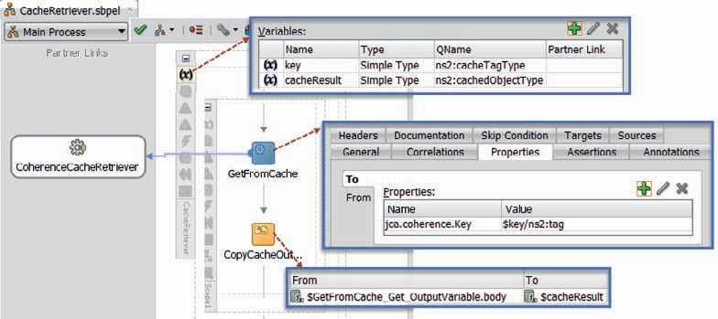

**FIGURE 9-4.** *Subprocess CacheRetriever that invoked the CoherenceCacheRetriever and copies*

*the result to the result variable*

schema definition Cache.xsd. This variable will hold the key with which an object is retrieved from and if needs be stored into the cache.

Add an Assign activity to set the *cacheTag* variable, based on the input element in the request message. Also add a new scope *FetchFromCache* inside this scope. Later on, we will add a test on whether the result was found in the cache. If not, the result has to be calculated—and stored on the cache.

Open the scope *FetchFromCache*. Create a scope level variable called *localCacheResult* and base it on type *cachedObjectType* in Cache.xsd.

These steps are all visualized in Figure 9-5.

Add a call activity to invoke the subprocess *CacheRetriever*. Map the *key* argument of the subprocess to variable *cacheTag*. Map the *cacheResult* to variable *localCacheResult*, as shown in Figure 9-6. Because this argument represents the output from the subprocess and only input variables can be copied by value, you have to uncheck the checkbox for Copy by Value.

Add an Assign activity under the (call to the) subprocess. Map the payload element in the variable *localCacheResult* to variable *intermediateResult*. Set the type of the copy rule to append. Check the *ignoreMissingFrom* option on the copy rule.

The payload element is an XSD anyType: it can contain any valid XML fragment. In order to derive from this element the actual contents we know to find there, we have to refine the copy rule in the BPEL source editor. In this case, we want to copy the result element from the payload to the *intermediateResult* variable. Refine the *from* expression as shown in the next code snippet:

 <assign name="CopyCacheOutcomeToIntermediateResult">

<extensionAssignOperation>

<bpelx:append ignoreMissingFromData="yes">

<bpelx:from>$localCacheResult/ns1:payload**/client:result**</bpelx:from>

<bpelx:to>$intermediateResult</bpelx:to>

</bpelx:append>

</extensionAssignOperation>

</assign>

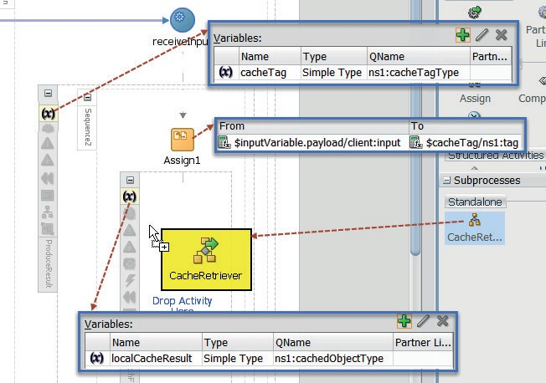

**FIGURE 9-5.** *Preparing the BPEL process for the call to the CacheRetriever subprocess*

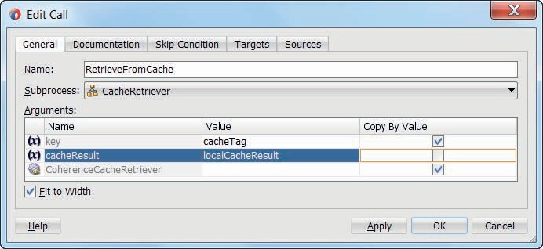

**FIGURE 9-6.** *Configuring the arguments for the call to the CacheRetriever subprocess*

##### Extend the Flow Logic

The SOA composite can be deployed and invoked at this point. It will perform just like before, because even though we attempt to retrieve the result from the cache, it is never actually put on the cache. All attempts to retrieve it are in vain, so we have not yet gained anything.

There are two approaches to a solution:

* + A process outside the current composite takes care of computing results and storing them in the Coherence cache; the *QuickAndSlowHello* composite may be able to benefit from

such values.

* + The *QuickAndSlowProcess* will store itself any value it calculates on the Coherence cache, in order to *remember* it in any future instances (for the same input).

To benefit from the cache whenever a result is found on it and to implement the second option, we need to make a few extensions in the *QuickAndSlowProcess*.

Add an If activity under the *FetchFromCache* scope. Set the label of the activity to

*IfDataInCache* and set the condition to

 $intermediateResult/client:result

which is a test for the existence of the result element in variable *intermediateResult*.

If the data was found on the cache, it has been loaded into $intermediateResult and we do not need to do anything else in the If activity. Therefore, a simple Empty activity suffices in the If branch.

In the Else branch, the intermediate result has to be computed. Therefore, drag scope *ComputeResult* to the Else branch. Under that scope, add a new scope *PutValueInCache*. This scope will be implemented in the next section, to actually record any computed results. Figure 9-7 shows the salient sections of the *QuickAndSlowProcess*.

##### Write Computed Result to Cache

Configure a second Coherence Adapter binding in the SOA composite. This one is called

*CoherenceCacheWriter*.

Use the same settings—except the operation type—as for the first Coherence Adapter: set the JNDI name of the Coherence connection to eis/Coherence/Local. Select Put as the operation type. In step 4 of the wizard, set *Cache Type* to XML. Set the *Cache Name* to adapter-local. Uncheck the checkbox for auto generating the key. Set the Key Type to String and leave the Key field empty. Accept the default for *time to live*. Press Next. Select element *CacheResult* from the Cache.xsd document as the schema element (for objects to put in the cache). Click Next and click Finish.

The Coherence Adapter reference is created.

Drag a BPEL subprocess component to the central area in the composite editor. Call the subprocess *CacheWriter*. Set the namespace to saibot.airport/services/generic/soacomposite. Click OK to have the subprocess created. Wire the subprocess to the *CoherenceCacheWriter* adapter binding.

Open the subprocess by double clicking the icon.

Create global variables *key* and *cachePayload*, based on the CacheTagType and CachedObjectType types in the Cache.xsd document. Both variables provide input to the subprocess and there is no output.

Add a scope *PutOnCache* to the BPEL subprocess. Inside the scope, add an Invoke activity, linked to the Partner Link *CoherenceCacheWriter*. In the Invoke activity editor, specify two local variable to be created for the input and the output. Note that we will not actually use the output variable.

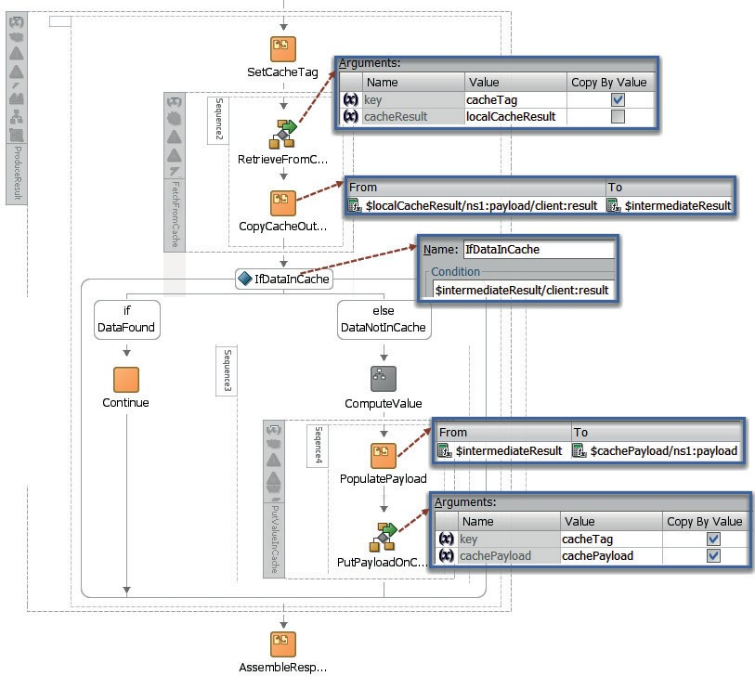

**FIGURE 9-7.** *The flow logic that attempts to find a result in the cache and that computes and*

*stores the result if it was not yet found*

Open the Properties tab in the Invoke editor. Click on the green plus icon to add a property to pass. Select property jca.coherence.Key from the drop-down list. Specify the following expression to derive the value for the Key property:

 $key/ns2:tag

This means that the Coherence Adapter is asked to store an object using a key with the string found in the tag element. Click on OK to complete the definition of the invoke activity.

Before the invoke, add an assign activity to copy the content of global variable *cachePayload* to the generated local input variable for the invoke to the Coherence Adapter. Figure 9-8 shows the complete subprocess.

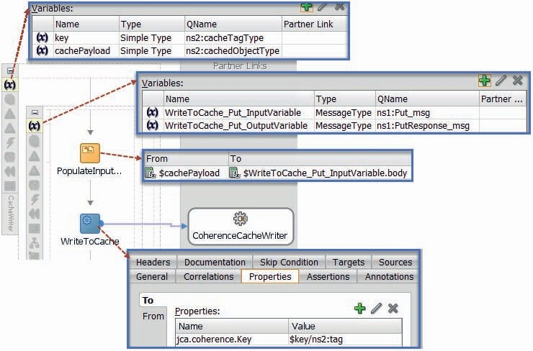

**FIGURE 9-8.** *Subprocess CacheWriter, to store payloads on the Coherence grid*

Return to the BPEL process editor for *QuickAndSlowProcess*. Open scope *PutValueInCache*.

Create a scope level variable called *cachePayload*, based on type *cachedObjectType* (in Cache.xsd).

Add (a call to) the *CacheWriter* subprocess to the scope. Map the *key* argument of the subprocess to variable *cacheTag*. Map the *cachePayload* argument to the new local scope variable *cachePayload*.

Finally, almost done now, add an assign activity just before the call to the subprocess. In this activity, copy variable *intermediateResult* to the payload element in variable *cachePayload*. Check the option *insertMissingToData* on the copy rule.

This completes the BPEL process *QuickAndSlow*—now with full cache support. It also is final piece in the *QuickAndSlowHello* composite application. Time to deploy the entire composite, and invoke the service it exposes. The first call—for input string “Jean” —takes more than 5 seconds. Subsequent calls—for that same input—are just over 0.1 second (Figure 9-9). When the input is changed to “Luc,” the service response takes again over 5 seconds to arrive and the second call for that same input takes again some 100 milliseconds. The impact of using cached results instead of recalculated results is clearly visible.

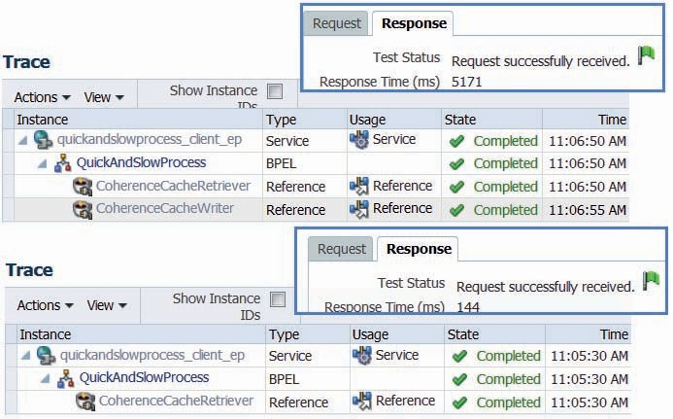

**FIGURE 9-9.** *What a difference caching can make (comparing first and sub sequent calls for a*

*certain request message)*

##### Create Reusable Subprocesses for the Cache Support

The entire composite is shown in Figure 9-10. It consists of a specific part—the QuickAndSlowProcess—and a generic section: the two subprocesses with associated Coherence Adapter bindings.

These generic elements—for writing to the cache and retrieving values from it—can be turned into component templates that make them easily reusable in other SOA composites. That allows us, for example, to reuse them in the next section, when we will spice up the *FlightStatusService*.

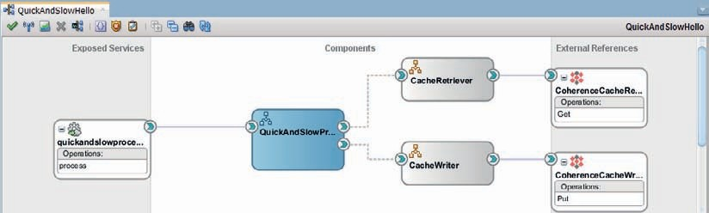

**FIGURE 9-10.** *The QuickAndSlowHello composite application*

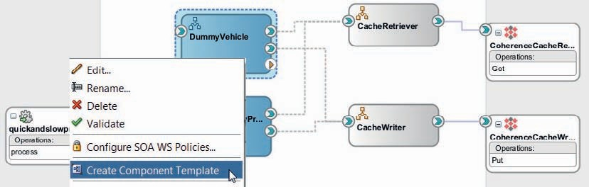

**FIGURE 9-11.** *Create a Component Template for the DummyVehicle BPEL process to actually*

*create a template with the two subprocess components and their associated Coherence Adapter bindings*

However, JDeveloper does not allow us to create a Component Template for a BPEL subprocess. We can bring the subprocess components along in a template created for a different component though. So, as a workaround, add a BPEL component to the *QuickAndSlow* composite, for example, called *DummyVehicle*—not to be exposed as SOAP Web Service. Open the BPEL editor for *DummyVehicle*. Add calls to the two subprocess components—just through drag and drop, no further configuration is required. Close the BPEL editor.

Right click on the *DummyVehicle* component, as shown in Figure 9-11. From the context menu, select option Create Component Template.

The Create Component Template wizard appears. On the first page, provide the name—for example, *CoherenceCacheSupport*—and a description that lets potential users of the template know what exactly it provides. You may change the location where the template will be created, or accept the default. On the second page, an overview is given of all files that will be bundled with the template—including the two BPEL subprocess components, the Coherence Adapter configurations and the relevant XSD files. Accept this selection. The template is now created. You could remove the *DummyVehicle* again, as it no longer serves any purpose.

###### NOTE

*You can review and manage the templates from the menu option Tools | Preferences | SOA | Templates.*

### Add Some Coherence-Powered Memory to the FlightService

The *FlightService* provides the current status for any flight that is scheduled to arrive or depart in a 36-hour time range. It is a crucial service—providing up-to-date flight information to hundreds of systems and tens of thousands of consumers. It is this service that we want to make faster—and this service that we would like to query the enterprise database far less frequently.

Using the generic component templates that were created in the previous section, we should be able to substantially reduce the load on the enterprise resources by fetching the flight status from the cache most of times. Having achieved that first goal, we have to deal with a second challenge: how to ensure that the cache does not serve information that is no longer valid because it is out of synch with the updated back end.

#### Introducing the FlightService

Open the *FlightService* application and project from the FlightService_step0 folder. The implementation is simplified: instead of a call to a real back-end system, the core BPEL process in this composite calls a local BPEL component—*DetermineFlightStatusFromBackendSystems*—to get the status of a specific flight. This implementation—shown in Figure 9-12—will suffice to demonstrate the use of the cache on a business service—and has the benefit of being easy to deploy and try out.

After inspecting the composite, deploy it to the Integrated WLS. Invoke the *FlightService* using the HTTP Analyzer for various flights. Retrieving the status of each flight takes about the same time—just a little over 4 seconds.

#### Add Cache Support

Instead of having to contact the back-end systems—through the *DetermineFlightStatusFromBackendSystems* component—we want our core BPEL process to only contact the back-end systems if it does not know the status of a particular flight. And the status is considered known if it is available from the cache. Fetching the status from the cache is both much faster and far less of a burden on the back-end systems.

Our first step will be to extend the *FlightService* composite with two BPEL subprocesses, based on the component template created in the previous section. This will create the link with the Coherence cache. Next, we will somewhat reconfigure the *FlightStatusProcessor*, in very much the same way as we did with the *QuickAndSlowProcess* in the previous section, leveraging the two subprocesses for reading from and writing to the cache.

##### Add CacheReader and CacheWrite Subprocess from Templates

Drag the *CoherenceCacheSupport* component template from the component palette—panel SOA Templates—to the Components area in the composite editor, as shown in Figure 9-13.

The wizard for creating a component based on a component template appears. It lists all files it is about to merge into the *FlightService* project, together with potential conflicts. In this case,

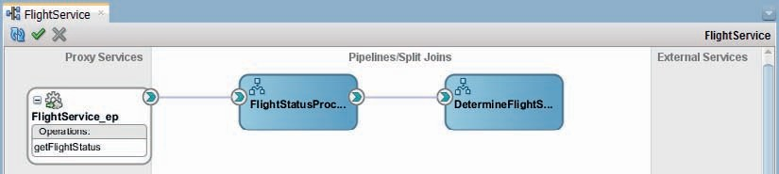

**FIGURE 9-12.** *The initial FlightService composite, without caching support*

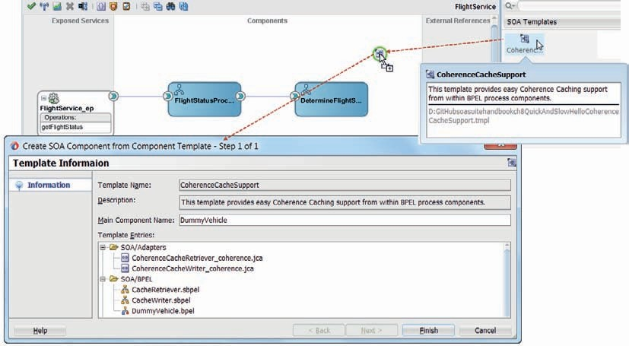

**FIGURE 9-13.** *Adding Component Template CoherenceCacheSupport to the SOA composite*

almost all files are new so there will be few conflicts. The exception is the composite.xml file that will be merged into the existing composite.xml.

Press Finish to have the BPEL subprocess components as well as the Coherence Adapter bindings added to the project. When components have been created for from the template, the composite looks as is shown in Figure 9-14.

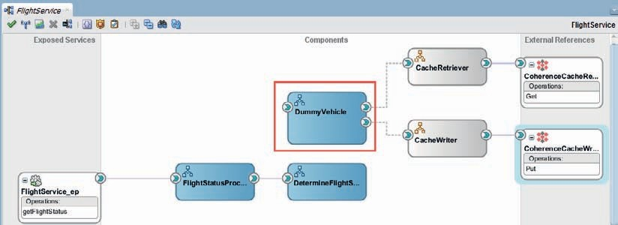

**FIGURE 9-14.** *FlightService composite with foundation for cache support created from*

*component template*

Remove the *DummyVehicle* component, which was included only to bring across the BPEL subprocess components.

##### Engage Cache Support from BPEL Process FlightStatusProcessor

Open the BPEL process editor for the *FlightStatusProcessor*. Let’s create the same overall structure used in the *QuickAndSlowProcess*.

Create a scope level variable in scope *ProduceResult* called *cacheTag*, based on the *cacheTagType* in schema definition Cache.xsd. This variable will hold the key with which an object is retrieved from and if needs be stored into the cache.

Add a scope called *FetchFromCache* as the first activity in the scope *ProduceResult*. Underneath that scope, add an If activity, labeled *IfDataInCache*. Set the condition for this activity to:

 $intermediateResult/ns1:result/ns1:FlightStatus/*[1]

which is a test for the existence of the *FlightStatus* element with at least one child element in variable *intermediateResult*. In the If branch of the activity, add an Empty activity. Move the scope *ComputeResult* to Else branch. Add a scope *PutValueInCache* following this *ComputeResult* scope. Figure 9-15 shows the situation after these edits.

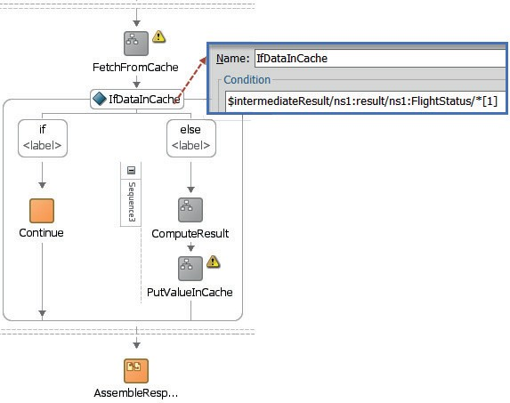

**FIGURE 9-15.** *The outline for the cache support: try to fetch from the cache and when not*

*found, compute and save on the cache for future use*

Add an assign activity just prior to the *FetchFromCache* scope. Set the tag element in the

*cacheTag* variable with a concatenation of the carrier, the flight number and the date:

 concat($inputVariable.in/ns1:Carrier,':',$inputVariable.in/ns1:FlightNumber,': ',string($inputVariable.in/ns1:FlightDate))

Open the scope *FetchFromCache*. Create a scope level variable called *localCacheResult*

which is based on type *cachedObjectType* in Cache.xsd.

Add (a call to) the subprocess *CacheRetriever*. Map the *key* argument of the subprocess to variable *cacheTag*. Map the *cacheResult* to variable *localCacheResult* and make sure to uncheck the checkbox for Copy by Value—because this is the output that should come back from the subprocess.

Add an assign activity after the *CacheRetriever* subprocess, to take the output in *localCacheResult* and copy it to variable *intermediateResult*. Map the payload element in the variable *localCacheResult* to the result element in variable *intermediateResult*. Check the *ignoreMissingFrom* option and the *insertMissingTo* option on the copy rule.

The payload element is an XSD anyType: it can contain any valid XML fragment. In order to retrieve from this element the actual contents we know to find there, we have to refine the copy rule in the BPEL source editor. Refine the *from* expression as shown in the next code snippet:

 <assign name="CopyCacheOutcomeToIntermediateResult">

<copy bpelx:insertMissingToData="yes" ignoreMissingFromData="yes">

<from>$localCacheResult/ns5:payload/ns1:result</from>

<to>$intermediateResult/ns1:result</to>

</copy>

</assign>

These steps are visualized in Figure 9-16.

Open scope *PutValueInCache*. Create a scope level variable called *cachePayload*, based on type *cachedObjectType* (in Cache.xsd).

Add (a call to) the *CacheWriter* subprocess to the scope. Map the *key* argument of the subprocess to variable *cacheTag*. Map the *cachePayload* argument to the new local scope variable *cachePayload*.

Finally, almost done now, add an assign activity just before the call to the subprocess. In this activity, copy variable *intermediateResult* to the payload element in variable *cachePayload*, and copy the expression xp20:current-dateTime() to the *creationTimestamp* element in $cachePayload.

##### Try Out the Cache-Enabled FlightService

Deploy the *FlightService* composite, which now looks like Figure 9-17. It has cache support enabled. That means that the first call for a combination of carrier, flight number, and data will still take over 4 seconds, but every subsequent call for that same combination should return well within 1 second. The result in those cases does not have to be reconstructed from back-end systems but instead can be reproduced from the cache.

Calling the *FlightService* three times in a row for the same combination of carrier, flight number, and flight date will make the effect of the cache quite obvious: the first call takes over 4 seconds, the other two should take no more than a fraction of a second.

Another telltale sign of the effect of the cache can be seen from the element *creationTimestamp*: if a timestamp is returned that is distinctly in the past, the flight status was retrieved from the cache.

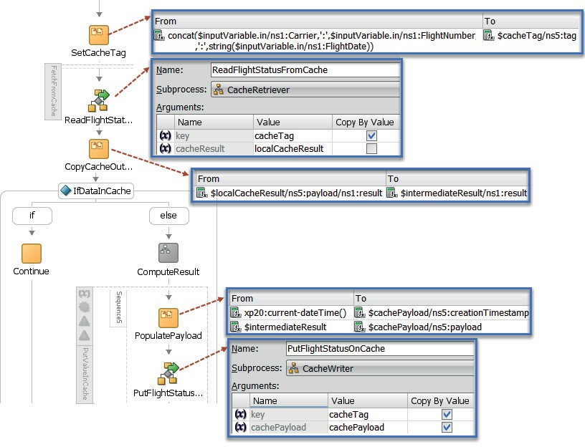

**FIGURE 9-16.** *The BPEL process FlightStatusProcess with caching support*

#### Add Refresh Cache Strategy

The flight status can efficiently be retrieved from the cache. That is good. What is less good is that as soon as that status is stored in the cache—it could become stale. Stale means that the situation in the cache deviates from the actual status in the back-end systems. Clearly, the flight service should not produce stale or incorrect data. Therefore, a mechanism is required that removes data for a flight from the cache that is known to be stale. The next time the status is requested for that flight, it will be retrieved from the back-end systems and stored anew in the cache.

###### NOTE

*The mechanism introduced here for guarding the freshness of the cache could even take responsibility for calculating and caching the fresh value. For now we take a somewhat simpler approach of merely ensuring the cache will not produce stale values.*

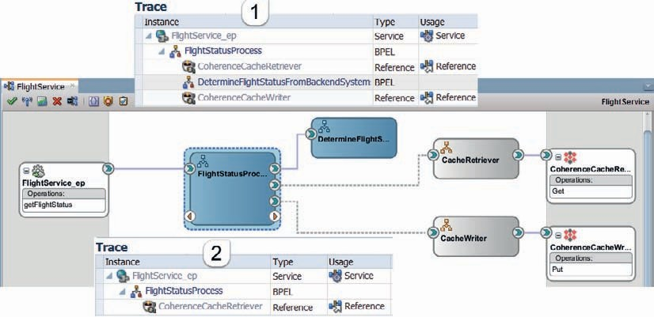

**FIGURE 9-17.** *FlightService composite with cache support based on subprocesses and Coherence*

*Adapter bindings created from component template; trace 1 indicates a request that could not be serviced with a an existing cache value and trace 2 is for one that did leverage the cache*

In our current case, we will publish a service *FlightStatusCacheService* on the Service Bus that should be invoked whenever the status of a flight changes—much like the *FlightUpdateNotificationService* introduced in Chapter 6 is invoked when a flight status is

updated. For now, we will not go into detail as to what agent will take responsibility for calling. Note that this same service could perhaps expose operations for preloading the cache at midnight with the flight status for all the flights of the coming day and for querying flights with specific characteristics.

**Create FlightStatusCacheService to Reset the Cache**

Open the Service Bus project *FlightStatusCacheService* in the *FlightStatusCacheService_step0 application*. It contains the WSDL for this service along with the associated Schema definitions.

Right click in the External Service lane. Select Insert Adapters | Coherence from the context menu. The Coherence Adapter configuration wizard appears. Call the adapter reference *RemoveFromCache*. Set the JNDI connection to eis/Coherence/Local. Select Operation Type *Remove*. Set the Cache Name to *Adapter-Local*. Type *dummy* into the Key field and leave the Filter field empty. We will use a JCA header property to specify the key of the object to be removed from the cache. Click Finish to complete the creation of the Adapter binding and the business service.

Next, right click the FlightStatusCacheService.wsdl file and select Service Bus | Generate Proxy Service from the context menu. Check the checkbox to also generate a pipeline. Set the name of the pipeline to *FlightStatusCachePipeline*. Set the endpoint URI to /flight/FlightStatusCacheService. Click Finish to create the proxy service and the pipeline. Then, wire the pipeline to the business service *RemoveFromCache*, as shown in Figure 9-18.

Open the pipeline. Modify the routing activity: configure it to invoke the *Remove* operation on the *RemoveFromCache* business service.

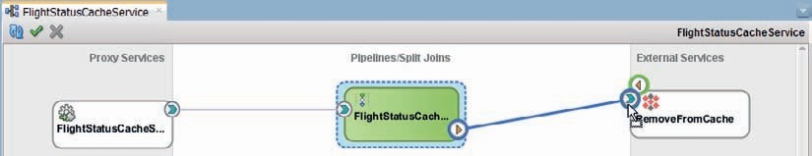

**FIGURE 9-18.** *Wire pipeline FlightStatusCachePipeline to the Coherence Cache business service*

Add a Transport Header activity to the Request Action section in the Routing activity. Add a Header for the jca protocol. Select or set the name to jca.coherence.Key. Then edit the expression to derive the value for the property. It should contain the equivalent of the concatenation of carrier, flight number, and flight date that we used in *FlightService* to put flight data on the cache and retrieve it from the cache:

 fn:concat($body/flig:getFlightStatusRequestMessage/flig:Carrier,':',$body/flig

:getFlightStatusRequestMessage/flig:FlightNumber,':',$body/flig:getFlightStatu sRequestMessage/flig:FlightDate)

###### TIP

*SOA Suite allows the creation of custom XPath functions through the implementation and registration of a simple Java class. Whenever you find yourself reusing the same, complex XPath expression over and over again, you could consider creating such a reusable custom XPath function for it.*

Figure 9-19 shows the pipeline and specifically the configuration of the Transport Header activity.

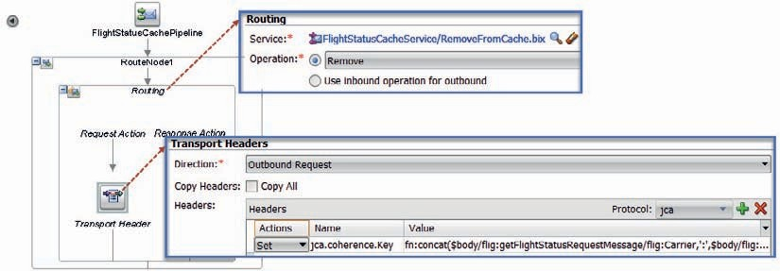

**FIGURE 9-19.** *Configuration of the FlightStatusCachePipeline—set the jca.coherence.Key*

*transport header*

Deploy the FlightStatusCacheService.

###### TIP

*The logic provided above in a Service Bus project could just as easily be implemented in an SOA composite application using a mediator and the same Coherence Adapter binding. The source code for this chapter has the* FlightStatusCacheServiceAlternative *folder with this alternative implementation.*

##### Test the Forced Cache Refresh

What we want to verify is the following scenario:

* + Invoke *FlightService* for a specific flight X—response takes more than 4 seconds and the cache is loaded.
  + Invoke *FlightService* for the same flight X—response is received in less than half a second, as it is produced from the cache.
  + Invoke *FlightService* for a specific flight Y—response takes more than 4 seconds because the status for this flight is not yet found in the cache; subsequently the cache is loaded

with the status of flight Y.

* + Invoke *FlightService* for the same flight X—response is still received in less than half a second.
  + Invoke *FlightStatusCacheService* for flight X—there has been a status update for that flight and the information has to be removed from the cache.
  + Invoke *FlightService* for flight X again—response takes more than 4 seconds because the status is retrieved afresh from the back-end systems because it was previously removed

from the cache; the newly derived status is stored in the cache.

* + Invoke *FlightService* for the same flight X—response is received in less than half a second, as it is produced from the cache.
  + Invoke *FlightService* for the flight Y—response is received in less than half a second because earlier on the status for this flight was produced and stored in the cache. Note

that the cache reset for Flight X did not affect the information for Flight Y.

Walk through these steps to verify whether the behavior you are experiencing is in accordance with your expectations.

### Leverage Service Bus Result Cache

The Service Bus has a built in integration with Coherence that doesn’t require the use of the JCA Coherence adapter. It is called Service Result Cache. Business services can be configured with the Service Result Cache, to cache the response from the business service for future use. The expiration time of the cached response is configured, as is the expression to derive the key under which the response is cached. All that is required to leverage this Service Result Cache is a little declarative configuration. Compared to the Coherence adapters we have seen in action earlier in this chapter, we lack the ability to explicitly reset the values in the Service Result Cache, for example when

some event tells us the cached data has grown stale. Simply put, Result Cache is easier to configure, but more limited in functionality than the explicit use of the Coherence Adapter.

We will see the Service Bus service result cache in action for a wrapper *FlightService* on the Service Bus that routes to the *FlightService* SOA composite. We will disable the cache support in the SOA composite, feel the effects and then switch on the service result cache to provide the cache fueled response acceleration again.

#### Expose FlightService on the Service Bus

Create a Service Bus application and project, both called *FlightServiceProxy*. Copy the folders WSDLs and Schemas from the *FlightService* SOA composite project to the *FlightServiceProxy* project.

In the project overview editor, right click on the External Services swim lane. Select Transports

| HTTP from the context menu, to create a business service that invokes the *FlightService* exposed by the SOA composite. Set the name of the business service to *FlightServiceSOAcomposite*.

On the second page, set type to WSDL and browse for the WSDL for the SOA composite *FlightService*. Use the URL with port 7101 over HTTP, instead of the URL for 7102 over HTTPS. The wizard will propose to import a number of resources associated with the *FlightService*.

Accept this proposal. Click on Next and click on Finish to create the business service. At this point, you can already test the business service by simply running it from the context menu.

Open the folder WSDLs and click on FlightService.wsdl to open the editor. Add a SOAP 1.1 binding to the WSDL, by clicking the green plus icon in the frame labeled bindings. This is necessary because the composite’s WSDL is abstract and a Service Bus proxy service has to be associated with a binding element from the WSDL definition. Save the changes.

Right click on the FlightService.wsdl file and select Service Bus | Generate Proxy Service from the context menu. The wizard appears to help create a proxy service and a pipeline from the WSDL interface definition. Call the service *FlightServicePS*. Call the pipeline *FlightPipeline* and check the checkbox to generate a pipeline wired to the proxy service. Click on Next. Set the Endpoint URI to /flight/FlightService. Click Finish.

Wire the freshly created pipeline to the business service, see Figure 9-20. Because the interface definition is the same for the proxy service, the pipeline, and the business service, you do not have to make any additional changes. You can run each of these three to verify whether the reference to the SOA composite works as expected and benefits from the cache support in the composite. The latter should mean that if you make two calls to either the proxy service, the pipeline, or the business service, at least the second should complete in less than 0.5 second.

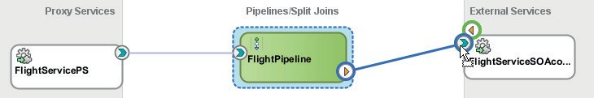

**FIGURE 9-20.** *The FlightServicePS proxy wraps the Flight Service SOA composite through*

*a business service with Service Result Cache configured*

#### Disable Cache Support in FlightService SOA Composite

Open the *FlightService* SOA composite. Open the *FlightStatusProcess* BPEL component. Change the condition in the If activity to false().

This ensures that even when the requested flight status is retrieved from the cache, the BPEL process will still recompute the status. The cache support has effectively been disabled.

Deploy the composite and make a few test calls to the Service Bus proxy service *FlightService*

to verify that each request now takes similarly long: more than 4 seconds.

#### Switch on Service Result Cache

Let’s now configure the result cache on the business service for calling the SOA Composite *FlightService*. Open the editor for the business service and bring up the Performance tab, as shown in Figure 9-21.

Check the checkbox labeled *Enable Result Caching*, to indicate that responses from the underlying service—the SOA composite *FlightService*—can be reused for subsequent requests. Set Cache Token Expression to the following XQuery expression—that derives a key based on the same components we used before: carrier, flight number. and flight date:

 fn:concat($body/flig:getFlightStatusRequestMessage/flig:Carrier,':',$body/flig

:getFlightStatusRequestMessage/flig:FlightNumber,':', $body/flig:getFlightStat usRequestMessage/flig:FlightDate)

Set the *Expiration Time* to a duration of 30 seconds. That means that any cached results are good for reuse during 30 seconds. After that period, these values should not be reused again and should eventually be removed from the cache. Alternatively, the expiration time can be derived dynamically in an XQuery expression that can use elements in either the request or the response message. The setting Default refers to a value specified in the configuration file osb-coherence- config.xml for element expiry-delay; initially that value is set to 5 minutes.

By adding the cache-ttl metadata element to the request sent to the business service, we override the cache-ttl that was derived from the Expiration Time expression configured on the business service at design time:

 <tran:cache-ttl [xmlns:tran="http://www.bea.com/wli/sb/transports">PT5S</](http://www.bea.com/wli/sb/transports) tran:cache-ttl>

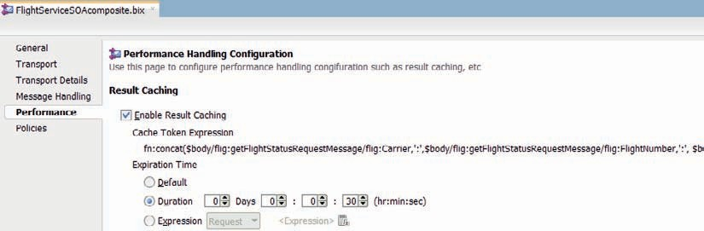

**FIGURE 9-21.** *Configuration of result caching for the business service*

When you invoke the business service, the response metadata that is shown in the Service Bus console contains header elements called cache-token and cache-originated. The former shows the cache token as derived from the expression specified for the result cache and the latter indicates whether the response could be retrieved from the cache or not.

Deploy the Service Bus project. Make a few calls to the Service Bus proxy service *FlightService* to verify that each first request for a specific flight (carrier, flight number, and flight date) still takes a little more than 4 seconds and that each subsequent request for a specific flight returns a response in less than 0.5 second. The latter is the effect of the result caching that has been enabled on the business service that wraps the SOA composite *FlightService*.

###### NOTE

*The service result cache does not expose cache refresh operations. Only through the expiration expression defined for the cached value can we influence the caching behavior. There is no direct access path to reset entries in the service result cache. That may be a good reason to work with relatively short expiry times, depending of course on the expected rate of change.*

### Summary

Recalculating the same result over and over again is a waste of resources and causes the response time to be longer than is necessary and can cause overloads in (back-end) systems. Use of a cache, where previously produced values are stored for reuse is a common mechanism to lower the load on back-end systems and improve the performance of the system.

SOA Suite is shipped with Coherence—an in-memory, multinode data grid. This grid can be used as a cache to easily store and retrieve objects to and from. Values in the cache can have an associated expiry time, can be XML fragments or Plain Old Java Objects and are available across different instances of composites, across different composites, and Service Bus projects and across different nodes in a SOA Suite cluster. SOA composites and Service Bus project can use the Coherence Adapter to interact with the cache. Additionally, a business service in a Service Bus project can be configured with the Result Cache option. This is a simplified integration with Coherence through which caching can be enabled in a straightforward, easy, and declarative way, with somewhat limited capabilities regarding refresh strategies.

Caching is primarily useful when the number of requests for a certain value far outnumbers the number of changes to that value and especially when producing the result is expensive—in terms of load on the back-end systems or even in terms of actual money—and time consuming. Another reason to consider use of a cache is to protect against unavailable back-end systems when it is better to have a potentially stale but still fairly recent value than no value at. If that is the case, the algorithm should be: retrieve always from back end, always store the value in the cache; when the back end is unavailable: retrieve the most recent value from the cache.

Anything put on a Coherence grid can be retrieved from that grid by any consumers, not just the one that put it there. One service can produce and record the result and another can retrieve such a result. That is somewhat akin to the Claim Check pattern—so called after the cloakroom that hands out a tag when a coat has been handed over and will produce that coat to anyone handing in the tag later on. So instead of handing a value from service to service, these services can also share that value through the cache, by exchanging the key to that cached value.

Note that when large documents or a large number of objects are put on the cache, this may result in quite substantial memory consumption. The Coherence cache used through the adapter or in conjunction with the business service result caching option can either be local on the same server as SOA Suite, which is the default, or it can be configured on remote clusters, possibly only used for caching.





CHAPTER

# 10

## Embedding Custom Logic Using Java and Spring Component

he SOA Suite is a platform on which Service Bus projects and SOA composites can be deployed to run and process requests. This platform provides many out of the box components that are configured through declarative programs into processing XML, calling

**T**

out to services, performing logic, and so on. Occasionally, these components and the declarative approach fall just short of what we need for a specific service implementation. In those cases, we can make use of custom Java components to complement the out of the box capabilities.

We have seen how we can call out to Enterprise JavaBeans and how both a Service Bus pipeline and a BPEL process can call out to a Java class. However, the transition from the service implementation to these Java contexts was not entirely smooth, and required us to jump through some hoops.

In this chapter, the Spring component is introduced. This is a first class citizen in the SCA fabric of SOA composites, along with BPEL, Mediator, Business Rules, and Human Task components that are discussed in subsequent chapters. This component allows custom Java classes and third party Java libraries to be easily integrated into SOA composite applications. We will discuss use of the Twitter4J library for interacting with Twitter as well as the Java SDK for Dropbox.

An important component in this chapter is the Mediator component. We will discuss how a mediator can forward a response it has received to another service component—instead of returning a response message. The mediator can make use of simple *assign values* steps to construct the routed message, instead of XSL, or XQuery-based transformations.

### Simple intro—First Steps with the Spring Component

A service interface describes operations and for each operation the input and output parameters. A Java interface does the same thing for the Java methods it exposes. It is, therefore, fairly easy to convert a Java interface into a web service interface described by a WSDL document with XSD types.

SOA Suite works from this notion and allows us to create Java classes that implement one or more interfaces and have these classes expose the web service equivalent of the Java interface(s) they implement in a SOA composite application. To that end, Java classes need to be configured in a Spring context component, defined through an extended Spring framework bean definition file. Beans configured in this component can publish any Java interface they implement as an SCA service to be invoked by other components in the SOA composite.

The Spring framework has at its core an IoC or Inversion of Control container, that can construct beans that are instances of Java classes into which property values and dependencies can be injected. Multiple beans can be configured in a single Spring component—with some beans being injected into others, to satisfy the dependencies of these objects. When a bean has a dependency that cannot be satisfied by another bean in the Spring context, this dependency can be promoted and exposed as an SCA reference that other components in the composite can provide the implementation for.

This must all sound very abstract, to those who do not know the Spring framework, so let us start with a very simple example.

#### The Greeter Service Based on the Java Greeter Interface

Create a new SOA composite application, called *SpringGreeter*, initially empty. This composite will expose a *GreeterService*, based on a Java interface that is exposed by a bean in a Spring

context component and implemented by a simple Java class. The service will take a string input and return it with a simple greeting—“Hello <name>”—added to it. In a second iteration, we will define a dependency in the class on a decorator. At first, this decorator will be provided by a local bean in the Spring context—based on a Java class that returns the all capitals version of the string with an exclamation mark added to it. Next, the dependency is promoted to a reference that a mediator component outside the Spring context is brought in for. Note: Create all classes and interfaces in a package called *springgreeter*.

##### Quick GreeterService Implementation

Create a Java interface called *Greeter*—in the same project as the SOA composite—with a single method that accepts a String and returns a String:

 public interface Greeter {

public String greet(String input);

}

Next, create a Java Class *GreeterImpl* that implements this interface: public class GreeterImpl implements Greeter {

@Override

public String greet(String input) { return "Hello "+input;

}

}

Make the project—which takes care of compiling these two Java artifacts.

Open the SOA composite editor. Drag a Spring context component from the component palette to the central area in the SOA composite. Create the Spring context component as *GreeterSpring*.

Double click the new component and configure the bean configuration file as follows:

 <bean id="greeterBean" class="springgreeter.GreeterImpl" />

<sca:service name="Greeter" target="greeterBean" type="springgreeter.Greeter" />

This defines through the second line that the *GreeterSpring* component exposes a service called *Greeter*, based on the Java Interface *Greeter* and implemented by a Spring bean identified as *GreeterBean*. The first line tells the Spring container that this *GreeterBean* can be constructed using the *GreeterImpl* class.

When you save the file, you will notice that the Spring component exposes a service now, as shown in Figure 10-1. Drag this service to the External Services swim lane on the left-hand side, and drop it. JDeveloper will show a popup, indicating that it is about to generate a WSDL document describing the web service derived from the *Greeter* interface. Click OK.

This completes the composite. Deploy it and make a test call to the operation *greet*. In XML terms, you should see the results from your own Java code’s operations.

##### Working with a Locally Satisfied Dependency

Create a second Java interface, called Decorator, with a single method *prettifyString*:

 public interface Decorator {

public String prettifyString(String input);

}

Open the GreeterImpl class and extend the implementation like this:

public class GreeterImpl implements Greeter {

**private Decorator decorator;**

**public void setDecorator(Decorator decorator) { this.decorator = decorator;**

**}**

@Override

public String greet(String input) {

return **decorator.prettifyString(**"Hello "+input**);**

}

}

The *GreeterImpl* class has a dependency now: before using the *GreeterBean*, someone should inject a Decorator into it. An obvious solution is the creation of a Java class that implements the Decorator interface on which a second Spring bean can be based that is injected:

 public class RealDecorator implements Decorator { @Override

public String prettifyString(String input) { return input.toUpperCase()+"!!";

}

}

Change the contents of the *GreeterSpring* context definition like this:

 <bean id="greeterBean" class="springgreeter.GreeterImpl" >

<property name="decorator" ref="decoratorBean" />

</bean>

<bean id="decoratorBean" class="springgreeter.RealDecorator" />

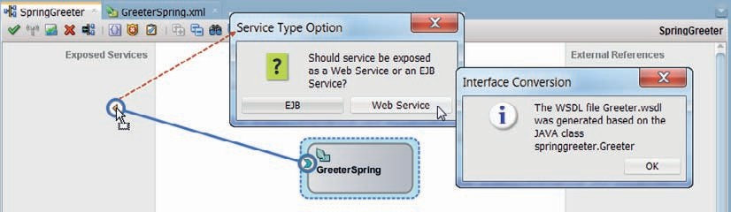

**FIGURE 10-1.** *Promote the service exposed by the Spring Context to an external web service*

*published by the SOA composite application*

Nothing changes in the sca:service element. The new dependency in the *GreeterBean* is resolved internally for now, between the Spring beans themselves.

Deploy the composite and make a test call. The effects from the injected Decorator are visible.

##### Satisfy a Bean Dependency with an SCA Component

The decorator that is now provided by another Spring bean, can also be provided by a mediator or BPEL component in the SOA composite, or even by an adapter or external reference at composite level. To bring this about, the dependency has to be promoted in the Spring context definition like this:

 <bean id="greeterBean" class="springgreeter.GreeterImpl">

<property name="decorator" ref="**StringDecorator**"/>

</bean>

<sca:reference name="StringDecorator" type="springgreeter.Decorator"/>

Here, the decorator property is no longer set using a local bean but instead it refers to the sca:reference element. When you save the changes and return to the SOA composite editor, you will see that the *GreeterSpring* component now exposes a reference.

In order to satisfy this dependency, create a new mediator component called *StringDecorator*.

Indicate that the interface will be defined later.

Wire the reference from the *GreeterSpring* component to the new *StringDecorator* mediator, as is shown in Figure 10-2. JDeveloper generates the WSDL definition for the *Decorator* interface that this reference requires. This WSDL will automatically become the service interface for the mediator component.

All that is left to do, is provide the implementation of a routing rule in the Mediator. Open the editor for *StringDecorator*. Add a routing rule of type *echo*. Click on the Assign Values icon for this routing rule and have the output derived as the lowercase value from the input, as is shown in Figure 10-3.

We now have a an example of an SOA composite that exposes a web service implemented by a Spring bean that relies on an implementation of the *Decorator* interface that is provided by a

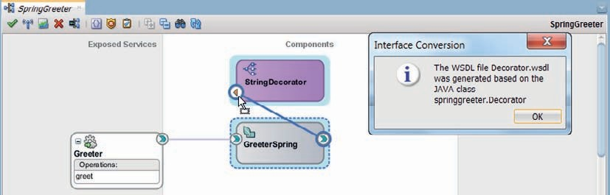

**FIGURE 10-2.** *Mediator StringDecorator satisfies the dependency from the GreeterSpring*

*component (and indirectly from the GreeterImpl Java class)*

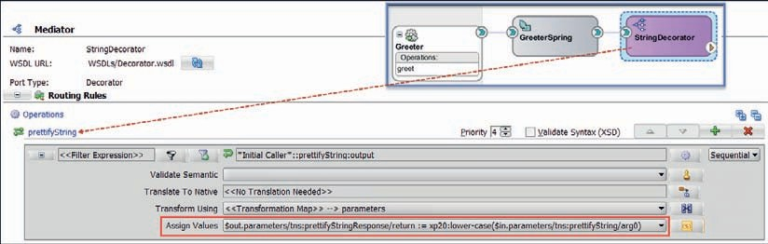

**FIGURE 10-3.** *Configure the Echo Routing Rule That Returns the Lower Case String*

mediator component. These are the essential ingredients of the integration of custom Java classes through the Spring component in SOA Suite.

Deploy the composite and make a test call. Verify that you see the effect of the *StringDecorator* (lower case output). Inspect the message flow trace for the test call in the Enterprise Manager FMW Control. You will see the Spring context invoked as well as the mediator component. There is no trace of individual Java classes inside the Spring component.

### Add the Twitter Channel to the FlightNotificationService

In Chapter 6, we have created the *FlightNotificationService*. This service sends notifications of updates in the status of a flight to an indicated recipient over the specified channel. Currently, this service leverages the outbound UMS adapter to send notifications over channels Email and Chat (IM). The marketing department of Saibot Airport has expressed an interest in adding Twitter (direct messages) as a channel for sending such notifications. Using the Spring component and the Twitter4J library, we will comply with that request.

#### Prepare the Application for Twitter Access

In order to be able to programmatically access a Twitter account and perform actions on its behalf such as reading and querying the timeline, posting status updates, and reading and sending direct messages, the application that will do these things has to be authorized. In order to create this authorization, go to https://apps.twitter.com/ and click on the Create New App button. You are taken to a page where you have to provide some details about your application—name, description, and website. When the application is registered, you can specify the permission level—set it to Read, Write, and Direct Messages. Next, generate the access token for the application. The access token and its associated secret along with the API key and the API secret are the four strings used in a Java program to access the Twitter API and authorize with it.

###### TIP

*The online resources for this chapter have step by step instructions and screenshots illustrating these actions. They also describe the certificate that has to be configured in the JVM Key Store to be able to access Twitter over a secure connection.*

Download Twitter4J from [http://twitter4j.org,](http://twitter4j.org/) for example, twitter4j-4.0.4.zip. Extract file twitter4j-core-4.0.4.jar (or whatever more recent version is available) from the zip file to the SOA/ SCA-INF/lib folder under the *FlightNotificationService* project. This JAR file contains the Java library that makes interaction with the Twitter API fairly easy.

Open the *FlightNotificationService* application and project. Open the project properties editor, from the context menu on the project node. Open the Libraries and Classpath tab. Click on Add JAR/Library. Browse for twitter4j-core-4.0.4.jar and add it to the project.

#### Create the Java Class to Send Twitter Direct Messages

Create Java Interface *TwitterMessageSender*:

 package saibot.airport.services.spring; public interface TwitterMessageSender {

void sendDirectMessage(String message, String recipient);

}

Create a new Java Class, called *TwitterClient* that implements the interface, using this code:

 package saibot.airport.services.spring;

public class TwitterClient implements TwitterMessageSender { private final String consumerKey = "ZdDrYourKey";

private final String consumerSecret = "srkVo4oYourSecret"; private final String accessToken = "12YourAccessToken"; private final String accessTokenSecret = "yZYYourTokenSecret";

private ILoggerBean logger;

public void setLogger(ILoggerBean logger) { this.logger = logger;

}

private Twitter constructTwitterInstance() { ConfigurationBuilder cb = new ConfigurationBuilder(); cb.setDebugEnabled(true)

.setOAuthConsumerKey(consumerKey)

.setOAuthConsumerSecret(consumerSecret)

.setOAuthAccessToken(accessToken)

.setOAuthAccessTokenSecret(accessTokenSecret);

Twitter sender = new TwitterFactory(cb.build()).getInstance(); return sender;

}

public void sendDirectMessage(String message, String recipient) { Twitter sender = constructTwitterInstance();

try {

message);

DirectMessage directmessage = sender.sendDirectMessage(recipient,

if (logger!=null) {

logger.log(Level.INFO, "Sent: " + directmessage.getText() + "

to @" + directmessage.getRecipientScreenName());

}

} catch (TwitterException e) { e.printStackTrace();

if (logger!=null) {

logger.log(Level.WARNING, "Failed to send Direct Twitter Message to "+recipient,e);

}

}

}

public static void main(String[] args) throws TwitterException { SimpleDateFormat sdf = new SimpleDateFormat("hh:mm aa");

new TwitterClient().sendDirectMessage("FLight - KL 423 - Status Update at " + sdf.format(new Date()) + " - Boarding at Gate 45 ", "yourTwitterAccount");

}

}

Provide the values for the consumer API Key, the consumer API secret, AccessToken and AccessTokenSecret that you generated when registering the application with your Twitter account.

###### NOTE

*The preferred way of providing these values would probably be to define them in a property file and from there have them injected as defined in the Spring configuration file into the* twitterMessageMaster *bean. That is a little more involved for the purpose of this chapter and would make it a little harder to test the Java Class—so we choose the plain, less elegant approach here.*

Run the Java class to see whether a first direct message is sent to the recipient you specify (this could be your own Twitter account).

The *ILoggerBean* interface referred to in this code is an interface of a bean that is preregistered in the SOA Suite. That bean is our gateway to the logging infrastructure of the SOA Suite. It can be configured in Spring components in SOA composites to be injected into our beans, as we will see in a little while.

#### Configure the Spring Context Component

Open the SOA composite editor for the *FlightUpdateNotificationService*. Drag a Spring component to the central section and drop it, as is shown in Figure 10-4.

The Create Spring [Context Component] editor appears. Set the name of the component to

*TwitterChannel* and create a new context. Press OK to have the context created.

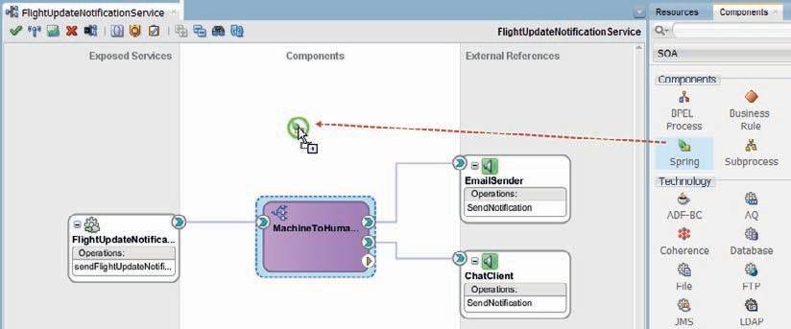

**FIGURE 10-4.** *Add Spring component to the composite application*

Double click on the new Spring component, to bring up the editor for the Spring context file.

Under the comment line Spring bean definitions go here, add a bean definition, as follows:

 <bean class="saibot.airport.services.spring.TwitterClient" id="twitterMessageMaster" >

<property name="logger" ref="loggerBean" />

</bean>

This defines a bean that will be identified with the string *twitterMessageMaster*. The bean is implemented by the *TwitterClient* class (which should have a no-argument constructor to be instantiated). The bean defines a property logger—and will have a *setLogger* method. Another bean identified by the string *loggerBean* will be injected into this *twitterMessageMaster* bean to provide the value for this property.

###### NOTE

*The identifier* loggerBean *is predefined in SOA Suite. It refers to the generic implementation of the* ILoggerBean *interface. The SOA Suite run time will recognize the identifier and will know what object to inject. Two additional preregistered beans are available:*

* + *headerHelperBean*: For getting and setting header properties
  + *instanceHelperBean*: For getting the following information: instance ID of the composite instance currently running, instance ID of the component instance currently running,

composite distinguished name (DN) containing the name of the spring service component

Next, add the following entry to the TwitterChannel.xml file.

 <sca:service name="TwitterMessenger" target="twitterMessageMaster" type="saibot.airport.services.spring.TwitterMessageSender" />

Here we specify that the Spring component *TwitterChannel* exposes a service to the other components in the SOA composite. Out of potentially many beans in the Spring context, one makes its interface available for outside parties to create a wire to and make calls to. The service is advertised as *TwitterMessenger* and the interface it implements is the Java Interface *TwitterMessageSender*. The service implementation is provided by the *TwitterMessageMaster* bean.

#### Engage the Spring Component

Drag a wire from the *MachineToHuman* Mediator to the *TwitterChannel* Spring component, as is shown in Figure 10-5. The latter exposes exactly one service, so JDeveloper knows for which Java Interface—*TwitterMessageSender*—it should create the corresponding WSDL for the Mediator to interact with.

You may want to take a quick look at the generated WSDL. The elements that represent the arguments have fairly meaningless names such as arg0 and arg1.

Next, create an XSL Map to transform from the input to the Mediator—the *sendFlightUpdateNotificationRequestMessage*—to the *sendDirectMessage* element in the generated TwitterMessageSender.wsdl file, that represents the input to the *TwitterMessageMaster*. Map the *ToAddress* element to the recipient and use the carrier, flight number, and assorted other elements to construct a meaningful direct message about the current flight status. Make sure it stays within 140 characters, as Twitter restricts a message to this length.

Open the Mediator editor for the *MachineToHuman* component. A new routing rule was added when you created the wire from the Mediator to the Spring component. Set the filter condition on this routing rule to

 $in.in/tns:sendFlightUpdateNotificationRequestMessage/ tns:CommunicationMetadata/tns:Channel='twitter'

to ensure that whenever the channel is specified as *twitter*, this routing rule is triggered. Set the Transformation to use the XSL Map that was just created. These settings are shown in Figure 10-6.

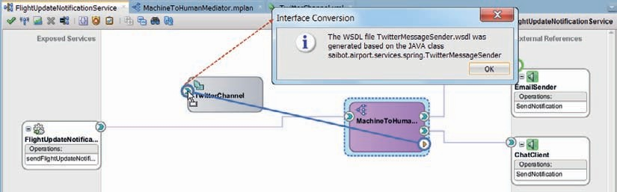

**FIGURE 10-5.** *Creating a wire from the Mediator to the Spring component causes a WSDL to be*

*generated for the Java Interface exposed by the Spring component*

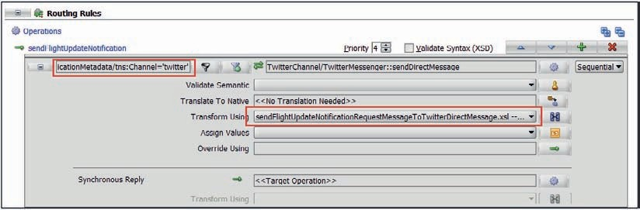

**FIGURE 10-6.** *Configuring the routing rule that filters on the twitter channel*

This completes this next iteration for the composite application.

#### Try Out the Twitter Message Master

Deploy the SOA composite to the Integrated WLS. Make a few calls to the *FlightUpdateNotificationService* with the *channel* set to *twitter* and a *ToAddress* that specifies a valid Twitter account (yours or one of a friend or even @SaibotAirport).

The messages should be sent when the SOA composite instance executes, as shown in Figure 10-7.

###### NOTE

*In this case, the custom Java code that is invoked could also have been implemented in an EJB or even a plain Java Servlet that is invoked through a Reference binding, or alternatively in a custom JCA Adapter or as a custom channel implementation in the UMS Adapter. All those solutions would have been more cumbersome in terms of implementation and deployment—but have advantages because of reuse potential. The largest benefit of using the Spring component in SOA composites compared to these alternatives is achieved when the Java code in the Spring beans makes use of services that are injected into the Spring component through references to other components, allowing the Java code to directly call out to BPEL components and JCA adapters. We will see this happening in the next section.*

**Logging Configuration and Monitoring**

In the Java code for the *TwitterClient* we made use of the *loggerBean* to send logging details to. These details are fed into the logging infrastructure of the SOA Suite run time that is integrated with the WebLogic Server logging mechanism.

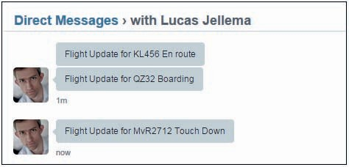

**FIGURE 10-7.** *Some direct messages sent from the SOA composite and received over Twitter*

To configure the logging level for the *LoggerBean*, open the Enterprise Manager FMW Control.

Right click on the node SOA | soa-infra under Target Navigation and activate menu item Logs | Log Configuration, as shown in Figure 10-8.

The Log Configuration page that appears is used to configure the settings for logging by various components of the run time platform. Enter the term *LoggerBean* in the search field and press the search button. The search action should return the [oracle.integration.platform.blocks. java.beans.impl]LoggerBean class. For this class, you can specify the desired Logging Level— meaning the minimum level for which log messages will be written to the specified log handler. On the Log Files tab, the configuration of the log handlers can be changed as well as the mapping between loggers (classes that produce logging) and log handlers.

When this configuration has been applied and the composite is invoked once more to send a FlightStatus update in the form of a Twitter message, we can find the associated log entry in the log file (obviously) as well as through the console on the Log Messages page (Figure 10-9): right click on the node SOA | soa-infra under Target Navigation and activate menu item

Logs | Log Messages.

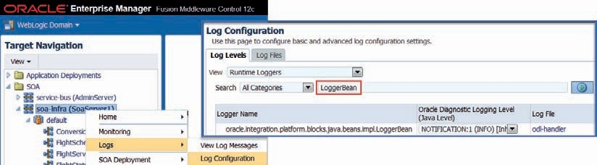

**FIGURE 10-8.** *Configure the log settings for the LoggerBean*

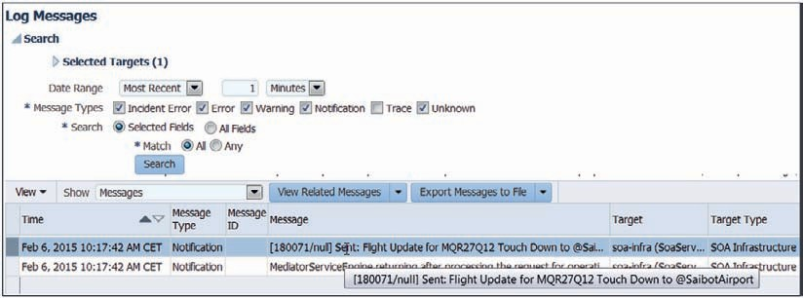

**FIGURE 10-9.** *Log Messages overview including the log entry through the LoggerBean from the*

*TwitterClient class*

### Create Spoken Flight Status Announcement and Put in Dropbox

In this section, we will wire together a number of Spring components and inject services into them. Together these components will implement the following functionality:

* + Turn the FlightUpdateNotification message into the verbal text for an announcement.
  + Turn the announcement into an MP3 stream using the *Google Text To Speech* API.
  + Put the MP3 file for the announcement in the Airport’s Public Dropbox folder (and return a direct link to it).

Using this combined functionality, we can extend the *FlightUpdateNotificationService* with a new channel that publishes a public tweet regarding the flight status change with a link to the audio file.

###### NOTE

*This chapter only includes the salient code snippets because including the full classes would take up too much space. The online resources for this chapter have every line of code. The starting point for this section is the step1 application—the final result is step2.*

###### TIP

*An interesting extension would be to also include translation of the flight update announcement into different languages. Using the Google Translate service (paid for) or Microsoft’s Bing Translator (free), it is fairly simple to include such functionality.*

**Convert Text to Speech**

There are various ways to turn text to speech from Java. Open source projects such as MaryTTS support local installation of a text to speech convertor. Alternatively, on line services like NeoSpeech, iSpeech and Cereproc provide text to speech conversion through HTTP calls. That also applies to the Google TTS API, which we will use in this section. This API is free. It allows a maximum of 100 characters per call. It supports multiple languages, through a simple HTTP GET API.

##### Create the Java Components

First, let’s create the Java interface for the Text to Speech converter:

 public interface TextToSpeechConverter {

public byte[] convertTextToSpeech(String text, String language);

public String convertTextToSpeechAndHandle(String text, String language, String title);

}

The second method is akin to an implementation of the claim check pattern: the text string passed in is turned to MP3 data. This data is then taken care of by the content handler that has been configured (see next); this content handler returns a string—the claim—that is a reference to the MP3 document. The content handler is defined through this Java Interface:

 public interface ContentHandler {

public String handleContent(byte[] content, String title);

The Java Class GoogleTextToSpeechConverter is created to implement the *TextToSpeechConverter*. It is based on a blog article by Jeff Chien [(http://bit.ly/1sW95Iv).](http://bit.ly/1sW95Iv))

 public class GoogleTextToSpeechConverter implements TextToSpeechConverter { private ContentHandler contentHandler;

public void setContentHandler(ContentHandler contentHandler) { this.contentHandler = contentHandler;

}

@Override

public byte[] convertTextToSpeech(String text, String language) { try {

return makeAudio(language, text.replaceAll(" ", "+"));

} catch (IOException e) { e.printStackTrace();

}

return null;

}

private byte[] makeAudio(String language, String text) throws IOException

{

byte[] mp3Buffer = null;

try {

byte[] buffer = new byte[1 << 8];

Path file = Paths.get(System.getProperty("user.home"), "temp.mp3"); SeekableByteChannel sbc =null;

sbc =

Files.newByteChannel(file,

EnumSet.of(StandardOpenOption.

CREATE,StandardOpenOption.TRUNCATE_EXISTING,

StandardOpenOption.WRITE));

InputStream in = null; URLConnection connection =

new [URL("http://www.translate.google.com/translate_tts?tl="](http://www.translate.google.com/translate_tts?tl) + language + "&q=" + text).openConnection();

//simulate a browser because Google doesn't let you get the mp3 without being able to identify it first

connection.setRequestProperty("User-Agent",

"Mozilla/4.0 (compatible; MSIE 6.0; Windows NT 5.1; .NET CLR 1.0.3705; .NET CLR 1.1.4322; .NET CLR

1.2.30703)");

connection.connect();

in = connection.getInputStream(); int count;

ByteBuffer bb;

while ((count = in.read(buffer)) != -1) { bb = ByteBuffer.wrap(buffer); sbc.write(bb);

bb.clear();

}

in.close();

in.close();

SeekableByteChannel byteChannel = Files.newByteChannel(file); ByteBuffer bb = ByteBuffer.allocate((int) byteChannel.size()); byteChannel.read(bb);

mp3Buffer = bb.array();

} catch (FileNotFoundException e) { e.printStackTrace();

} catch (IOException e) { e.printStackTrace();

}

return mp3Buffer;

}

@Override

public String convertTextToSpeechAndHandle(String text, String language, String title) {

byte[] buffer = convertTextToSpeech(text, language);

String result="NONE";

if (contentHandler!=null) {

result = contentHandler.handleContent(buffer, title);

}

return result;

}

}

This code is the simplified version of the code included in the online resources.

##### Configure the TextToSpeechConverter Spring Context Component

Create a new Spring content component in the SOA Composite, called *TextToSpeechConverter*. Configure the following definition:

 <bean class="saibot.airport.services.spring.GoogleTextToSpeechConverter" id="googleTextToSpeechConverterBean">

<property name="contentHandler">

<ref bean="ContentHandler"/>

</property>

</bean>

<sca:service name="TextToSpeechConverter" target="googleTextToSpeechConver terBean"

type="saibot.airport.services.spring.TextToSpeechConverter"/>

<sca:reference name="ContentHandler" type="saibot.airport.services.spring.

ContentHandler"/>

This specification declares the *TextToSpeechConverter* component to expose one service— *TextToSpeechConverter*—based on the Java Interface with that same name, provided by bean *GoogleTextToSpeechConverterBean* implemented by the Class *GoogleTextToSpeechConverter*. This class has a method *setContentHandler*. When the bean is instantiated, this property is set using the reference injected by the SCA engine based on the reference *ContentHandler* exposed by this Spring component. That means that in order to successfully use this Spring component, we have to make sure to wire a component to the *ContentHandler* reference, a component that implements the *ContentHandler* interface.

#### Publish File to Dropbox

Dropbox provides a cloud-based document service for storing and sharing documents. This service can be accessed from various devices, using apps and agents and a browser interface. Additionally, the Dropbox service can be accessed programmatically through a REST API and a number of SDKs. One of these is a Java SDK. Using this SDK, accessing the Dropbox service for operations such as upload and download file is very simple.

##### Getting Ready to Access Dropbox

Just as with Twitter, you need to register the application that will use the Dropbox API. Then each user whose Dropbox account is to be accessed from that application will have to explicitly authorize the application. The results from these steps are an application key and secret, and for each user an access token. The steps are described here: [https://www.dropbox.com/dev](http://www.dropbox.com/developers/)elopers/ core/start/java.

Next, go to [https://www.dropbox.com/developers/core/sdks/ja](http://www.dropbox.com/developers/core/sdks/java)va to download the Java SDK for Dropbox. Add the Dropbox-core-sdk-x.y.z.jar and the Jackson-core-x.y.z.jar to the SCA-INF/lib

folder of the project. Also add both jar files to the project in the Project Properties | Libraries and Classpath page.

To work around a class issue with HttpsURLConnection on WebLogic—note that this does not happen when you run the Dropbox client locally in JDeveloper—you have to make a configuration change in the setDomainEnv.sh or setDomainEnv.bat file in the $DOMAIN_HOME/ bin directory. Add the following system property to the JAVA_OPTIONS (to force WebLogic to use standard Sun’s implementation of SSL):

JAVA_OPTIONS="${JAVA_OPTIONS} -DUseSunHttpHandler=true"

This property only takes effect after a restart of the server.

##### Creating the Dropbox Java Client

The Java Interface our Dropbox Java Client will implement is a simple one:

 public interface DropboxAdapter {

/**

* @param fileContents the bytes that for the contents of the file
* @param fileName the name of the file that should be created on Dropbox
* @param path the target folder on Dropbox into which the file should be created (for example /Public)
* @return the public, shareable URL where the file can be accessed on Dropbox

*/

public String writeFileToDropbox( byte[] fileContents, String fileName, String path);

}

The Java class that will do the actual file uploading through the Dropbox Java SDK is implemented as follows:

 public class DropboxClient implements DropboxAdapter, ContentHandler {

private final String accessToken = "YourToken"; final String APP_KEY = "YourAppKey";

final String APP_SECRET = "YourAppSecret";

private DbxRequestConfig config ; public DropboxClient() {

DbxAppInfo appInfo = new DbxAppInfo(APP_KEY, APP_SECRET); config = new DbxRequestConfig(

"SaibotAirport0", Locale.getDefault().toString());

}

@Override

public String writeFileToDropbox(byte[] fileContents, String fileName, String path) {

DbxClient client = new DbxClient(config, accessToken); String shareableURL="";

nts);

ByteArrayInputStream contentStream = new ByteArrayInputStream(fileConte

try {

DbxEntry.File uploadedFile = client.uploadFile(path +"/"+fileName, DbxWriteMode.add(), fileContents.length, contentStream);

shareableURL = client.createShareableUrl(uploadedFile.path); DbxUrlWithExpiration tempurl = client.createTemporaryDirectUrl(uplo

adedFile.path);

shareableURL = tempurl.url;

} catch (DbxException e) { //TODO: implement

} catch (IOException e) { //TODO: implement

} finally {

try {

contentStream.close();

} catch (IOException e) { //TODO: implement

}

}

return shareableURL;

}

@Override

public String handleContent(byte[] content, String title) { String url = writeFileToDropbox(content, title, "/Public"); return url;

}

}

Note that this class not only implements the *DropboxAdapter* interface, but also the *ContentHandler* interface that was specified in the previous section and that will be used to have this class process the results from the *TextToSpeechConverter*.

##### Configure the Dropbox Adapter Spring Component

Create a new Spring Component, called *DropboxAdapter*. Configure the following specification:

 <bean class="saibot.airport.services.spring.DropboxClient" id="dropboxAdapterBean" >

</bean>

<sca:service name="DropboxAdapter" target="dropboxAdapterBean" type="saibot. airport.services.spring.DropboxAdapter" />

The component exposes a single service, based on Java Interface *DropboxAdapter* and implemented through the *DropboxClient* Class that is used to define the *dropboxAdapterBean*. Components inside the SOA composite can be wired to this *DropboxAdapterService*. They can pass the contents of files to have them uploaded to a Dropbox folder in the preconfigured account. Before too long, we still create our first wire to this component.

#### Compose Flight Announcement

The composition of the actual announcement that should be voiced will take a place in a Java class that is embedded in a Spring component that will be invoked from the

*MachineToHumanMediator*. The class receives a *Flight* object with the details about the latest flight status (this is a Java Bean with a number of properties, included in the on line sources). It uses a helper class to convert a number of values—status, airline—to proper read-out-loud values. This helper class in turn has several dependencies that are satisfied in part by local beans and in part through external references. To the helper class, it makes no difference whether another Spring bean is the provider of a dependency or whether that is a Mediator component (or some other SCA component) wired to the external reference.

##### The Custom Java Classes for Composing the Flight Announcement

The external interface that is to be exposed for the Announcement Component is:

public interface Announcer {

public String composeFlightStatusAnnouncement( Flight flight);

}

The Java class that implements this interface is fairly simple. In part because it does not create very refined announcements and in part because it engages a helper class—*FlightDetailProvider*— to do some of the heavy lifting:

 public class FlightAnnouncementComposer implements Announcer { private FlightDetailProvider flightDetailProvider;

public void setFlightDetailProvider(FlightDetailProvider flightDetailProvider) {

this.flightDetailProvider = flightDetailProvider;

}

@Override

public String composeFlightStatusAnnouncement(Flight flight) {

String airline = flightDetailProvider.getCarrierAnnouncementName(flig ht.getCarrier());

String action = flightDetailProvider.getActionAnnouncementTerm(flight. getAction());

return "Announcement about flight "+flight.getCarrier()+" "+getSeparateNumbers(flight.getFlightNumber())+" operated by "+airline+ " This flight is "+action;

}

private String getSeparateNumbers(String flightNumber) { String spelledOutFlightNumber ="";

for (int i=0;i< flightNumber.length(); i++) { spelledOutFlightNumber = spelledOutFlightNumber+ flightNumber.

substring(i,i+1) + " " ;

}

return spelledOutFlightNumber;

}

The FlightDetailProvider class is defined as follows:

 public class FlightDetailProvider { private ValueMapper airlineMapper;

private ValueMapper flightActionMapper;

public void setAirlineMapper(ValueMapper airlineMapper) { this.airlineMapper = airlineMapper;

}

public void setFlightActionMapper(ValueMapper flightActionMapper) { this.flightActionMapper = flightActionMapper;

}

public String getCarrierAnnouncementName( String carrier) { return airlineMapper.mapValue("carrier", carrier);

}

public String getActionAnnouncementTerm( String action) { return flightActionMapper.mapValue("flightAction", action);

}

}

The interface ValueMapper:

 public interface ValueMapper {

public String mapValue(String domain, String sourceValue);

}

And one implementation of the ValueMapper interface is the class:

 public class FlightActionMapper implements ValueMapper { @Override

public String mapValue(String domain, String sourceValue) { String mappedValue = "";

switch (sourceValue) { case "FinalApproach":

mappedValue = " almost at our airport. It is in its final approach and ready for touch down shortly. ";

break;

case "GateOpen":

mappedValue = " open for boarding at the gate. "; break;

case "GateClosing":

mappedValue = " currently closing its door. Final passengers have to come to the gate immediately. ";

break;

...

case "AtGate":

mappedValue = " safely arrived at the gate where off loading will commence shortly. ";

break; default:

mappedValue = sourceValue;

}

return mappedValue;

}

}

##### Spring Component FlightAnnouncementComposer

Create a new Spring component in the SOA composite, called *FlightAnnouncementComposer*. Configure the following beans, service and reference:

 <bean class="saibot.airport.services.spring.FlightAnnouncementComposer" id="Fl ightAnnouncementComposerBean">

<property name="flightDetailProvider">

<ref bean="FlightDetailProviderBean"/>

</property>

</bean>

<bean class="saibot.airport.services.spring.FlightDetailProvider" id="FlightDetailProviderBean">

<property name="airlineMapper">

<ref bean="CarrierMapper"/>

</property>

<property name="flightActionMapper">

<ref bean="FlightActionMapperBean"/>

</property>

</bean>

<bean class="saibot.airport.services.spring.FlightStatusMapper" id="FlightStatusMapperBean"/>

<sca:service name="FlightAnnouncementComposer" target="FlightAnnouncementC omposerBean"

type="saibot.airport.services.spring.Announcer"/>

<sca:reference name="CarrierMapper" type="saibot.airport.services.spring.

ValueMapper"/>

The *FlightAnnouncementComposerBean* has a single property whose value is provided by the *FlightDetailProviderBean*. This bean has two properties or two dependencies. One is satisfied by local bean *FlightStatusMapperBean* and the other—*airlineMapper*—is promoted to the level of the sca:reference *CarrierMapper*. This means that the Spring component itself does not have the implementation of the *CarrierMapper* and it relies on the SCA engine to provide such an implementation through the reference. In the next section we will have a mediator wired to this reference, to provide the *CarrierMapper* functionality.

##### Create a CarrierMapper

The *CarrierMapper* performs a fairly simple task: based on the IATA carrier code, it provides the proper name for an airline to be used in the flight status announcements. That is a task for which the SOA Suite provides an easy solution: the Domain Value Map or DVM that we have encountered in earlier chapters. A DVM defines one or more domains. A domain consists in its simplest form of source values for which a translated or mapped value is provided.

Create a new Domain Value Map Airlines.dvm in the folder DVM. Configure the DVM to have columns *IATACode* and *FullName*. Provide some entries for airlines that you will use later on in

your flight status updates. Note that through SOA Composer, the contents of DVMs can be edited at run time.

Create a new mediator called *CarrierMapper* and specify that the interface will be created later on. When this mediator is later on wired from the *CarrierMapper* reference in the *FlightAnnouncementComposer* component, it will get its interface defined. At that moment, a routing rule will be defined that is next configured to leverage the DVM.

#### Extend TwitterChannel to Publish Updates

The Java class *TwitterClient* has to be extended to also publish status updates, that is, tweet messages. And, in order to make this new functionality available to other components in the SOA composite, we have to extend an existing or define a new Java Interface that is specified in the Spring component’s definition file.

We choose to create a new Java Interface:

 public interface TwitterStatusUpdater { void updateStatus(String message);

}

The class TwitterClient is modified to also implement this interface: public class TwitterClient implements TwitterMessageSender**, TwitterStatusUpdater** {

@Override

public void updateStatus(String message) { Twitter sender = constructTwitterInstance(); try {

sender.updateStatus(message);

} catch (TwitterException e) { e.printStackTrace();

if (logger!=null) {

logger.log(Level.WARNING, "Failed to update Twitter Status",e);

}

}

}

Then the Spring component definition file TwitterChannel.xml is updated with this new definition:

 <sca:service name="Tweeter" target="twitterMessageMaster" type="saibot. airport.services.spring.TwitterStatusUpdater" />

This defines the Spring component to publish a second service, described by the *TwitterStatusUpdater* interface and provided by the *twitterMessageMaster* bean (that is based on the *TwitterClient* class).

#### Wiring the Pieces Together

The composite application now looks as is shown in Figure 10-10. The new components *DropboxAdapter*, *TextToSpeechConverter,* and *FlightAnnouncementComposer* stand ready to be engaged. Notice how the latter two do not only expose services to be invoked but also references to be injected.

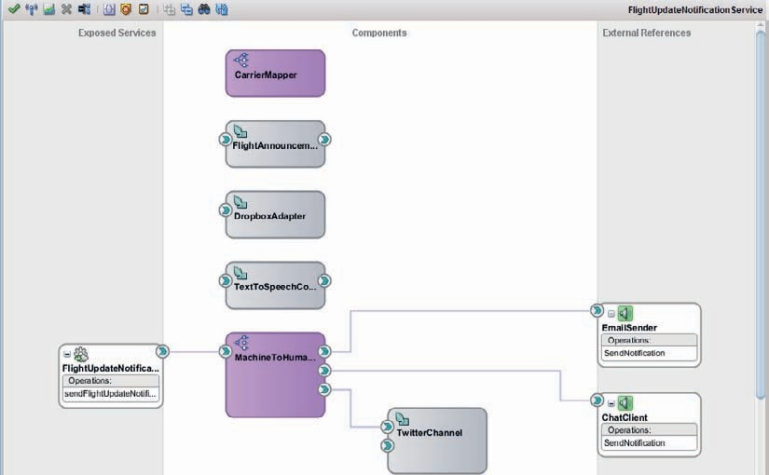

**FIGURE 10-10.** *FlightUpdateNotificationService SOA composite prior to wiring the components*

*together*

##### Create Wires to and from the FlightAnnouncementComposer

Wire *CarrierMapper* to *FlightAnnouncementComposer*, to fulfill the requirement from the latter to have a *ValueMapper* implementation that will take a string value (with in this case the IATA code for a carrier) and turn it into the name of the airline as it should be used in spoken announcements. When this wire is created, JDeveloper will generate the ValueMapper.wsdl file that describes in web services terminology what the Java Interface *ValueMapper* entails. The WSDL file contains the XSD definition of the input to and output from the *mapValue* method that *CarrierMapper* mediator is promising to implement.

Open the editor for mediator *CarrierMapper*. Add a routing rule of type *Echo Reply*. Click on the icon for Assign Values. Drag an expression to the mapValueResponse/return element in the output, as shown in Figure 10-11. Double click on the expression icon to bring up the editor. Set the expression to:

 dvm:lookupValue('DVM/Airlines.dvm','IATACode', $in.parameters/tns:mapValue/ arg1,'FullName', $in.parameters/tns:mapValue/arg1)

Here we specify how the return value is derived using the Domain Value Map Airlines.dvm with the source value—the IATA code for an airline—and locating the corresponding FullName in the DVM. If the airline cannot be found in the DVM, we will stick to the input code as the next best thing for the return value.

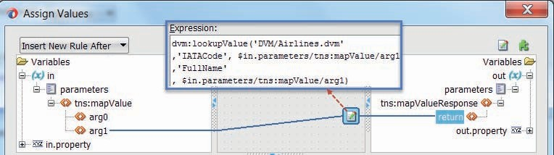

**FIGURE 10-11.** *Specify how the response from mediator CarrierMapper is derived from the*

*input and the DVM*

Wire Spring component *FlightAnnouncementComposer* to mediator *MachineToHumanMediator*.

This creates a new routing rule in the latter. Set the filter condition on this routing rule to

 $in.in/tns:sendFlightUpdateNotificationRequestMessage/ tns:CommunicationMetadata/tns:Channel='audio'

##### TextToSpeechConverter

The *TextToSpeechConverter* exposes a reference that should implement the *ContentHandler* interface. The *contenthandler* that is injected will be invoked after the MP3 has been generated, to take good care of the audio stream. The handler will return a string that can be seen as a claim to the audio content that it has been stored somewhere. In our scenario, this will be a URL to the MP3 file as it has been uploaded to the Public folder in the *Saibot Airport Dropbox* account.

Instead of wiring the *DropboxAdapter* directly to the *TextToSpeechConverter*, we will use a mediator in between. One reason is that the interface exposed by the *DropboxAdapter* may well not be a precise match to the interface required by the reference on the *TextToSpeechConverter*. Another reason is that in a mediator we can add additional routing rules to also route the MP3 content to other handlers.

Create mediator *MP3Router* and indicate that the *Interface will be created later*. Create a wire from the reference on *TextToSpeechConverter* to this *MP3Router* component. At this point, the interface ContentHandler.wsdl will be generated. As far as the *TextToSpeechConverter* is concerned, its dependency has been satisfied now. The buck has passed to the *MP3Router*, to handle the audio content.

The *DropboxAdapter* is of course the component we have in mind to receive the MP3 data and store them in the Public folder. Wire the reference on the *MP3Router* to the service on the *DropboxAdapter*—as is shown in Figure 10-12. JDeveloper will generate the DropboxAdapter. wsdl document to describe what the *DropboxAdapter* has to offer.

We need to configure the routing rule in the *MP3Router* mediator to make the output from the *TextToSpeechConverter* fit the input of the *DropboxAdapter*. Open the mediator editor for *MP3Router*. Open the Assign Values dialog for the routing rule, see Figure 10-13. Wire the arg0 element in the input (as described by the ContentHandler interface) to the arg0 (file contents) element in the out

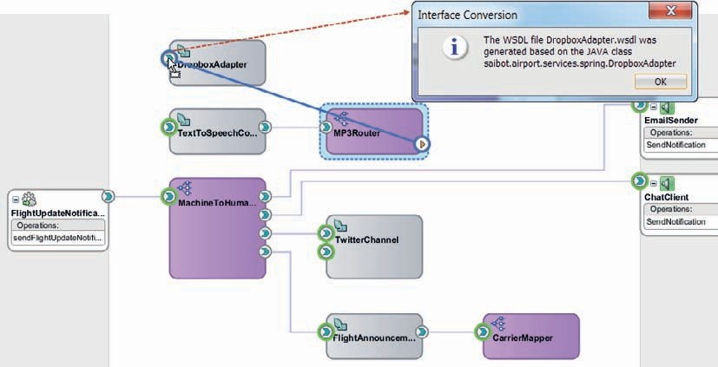

**FIGURE 10-12.** *Creating the wire between MP3Router and DropboxAdapter*

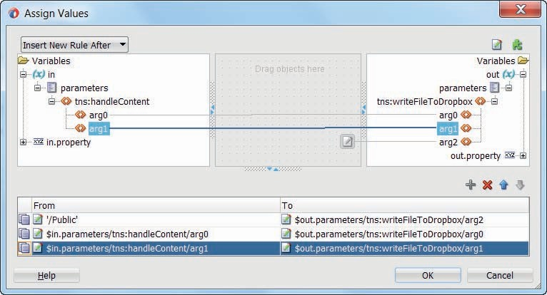

**FIGURE 10-13.** *Setting the values to be passed to the Dropbox adapter*

variable (which is the input to the *DropboxAdapter*). Do the same for the arg1 element and the arg1 (filename) element. Assign the expression “/Public” to the arg2 (path) element in the out variable.

The *writeFileToDropbox* operation is a two way synchronous operation. Its reply is to be forwarded to the *TwitterChannel* component, to be turned into a Tweet on the *SaibotAirport* twitter stream. We will configure the routing rule accordingly, as shown in Figure 10-14. First, create a wire from the MP3 mediator to the *TwitterChannel* component.

Back in the mediator editor, click on the *Browse for Target Services* icon for the Synchronous Reply section of the routing rule. In the popup titled Target Type select *Existing Service*. Click on OK. In the Target Service browser that appears next, select operation *updateStatus* under Springs | TwitterChannel | Services | Tweeter.

When you click OK, a wire is created between the *MP3Router* and the *TwitterChannel* components. This visualizes the routing of the reply the *MP3Router* receives after the *DropboxAdapter* has put the MP3 file on the Public folder.

Open the Assign Values dialog for this synchronous reply. Assign the following expression to the updateStatus/arg0 child element in the out variable:

 concat('Saibot Airport Flight Announcement was published at ',$in.parameters/ tns:writeFileToDropboxResponse/return)

This defines the contents of the Tweet that will be published after the MP3 file with the flight status announcement has been published.

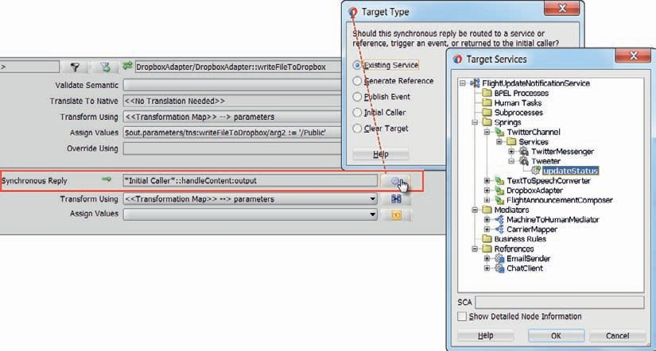

**FIGURE 10-14.** *Configuring the routing rule for forwarding the reply from the DropboxAdapter*

*to the Tweeter component’s updateStatus operation*

##### Route the Announcement to the TextSpeechConverter

We have strung together the *TextToSpeechConverter*, *MP3Router*, *DropboxAdapter,* and *TwitterChannel* components. However, this string does not yet have a happy beginning. For that to happen, we have to configure the routing rule for the *audio* channel in the *MachineToHumanMediator*. First, create a wire from the mediator to the *TextToSpeechConverter* component. Then open the editor for the mediator. Configure the target service for the synchronous reply on the “audio” routing rule to be the *TextToSpeechConverter*—the operation *convertTextToSpeechAndHandle* to be exact.

Use the Assign Values dialog to set the input values for the *TextToSpeechConverter*. The text element is to be derived from the **composeFlightStatusAnnouncementResponse/return** element returned from the *FlightAnnouncementComposer* component. Set the language and title to “en” and “FlightAnnouncement.mp3,” respectively.

###### TIP

*In the Assign Values dialog, we cannot use data from the original request message to set values in the message based on the forwarded reply. However, when we use a transformation, we can use the original request as a source next to the response message that is being forwarded. That would allow us, for example, to define a filename that contains the flight number of the flight that the announcement is about.*

##### File Adapter to Locally Write the MP3 File

In addition to the MP3 file that is put on the Dropbox, it may be convenient to also create that MP3 file locally. Using the File Adapter, it is of course very straightforward to create such a local file.

Drag a File Adapter to the External Reference swim lane in the composite editor, as shown in Figure 10-15. Set the name to *MP3Writer*. Accept the default JNDI name. Select the *Write* operation. On the File Configuration page in the File Adapter wizard, select *Logical Name* for the Directory and set the logical name as MP3_ANNOUNCEMENTS_FOLDER. Set the File Naming convention to FlightAnnouncement.mp3—or any arbitrary value, because we will dynamically set the file name. Set the number of messages per file to 1.

On the Messages, check the checkbox for *Native format transformation is not required* (Schema is Opaque). The contents of the file is binary—and no attempt should be made by the File Adapter to transform that binary data in any way. Click Next and click Finish to complete the File Adapter configuration.

Next, create a wire from mediator *MP3Router* to this File Adapter. This adds a second routing rule to the mediator, to carry the MP3 data received from the *TextToSpeechConverter* to a second target. Open the mediator editor to configure the data mapping for this routing rule. Click on the Assign Values icon for the routing rule. Wire element handleContent/arg0 in the *in* variable to the *opaqueElement* in the out variable. Assign the value from element handleContent/arg1 to the header property $out.property.jca.file.FileName.

In the composite editor, [single] click on the MP3Writer (Figure 10-16). Ensure the properties palette is displayed. Open the tab Composite Properties. This tab presents the property MP3_ ANNOUNCEMENTS_FOLDER—the logical name of the directory into which the file adapter should deposit the files it writes. Set an appropriate value for your local environment for this property. The value you define is saved in the composite.xml file.

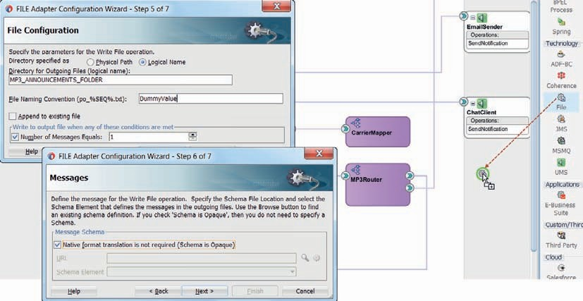

**FIGURE 10-15.** *Add an outbound File Adapter binding to write raw binary input to a file*

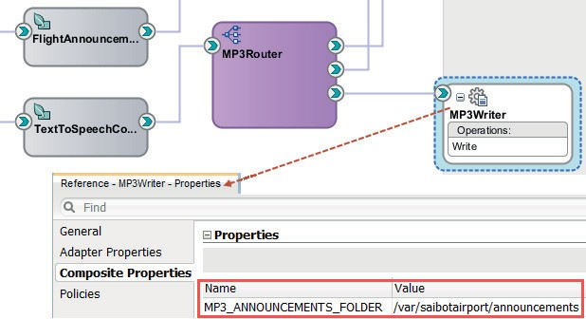

**FIGURE 10-16.** *Set a value for the property MP3_ANNOUNCEMENTS_FOLDER*

###### TIP

*After deployment, the value of this and other properties can be modified in the Enterprise Manager FMW Control, on the Properties tab for the specific component under the*

FlightUpdateUpdateNotificationService *composite—as discussed in detail in Chapter 23.*

#### The Complete End-to-End Audio Channel

With the steps described in the previous sections, we now have an SOA composite that implements an audio channel to announce flight status updates in the form of audio that can be fed to the Airport’s PA system. Figure 10-17 shows the composite and highlights the flow for the audio channel through the composite.

It starts with the routing rule for the *audio* channel in the *MachineToHumanMediator*. This rule routes the flight status message to the *FlightAnnouncementComposer* (1). This Spring component makes use of the *CarrierMapper* mediator with DVM inside to derive the full name of the airline (2). The announcement is passed back to the *MachineToHumanMediator* that forwards it to the *TextToSpeechConvertor* (3). This Spring component generates the MP3 file and passes it to the injected *MP3Router* component (4). This mediator calls the *DropboxAdapter* to create a file in the Public Dropbox folder and return the URL for that file (5). The *MP3Router* forwards this reply from the *DropboxAdapter* to the *TwitterChannel* component (6), to publish a Tweet on the SaibotAirport twitter stream.

The *MP3Router* also calls the file adapter *MP3Writer* (7) with the content received from the

*TextToSpeechConverter*, to write the MP3 file on a local environment. By configuring the routing

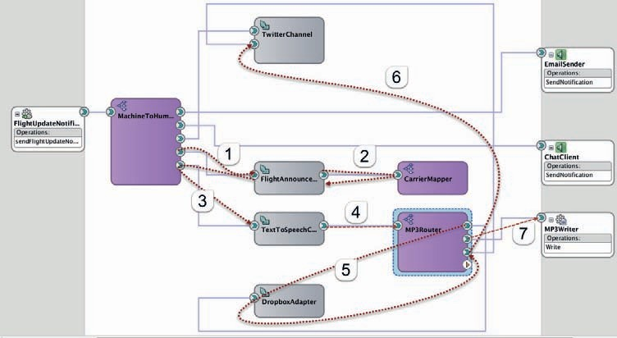

**FIGURE 10-17.** *The FlightUpdateNotificationService composite with the entire flow for the*

*audio channel*

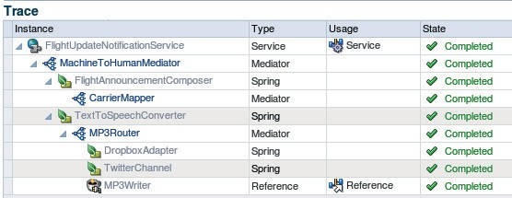

**FIGURE 10-18.** *The message flow trace for the audio channel route through*

*FlightUpdateNotificationService*

rule filters on the *MP3Router*, we can disable or enable one or both routes for the MP3 file, for example, to try to the generation of the MP3 files before publishing these files to the world.

Deploy the SOA composite. Invoke the service exposed by the composite with some made-up combination of flight data. The results of your call should be manifold:

* An MP3 file put on the Public folder in Dropbox
* A Tweet published with a URL referring to the file in the Dropbox
* A local MP3 file with the same contents as the one on the Dropbox

and of course an SOA composite instance with a full message flow trace to be inspected in the EM FWM Control (Figure 10-18), with access to every step along the way such as the text of the announcement and the raw, base64 MP3 data.

**Other Java Hooks and Crannies**

The SOA Suite is a Java EE application itself that offers developers many opportunities to complement the standard functionality with customized behavior implemented using Java. Call outs to embedded Java—in Service Bus pipelines and using Embedded Java activities in BPEL—as well as to external Java code—EJB, JMS—are but simple examples. The Spring component is a great way to embed Java in an encapsulated way that provides good integration in SOA composites, both through exposed service and references.

Several other options for Java based customizations are available in the SOA Suite. The most important ones are listed here:

* *Custom XPath function:* SOA Suite allows the creation of custom XPath functions through the implementation and registration of a simple Java Class. Such XPath

functions—and therefore the underlying Java code—can be invoked from Service Bus projects and SOA composites, in XSL-Maps and XQuery transformations as well as in assignments in Service Bus Pipelines, Mediators, and BPEL processes.

* + *Mediator Callout:* Associated with an Operation in a Mediator can be Java Callout class that has to implement the IJavaCallout interface or for convenience can

extend from class AbstractJavaCalloutImpl. In the callout, the headers, payload and properties can be inspected, validated, and manipulated both before the routing takes place and after the response from the target service comes in.

* + *File Adapter Valve:* A File Adapter binding—both inbound and outbound—can be configured with one or more Valves: custom Java classes that implement

the interface Valve or StagedValve or—to make life easier—simply extend from AbstractValve. These classes perform pre-processing of the file content (on the inbound side) before it enters the file adapter proper or post processing (outbound) on the content that has left the file adapter before it is written to the file system.

Valves can be used for file processing operations like decrypt/encrypt, decompress/ compress and transformation.

* + *Custom OWSM Policy* (attached at the very edge of service implementations): In Chapter 24, we will discuss security and the role of OWSM (Oracle Web

Service Manager) policies in the protection of inbound or outbound services and references, for both Service Bus services and SOA composites. In addition to all out of the box policies, we can add custom policies and use custom Java Classes for the implementation of such policies. These policies live and execute on the very edge of the service—either before the service is even entered (inbound) or at the very

last moment before the request message is sent to an external service (outbound). Policies can be used to inspect the contents of messages and also to manipulate the said contents. When all else fails, extreme pre- and post-processing of messages can therefore be implemented using custom policies.

* + *Custom JCA Adapter:* The JCA adapter framework is a generic Java EE facility in WebLogic that Oracle itself has made use of to create and integrate the various

JCA adapters we have met—JMS, UMS, Database, AQ, File, and FTP. We can also create our own JCA adapter—using custom Java classes and adhering to the rules of the JCA framework. For example, an outbound adapter that publishes files to Dropbox, as an alternative to the out of the box File and FTP adapters would be valid to create. Or an inbound adapter that polls a particular RSS feed or Twitter stream and triggers new composite instances when an entry is found that satisfies certain conditions.

### Summary

The SOA Suite ships with a large collection of out of the box features and functions, catering for many situations, requirements, and interactions. However, there will still be the occasional challenge where the shipped components do not do the job at hand. For those situations, the SOA Suite offers developers many options to complement, customize, and extend the default platform through the use of custom Java logic. Embedded Java, Java Callouts, Custom Java based Security policies, Custom JCA Adapters, Custom XPath functions are some examples of such extension points.

The Spring component is another way of introducing custom Java classes into SOA composite application. Such Java classes can perform virtually any specific custom function imaginable, using third party libraries if needed, configured according to the Spring framework. Selected operations from the Spring content can be exposed as [SCA] services that can be invoked by other components in the composite application. Some dependencies can similarly be exposed as [SCA] references, which can be satisfied through wires to other components in the composite application. Through these references, it becomes easy to inject a mediator, BPEL component, or any JCA adapter into a custom Java class, where it will be accessed through a standard Java interface, in the same way as any other Spring bean. The Spring context component is capable of working with Groovy and AspectJ classes just as well as regular Spring beans.

Using custom Java classes should not be your first option. Using out of the box functionality is the preferred alternative—when available. Such functionality is better integrated, has been tested, probably performs better, and will be easier to upgrade. However, when the standard platform capabilities do not suffice, the use of the Spring context and the other Java extension options almost always ensure a way forward.



CHAPTER

# 11

## Business Rules to Capture

Business Logic to Automate Decisions

OA composite applications contain various forms of logic. These have some overlap, but they also have their own specific actors, implementation technologies, and maintenance cycles. There is, of course, implementation logic written by programmers in programming

**S**

languages such as BPEL, XPath and XSLT, Java, and even PL/SQL. There is also process logic, designed perhaps using the Business Process Analysis Suite, modeled in BPMN or BPEL by business analysts.

Another type of logic is business logic—describing and implementing derivations, validations, calculations, and other business rules. Frequently this last type of logic is described by the analysts—in free format text—and then implemented by developers as part of the programs they write. It is fairly common to find the implementation of business logic done in several places in the application using hard-coded values and references. The business logic cannot easily be told apart from the implementation logic of the computer program, cannot be modified without the help of the programmers, and cannot be deployed without redeploying the entire application. This is a problem since business logic—especially business rules tend to change in a faster pace than other logic.

This chapter introduces the Decision Service component in SOA Suite, also known as the Business Rule service component. We will use the name Business Rule from now on. This type of component implements business logic and exposes it as an SCA component that can easily be integrated into other components such as BPEL processes, Human Workflows, and Mediators. This business logic can also be invoked through a Java API. Implementing business logic in a central, encapsulated, reusable component makes it much easier to manage and maintain and actually reuse such logic.

Oracle Business Rules is very good at evaluating the business logic expressed in the special RL (Rule Language) language—with high performance and good scalability, especially compared to alternative implementations of the same logic in, for example, XPath. Business rules created within SOA composite applications usually work with the RL language, which allows definition of rules in a very declarative way that is even accessible to non-programming business analysts. The run-time infrastructure—through the SOA Composer tool—allows editing the business logic after the application has been deployed, contributing to business agility, because the frequency with which this type of logic changes is typically different from—and usually higher than—the frequency in which the other types of logic change. It is a huge boon to be able to modify business rules at run time without redeploying your process.

We will meet the Business Rule component in this chapter and see how business rules can be implemented and integrated in composite applications or exposed as elementary services. In part 5, when we discuss [business] processes, we will discuss the Business Rule component again—to encapsulate the decision logic required to steer the process flow.

### Calculating the Airport Charge for a Flight—Round One

The calculation of the airport charge for a particular flight is not trivial. Various considerations play a part in the airport charge, including regulations, scarce resources, long-term strategy and short-term stimuli and of course the fierce competition in the airport market. The formulas for calculating the charge are fairly complex and are susceptible to frequent change and to business driven exceptions. The documents describing the calculation of the charge are frequently lengthy

and contain many if/then clauses. The IT architects at Saibot Airport were quick to realize that a business rule is a good way of implementing the business logic that calculates the charge. The business rule encapsulates the derivation logic for the charge, makes it easy to reuse and gives the business easy access to the key parameters driving the calculation.

In its bare form, the airport charge is calculated based on the weight of the aircraft, using the following formula: if the weight is under 20,000 kg, then the charge is (currently) set at 94 euros. Else the charge is calculated as 4.70 euro per 1000 kg of weight. In two iterations we will later on introduce considerations around cargo versus passengers, noise category of the aircraft, time of the day and landing versus take off.

#### Prepare SOA Composite Application

Create a new SOA composite application with a SOA project called *AirportCharge*. Create it as initially empty. Add the file AirportChargeCalculation.xsd to the Schemas folder. Then drag a Business Rule component from the component palette to the composite editor. When you drop it, the dialog shown in Figure 11-1 appears. Set the name of the business rule component to *AirportChargeArbiter*. Set the package to saibot.airport.finance.airportcharge. Define an input parameter called *Flight*, based on the *FlightType* in the XSD file. Also define an output parameter called *AirportCharge* based on the *AirportChargeType* in said XSD file. Click OK to complete the creation of the business rule component and its associated rule dictionary.

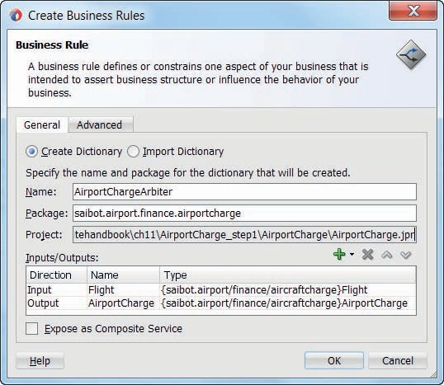

**FIGURE 11-1.** *Initial creation of the AirportChargeArbiter business rule component*

#### Implement Business Rule

Double click on the business rule component in the SOA composite editor to start refining the details for this business rule dictionary, in order to provide the business logic behind this *AirportChargeArbiter* component.

The dictionary consists of a number of elements:

* Facts and their properties—the definitions of the business entities that are evaluated and manipulated by the rules; the input and output defined for the Business Rule

component—based on XSD types—resulted in Fact definition. Additional Facts can be added—based on Java Classes, XSD Types, RL (Rule Language) definitions or ADF BC View Objects.

* Functions—encapsulated logic expressed in RL; a number of predefined functions are available by default
* Globals—constants with a name and a value; these globals can be referenced throughout rule definitions by their logical name that at run time is substituted with their value.

Updating the business logic can be as simple as changing the value of a global

* Value Sets—named lists of allowable values that are associated with properties in facts; a value set association can be used for validation of input facts (at run time) and can be

used at design time for quick rule editing and for conflict analysis on decision tables

* Decision Functions—special functions that define the external interface of the Business Rule dictionary in terms of rule sets, input and output facts and initializations
* Rules Sets with General (if/then) Rules and Decision Tables—the actual decision logic captured in rules that are triggered by Decision Functions
* Test Models—containers of Test Suites with Test Cases to try and test the logic in Decision Functions; these describe both the test input as well as the expected outcome

##### Define Globals

Globals in Business Rules are defined across all functions and rules in the dictionary created for a single [SCA] Business Rule component. These values are defined in a single location and can be reused in many locations—across rule sets, if-then rules and decision tables. The most common refinement of a business rule is a simple readjustment of the value of a global that is used as a parameter in the rule, such as the cut off rate, the discount percentage or upper limit.

In the calculation of the base airport rate, we work with three globals—that can easily be modified when business so dictates:

* WeightLimit—the weight limit in kg that forms the boundary between the flat fee and the variable, weight based feed; initial value is 20,000.
* PerThousandKilogramRate—the rate in euros that is charged for every 1000 kg MTOW (maximum aircraft weight) for aircrafts heavier than the WeightLimit; initial value is 4.70.
* BaseRateForUnderLimitWeight—the flat fee in euros charged for aircrafts with less weight than the WeightLimit; initial value is 94.00.

Define these *globals* in the Business Rule dictionary as shown in Figure 11-2.

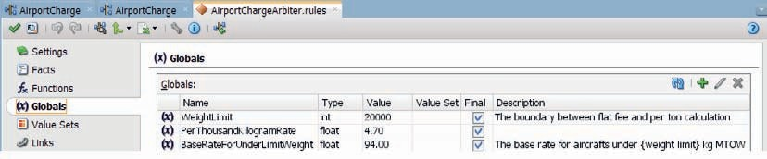

**FIGURE 11-2.** *Defining global business parameters that are to be referenced in business rules*

##### Facts Generated from Schema

Click on the Facts tab. This tab contains all fact types that we can base variables on in the business rule dictionary. These fact types can be defined in four categories: based on XML Types, on Java Classes, on ADF BC ViewObjects and defined as native Business Rule Fact. When facts are used in the decision function that is exposed as web service, they should be XML facts. For internal functions, other fact types can be used as well.

When we initially created the business rule with input and output based on the elements in the schema definition AirportChargeCalculation.xsd, facts were immediately generated based on the underlying XSD types *AirportChargeType* and *FlightType*, as shown in Figure 11-3. You may change the name of the aliases for the facts and their properties—to bring them more in line with the business terminology that you want to use in the business rule definitions. However, if the XSD definition was created in business friendly terms there is little need for making changes here.

If you click on the edit icon, you can inspect and change the details for the fact types and their attributes.

##### IF/Then Rule Set to Calculate the Base Rate

We will work initially with two rule sets: one to calculate the base rate, based on the weight of the aircraft and the second to calculate the total charge. At this moment, the total charge is equal to the base rate. In the next section, we will make the calculation a little more realistic by introducing several surcharges.

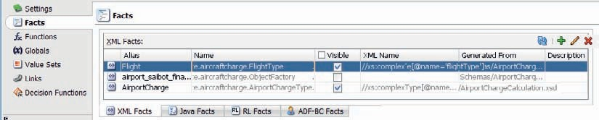

**FIGURE 11-3.** *The XML facts generated from the XSD types on which the input and output*

*are based*

Open the Rule Sets tab. Click on the initial rule set. Change its name to *CalculateBaseRate*. Click on the green plus sign under General Rules to add a simple If/Then rule, as shown in Figure 11-4.

The editor opens for the new rule. Set the name of the rule to *UnderWeightLimit*. Enter a

*simple test* under IF. Set the test equal to:

 Flight.aircraftMTOW < WeightLimit

using the code completion support to select the aircraftMTOW property on the Flight Fact as well as the global WeightLimit.

Set the THEN action to:

 Assert new AirportCharge( baseRate: BaseRateForUnderLimitWeight, totalCharge:0)

Click on the green plus icon to create a second IF/THEN rule. This second rule will trigger when the aircraft’s MTOW is equal to or larger than the WeightLimit. When that happens, it will assert a new AirportCharge fact with the baseRate set to

 PerThousandKilogramRate*Flight.aircraftMTOW/1000

Figure 11-5 shows these two rules.

Now create a second Rule Set called *CalculateTotalCharge*. Add a single IF/THEN rule.

This rule is triggered by the assertion of the new *AirportCharge* fact by one of the rules in the previous rule set.

Set the IF condition to

 AirportCharge.totalCharge == 0

And the THEN action to

 assign.AirportCharge.totalCharge = AirportCharge.baseRate

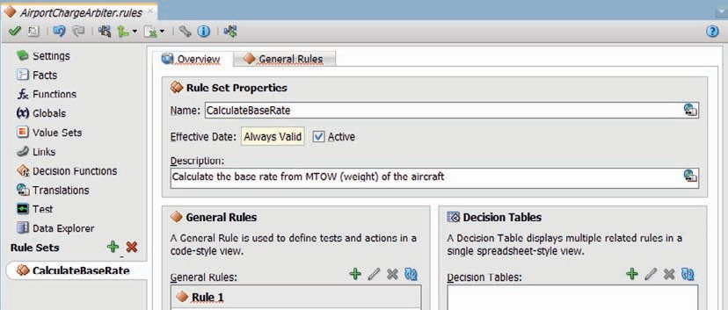

**FIGURE 11-4.** *Create rule set CalculateBaseRate with a first If/Then Rule*

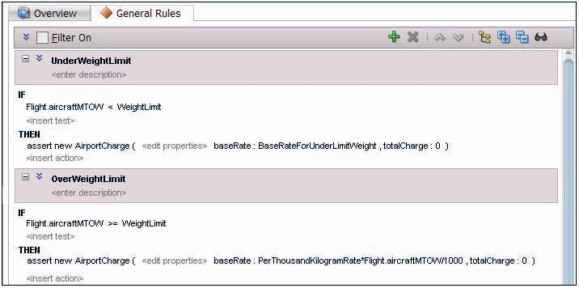

**FIGURE 11-5.** *The two IF/THEN rules in the CalculateBaseRate rule set*

These steps are shown in Figure 11-6.

This simple calculation will be replaced with a more complex one that involves surcharge percentages in a later section.

##### Edit the Generated Decision Function

Rule Sets cannot be invoked directly. We can create decision functions in the business rule dictionary that can trigger rule sets. In fact, when we first created the business rule component, a default decision function was generated, called DecisionService_1. Click on the tab labeled

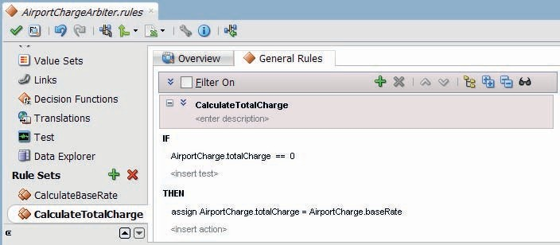

**FIGURE 11-6.** *The rule CalculateTotalCharge to calculate the final charge for an aircraft movement*

Decision Functions. Change the name of the generated function into *CalculateAirportCharge*, see Figure 11-7.

This function is configured to be exposed with a [web] service interface, as you can tell from the checked checkbox labeled Web Service. Through this interface, other components—Mediator, BPEL, and BPMN—can be wired to the Business Rule. It is recommended to not expose the Business Rule component directly as an external service from the SOA composite, but to always use a Mediator as wrapper around the Business Rule.

The decision function has been configured with an input parameter—called Flight and based on the Flight Fact Type. It also has an output parameter called after and based on the AirportCharge Fact Type. The tab *Rule Sets & Decision Functions* contains the collection of Rule Sets that is to be triggered when this decision function is invoked. The initial rule set—now renamed to CalculateBaseRate is listed. Add the Rule Set CalculateTotalCharge to the selected set on the right side. Now, when this function is invoked, after the Flight fact has been asserted, both Rule Sets are active to be triggered. Click on OK to close the Decision Function editor.

#### Test the Business Rule

It is pretty simple to take the decision function for a spin. Testing facilities are integrated in the design time environment for the business rule dictionary. We do not have to deploy the SOA composite before we can check out the implemented functionality.

On the Decision Functions tab, click on the decision function *CalculateAirportCharge*. Click on the Test icon, as shown in Figure 11-8. In the test editor pop up, click on the green plus icon to create a new test suite. Assign a probable name. Then click OK to return to the table with test suites. Select the new test suite and click on the edit icon.

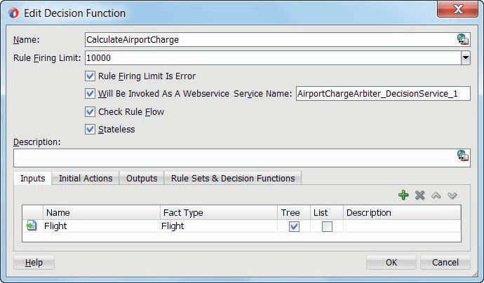

**FIGURE 11-7.** *Decision Function CalculateAirportCharge—exposed as web service and*

*associated with two rule sets*

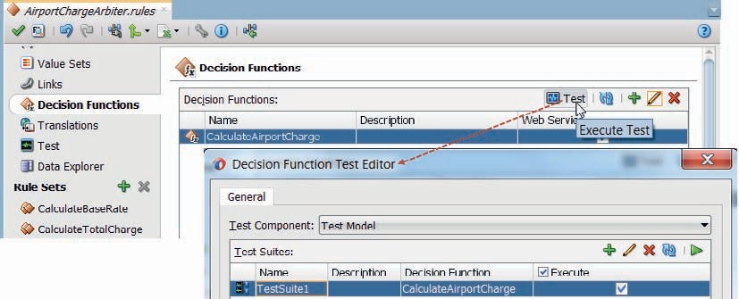

**FIGURE 11-8.** *Create a Test Suite for the CalculateAirportCharge rule set*

This brings up the Test Suite editor. Click on the green plus icon in the test case table to create a new test case. Indicate in the name of this test case that it handles about an under-the-weight- limit aircraft. Then edit the test case by setting values for both the input Flight fact—aircraftMTOW

: 15000 and numberOfPassengers : 150—and the expected output AirportCharge fact—baseRate and totalCharge both equal to the global BaseRateForUnderLimitWeight, as shown in Figure 11-9.

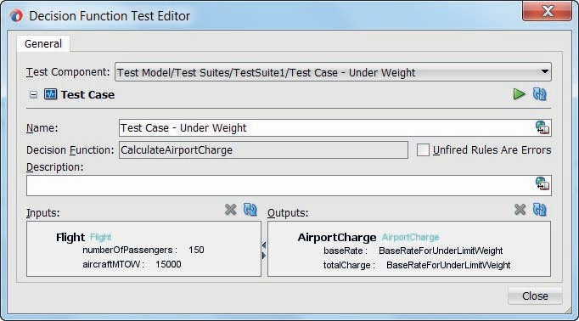

**FIGURE 11-9.** *Configuration of the Under Weight test case*

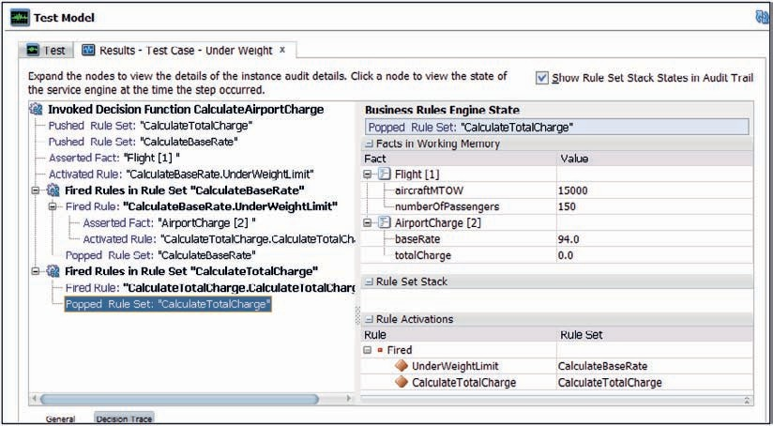

**FIGURE 11-10.** *Execution trace for the CalculeAirportCharge decision function*

Click on the green play icon to execute this test case. The result should be a passed test case, as well as an interesting trace of the execution of the test case, as shown in Figure 11-10. This overview makes it clear what exactly went on during the execution of the decision function.

Note: It should be read inside-out, where first rule UnderWeightLimit in the rule set CalculateBaseRate was fired, followed by rule CalculateTotalCharge in the Rule Set with that same name. The trace also gives us insight into the facts and their value in memory at each stage of the execution. This is a tremendous help when debugging the rules.

#### Deploy and Test the Composite

Because the decision function is marked to be exposed as a web service, JDeveloper has generated a WSDL document for it as well as registered it as an SCA component in the component.xml file. When you return to the SOA composite editor, you will see a service exposed by the business rule component. This service is not well suited to be exposed directly at the composite level as it is quite technical and implementation specific. Therefore it is useful to add a mediator component with a friendlier interface as a wrapper around the business rule component if you want to expose the decision logic.

Drag a mediator component to the SOA composite. Call it *AirportChargeService*. Select the Synchronous Interface and define the input based on the *Flight* element and the output on the *AirportCharge* element in the schema file AirportChargeCalulcation.xsd. Check the checkbox to expose the mediator at composite level, as shown in Figure 11-11. Once the mediator is added to

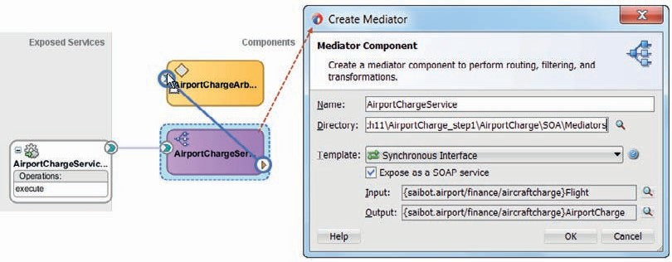

**FIGURE 11-11.** *Edit the new mediator and wire it to the business rule AirportChargeArbiter*

the composite, wire it to the business rule component and connect it to the operation

*callFunctionStateless*.

Double click the mediator to bring up the editor. Open the Assign Values dialog for the request step in the routing rule. Map the *Flight* element in the input to the corresponding *Flight* element in the *parameterList* element. Also configure Assign Values for the reply. Set the *AirportCharge* element in the output based on the corresponding element in the *resultList* element in the reply from operation *callFunctionStateless*.

Deploy the SOA composite to the Integrated WLS. When the deployment is complete, make a few test calls from for example the HttpAnalyzer or SoapUI. You can check the message flow trace and audit trail in the Enterprise Manager FMW Control; the output is similar to what the test case produced earlier in Figure 11-10.

#### Extend Business Rule with Cargo Consideration

Now suppose—as is the case for many airports around the world—that the airport charge is lower for cargo planes than for passenger flights. In that case our calculation of the base rate has to be adjusted. First of all, we introduce a new global that defines the number of passengers that is the maximum for a flight to be still considered a cargo flight. This number could be zero, but we could also allow a few passengers and still charge the flight as a cargo flight.

Define this new global of type int, called *MaxNumberOfPassengersOnCargoFlight*. Set the value to 5 for now.

Open the rule set *CalculateBaseRate*. Add a rule called *CargoCorrection* like this (and as shown in Figure 11-12):

 IF Flight.numberOfPassengers <= MaxNumberOfPassengersOnCargoFlight THEN modify AirportCharge ( baseRate: Airport.baseRate/2)

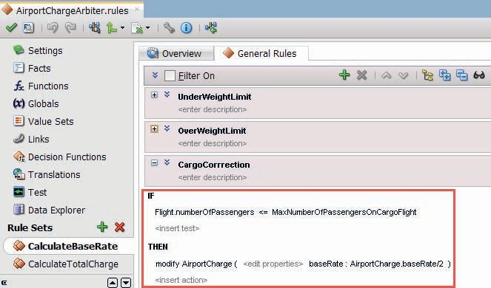

**FIGURE 11-12.** *Add the If/Then rule CargoCorrect*

Create a new test case in the test suite for the decision function *CalculateAirportCharge* for a flight with 5 or less passengers. Verify that the calculated charge is half of the value previously

expected. Also check the trace to confirm that the new rule *CargoCorrection* is indeed executed.

You may want to deploy the composite and verify that the *AirportChargeService* now exhibits the modified behavior when it comes to cargo flights.

#### Use SOA Composer for Online Manipulation of Business Rule Parameters

The SOA Composer tool is a browser based tool that allows run-time access to a number of aspects of SOA composites, including Domain Value Maps, Composite Sensors, and Business Rules. On the Integrated WLS and running against JavaDB, the SOA Composer will only allow read only access to these definitions. On the full server install with the Oracle Database backed MDS, business rules and other definitions can be manipulated as well. That means that without having to open JDeveloper to change the business rule and deploy the modified composite, the business rule logic can be edited at run time. Changing global values, for example, is very simple to do. Rolling out new airport rates per 1000 kg MTOW, for example, is done in minutes, as is setting the new cut off weight or the flat fee for aircrafts below that cut off weight.

The URL for this tool on the Integrated WLS is http://localhost:7101/soa/composer.

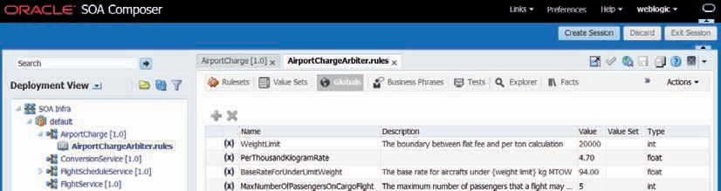

**FIGURE 11-13.** *Inspecting and possibly editing the values of globals or other aspects of business*

*rule definitions through the SOA Composer*

When you open the SOA Composer on the full server installation, you can change, for example, the global *PerThousandKilogramRate* that is crucial in calculating the airport charge for heavy airplanes (see Figure 11-13). Open an edit session, change the global’s value, commit the session and reinvoke the *AircraftChargeService* to see the effect of the changed value.

### Introduction of the Decision Table

Business logic can be quite complex. Up until now in this chapter, we have seen fairly simple, straightforward IF/THEN rule sets with a limited number of variations. However, it is not hard to imagine more convoluted rules, for situations where multiple dimensions influence the outcome and several options may apply along each dimension. The decision table–style rule set in Oracle Business Rules helps to manage such situations.

#### Decision Table for the Daily Starbucks Decision-Making Process

Take, for example, the decision-making process the CEO of Saibot has to go through at the Starbucks counter. Several factors influence the process and help determine the outcome. In the morning, coffee is the obvious choice. Afternoons usually are for tea, and coffee again at night. However, in the winter she may opt for hot chocolate drinks in the afternoon and in the spring she typically picks soy milk in the evening. When she has plenty of time and is not stressed at all, she may take the largest drink on offer, except when it is raining. When she has very little time, she may take a cold drink—although never in the fall. And on and on and on.

We see at least four dimensions in the decision-making process—time of day, weather conditions, stress level, and season—and along each dimension, one of several cases may be true.

This decision-making process can be turned into a long list of IF/THEN rules, with the likes of if season = “SUMMER” and stresslevel = “relaxed” and time_of_day = “MORNING” and weather=“HOT” THEN assert new Order (drink: “grande latte”).

Such a list would be a pain to create and even more so to maintain. A decision table does more or less the same, but is much easier to read and maintain. For this example, it works like this (with only a subset of the 3*3*2*4 = 72 columns):

|  |  |  |  |  |  |  |  |  |
| --- | --- | --- | --- | --- | --- | --- | --- | --- |
| **Conditions** | **Rule R1** | **Rule R2** | **Rule R3** | **Rule R4** | **Rule R5** | **Rule R6** | **Rule R7** | **Rule R8** |
| **Time of day** | Morning | Afternoon | Evening | Morning | Afternoon | Morning | Evening | Afternoon |
| **Weather** | Cold | Cold | Cold | Hot | Cold | Cold | Normal | Hot |
| **Stress level** | Relaxed | Relaxed | Relaxed | Harried | Harried | Harried | Harried | Relaxed |
| **Season** | Winter | Winter | Winter | Winter | Fall | Fall | Spring | Summer |
| **Actions** |  |  |  |  |  |  |  |  |
| **Order drink** | Large | Large hot | Double | Small iced | Small hot | Small black | Small | Large hot tea |
|  | cappuccino | chocolate | espresso | coffee | chocolate | coffee | soy milk | (earl grey) |
| **Order snack** | Oatmeal cookie | Chocolate chip cookie | Bar of dark chocolate | — | — | Blueberry muffin | — | Biscuit |

Every column can be read like a single IF/THEN rule. For example, the first column: if time of day=“morning” and weather =“cold” and stress level = “relaxed” and season=“winter” then assert new Order (drink: large cappuccino; snack: oatmeal cookie).

Every row contains a condition—all possible states that may apply to a certain property. A column (rule) is matched for the input record when each row in that column matches the data. Note

that the input does not necessarily contain the exact values used in this matrix. In this coffee counter example, it might very well be that the input record contains the current date and time,

a temperature, and an indication of Saibot Airport’s CEO’s stress level. The first three values do not directly match the options in the matrix. We need to convert time, date, and temperature to the terminology used in the decision table:

 (10AM, 4th July, 86F, relaxed) => (morning, Summer, Hot, relaxed)

We make use of value sets for this, defined as part of the business rule dictionary. Every property is associated with a value set—a set of allowable values or allowable ranges. Well- known value sets include Boolean, Gender, and Color of Traffic Light. Instead of a single allowable value, each entry in a value set can be an allowable range. When the value for the property falls within the allowable range entry in the value set, the associated label or alias can be assigned. For example, the Season value set has four entries, each an allowable date range that will convert the date to the season. In a similar way, three time ranges in the Time of Day value set help choose between morning, afternoon, and evening.

### Extended Airport Charge Calculation— Using a Decision Table

The calculation of the airport charge is not as simple as we discussed in the previous section. There is more at stake than just the weight and the type of flight. The formula also takes into account a surcharge for which the calculation depends on the noise category of the aircraft, the timeslot of the flight and whether the flight takes off or touches down. Simply put: for each combination of noise category, time slot and arrival or departure, a different surcharge percentage is determined. The total charge is calculated from the base rate corrected with this surcharge percentage.

Just as in the Starbucks example, various factors play a role in the derivation of the surcharge, each having a value in a specific category. We could either implement the derivation with a large number of IF/THEN rules or introduce a decision table to deal with this derivation. As discussed earlier, for a large number of variations, decision tables are generally the better choice.

#### Prepare Business Rule for the Decision Table

The factors that weigh in for the calculation of the surcharge have to be provided to the business through an extended version of the *Flight* fact. This fact as well as the web service interface exposed by the decision function is based on complex type *flightType* in the AirportChargeCalculation.xsd. We have to modify that type then refresh the fact and prepare the Value Sets.

##### Modify the XSD and Update the Facts Accordingly

Open this file and add these lines to the *flightType*:

 <xsd:element name="SlotTime" nillable="false" type="xsd:time" minOccurs="1" maxOccurs="1"/>

<xsd:element name="ArrivalOrDeparture" nillable="false" type="xsd:string" minOccurs="1" maxOccurs="1"/>

<xsd:element name="AircraftNoiseCategory" nillable="false" type="fac:noiseCategoryType" minOccurs="1" maxOccurs="1"/>

and this single line to the *airportChargeType*:

 <xsd:element name="surchargePercentage" nillable="false" type="xsd:int" minOccurs="1" maxOccurs="1"/>

Also add this simple type:

 <xsd:simpleType name="noiseCategoryType">

<xsd:restriction base="xsd:string">

<xsd:enumeration value="MCC3"/>

<xsd:enumeration value="A"/>

<xsd:enumeration value="B"/>

<xsd:enumeration value="C"/>

</xsd:restriction>

</xsd:simpleType>

Save these changes to the XSD document.

To synchronize the *Flight* and *AirportCharge* facts in the business rule with the updated definitions of the underlying XSD types, open the Facts tab in the business rule editor. In the upper right hand corner of the Fact table is a little icon. Click on it and pick the first option in the drop-down menu. This option says *Reload Facts based on Modified Schema* and that is what it will do: update the facts in accordance with the changes applied to complex types in the AirportChargeCalculation.xsd document.

When the reload action is complete, you can double click the *Flight* fact to check whether new properties have been added for the *slot time*, the *noise category* and the *arrival or departure* of the flight. The property *aircraftNoiseCategory* should be associated with a Value Set called *NoiseCategoryType*. This Value Set describes the allowable values for this property. It is derived from the simple type with enumeration in the XSD document.

##### Create Value Sets

A Value Set in the business rule dictionary describes a set of values or value ranges. Each value or value range in the set can be labeled with an alias that can be referred to in, for example, rule test expressions and actions and also in conditions in decision table. Value Sets can be associated

with fact properties as well as with input and output parameters to [decision] functions and globals. The value set can be used to enforce that only allowable values are set in these variables.

We need Value Sets to define the possible values for each of the conditions defined in the rows of the decision table. In this case that means that for all of the following we need to define a value set that contains the possible values: noise category, slot time, and arrival/departure.

###### TIP

*If a fact property can have values that are irrelevant for the business rules, these values can all be grouped under the value set entry called* otherwise*. In decision table conditions, we can check for the* otherwise *value in fact properties—evaluating to true when the property does not have any of the explicitly defined values*

*in the value set.*

Open the Value Sets tab. The value set for the noise category is already created. Open this value set. It contains five values—including one with alias “null.” Change this alias to “Unknown” and click OK to save this change.

New Value Sets are needed for *Time of Day* (associated with *SlotTime*) and *Arrival Or Departure*. Figure 11-14 shown the definition of the latter. Click on the green plus icon and select Value Set from the drop-down list. Specify the name of the new Value Set as *ArrivalOrDeparture*. Click on the edit icon to bring up the Value Set editor. Define three values: “D” (with alias “Departure”), “A” (with alias “Arrival”) and otherwise. Press OK to close the editor.

Click again on the green plus icon and this time select Range Value Set from the drop-down list. Specify the name of the new Value Set as *SlotTime*. Click on the edit icon to bring up the value set editor. Set the Data Type to *Time*. Add three Range Values, in addition to –Infinity, as shown in Figure 11-15. The End Points should be 05:30:00+00:00, 07:00:00+00:00, and

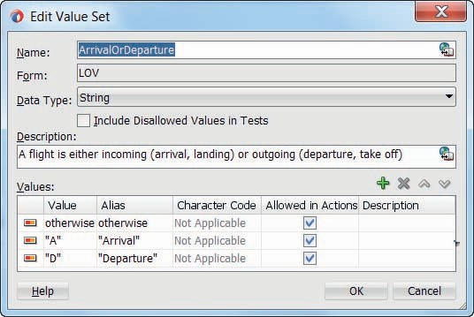

**FIGURE 11-14.** *Editing the Value Set ArrivalOrDeparture*

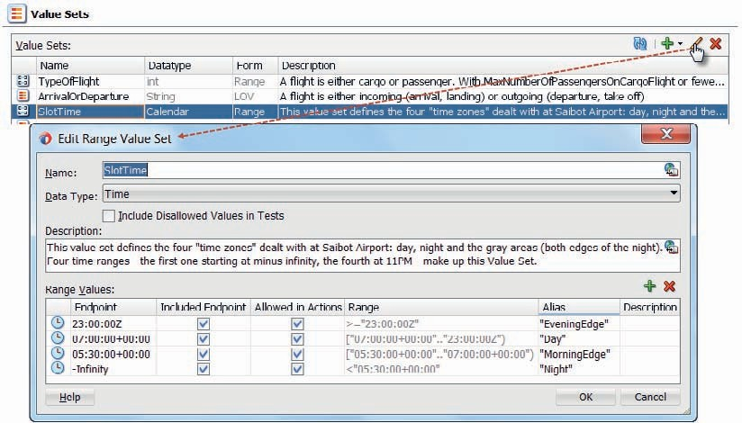

**FIGURE 11-15.** *The definition of the SlotTime Range Value set*

23:00:00Z. The four aliases used for the Range Values should be Night, MorningEdge, Day, and EveningEdge.

Open the Fact editor for *Flight*—as shown in Figure 11-16. Associate properties *arrivalOrDeparture* and *slotTime* with the Value Sets *ArrivalOrDeparture* and *SlotTime,* respectively.

##### Update Rule CalculateTotalCharge

The calculation of the total charge in rule set *CalculateTotalCharge* has to be altered, to include the surcharge percentage that is to be established by the decision table. Open the rule set and change the implementation of the THEN action in the rule to:

 Assign AirportCharge.totalCharge = AirportCharge.baseRate * (1 + AirportCharge.surchargePercentage/100)

as shown in Figure 11-17.

#### Create the Decision Table for Deriving the Surcharge Factor

All the preparations have been made. The one thing lacking is the rule set with the decision table to determine the surcharge percentage in the *AirportCharge* fact.

##### Create Rule Set and Decision Table

Create a new rule set called *FlightSurchargeCalculation*. Add a decision table to the rule set, called

*FlightSurchareDecisionTable*—as shown in Figure 11-18.

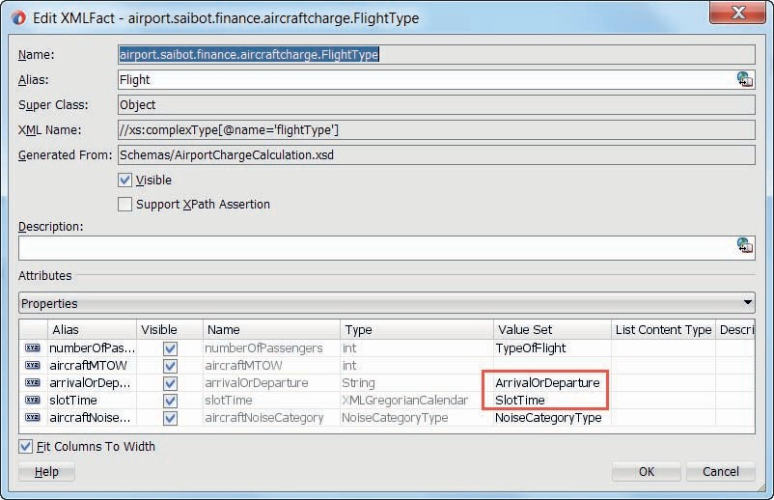

**FIGURE 11-16.** *Edit the Flight fact type—set the Value Set property for attributes*

*ArrivalOrDeparture and SlotTime*

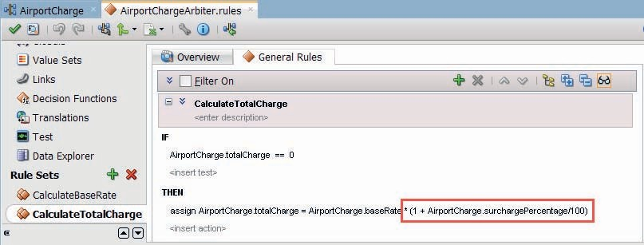

**FIGURE 11-17.** *Add the surchargePercentage to the calculation of the total charge*

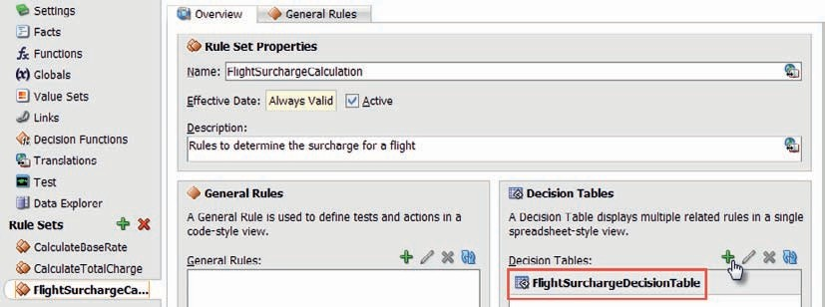

**FIGURE 11-18.** *New rule set FlightSurchargeCalculation with a DecisionTable called*

*FlightSurchareDecisionTable*

The table has three areas: the conditions and the actions (rows) and the rules (columns).

Optionally a fourth section can be shown, called *Conflict Resolution*. Conflicts can occur when business rules are incomplete or contain contradicting rules.

A condition is a value that is the result of an expression, usually based on one or more input values (or the current date or time), and associated with a Value Set. Conditions in our example are the flight properties *slotTime*, *aircraftNoiseCategory,* and *arrivalOrDeparture*. The decision table for establishing the surcharge percentage will have one condition for each of these three factors contributing to that percentage.

Click on the green plus icon to create a new condition C1. Define the condition as Flight. aircraftNoiseCategory.

A rule is defined through a column with in the cell values for each of the conditions—the rows that each represent a *Flight* property. When the values in the *Flight* fact match with all cells in a rule—and this should happen with any Fact for exactly one rule—then the actions in the bottom half of the decision table are activated within that rule column. When a rule has no value in a specific row (for a condition), it means the rule will match for every value the condition may have (in other words, the rule does not care about that particular condition).

Rule [column] R1 is already defined. Configure its cell for condition C1 to match on values MCC_3 and Unknown, as shown in Figure 11-19.

The action is usually defined using one or more parameters—whose values depend on the specific rule (or column) that matches the conditions. Our decision table for deriving the surcharge percentage for a flight has a generic action of type *modify* that assigns a value to the *surchargePercentage* property in the *AirportCharge* fact, as shown in Figure 11-20.

The actual value to be set is defined for each rule specifically, in the bottom section for that rule’s column. Set this value to 60, because the surcharge on top of the base rate for aircrafts in the noisiest category MCC3 is set at 60 percent.

Add rules R2 through R4 that trigger on the other values A, B, and C for noise category. The associated surcharge percentage values are 40, 0 and −20. Figure 11-21 shows the current situation in the decision table.

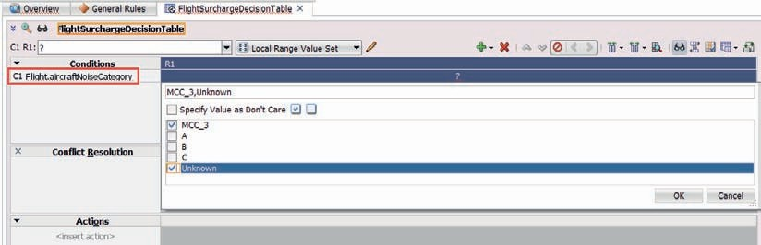

**FIGURE 11-19.** *Configuring the cell that defines when Rule R1 triggers for condition C1: for*

*MCC_3 and Unknown noise category values*

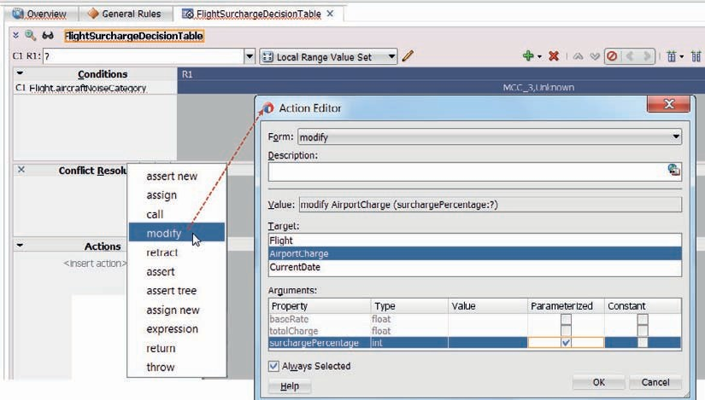

**FIGURE 11-20.** *Defining the generic action to set the surchargePercentage on the AirportCharge;*

*note that the actual value is parameterized which means: set at each individual rule*

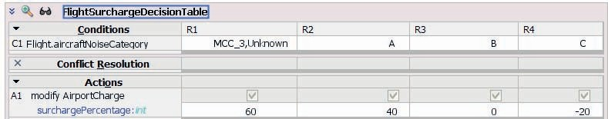

**FIGURE 11-21.** *Decision table with one condition and four rules triggering on the possible*

*values and setting the surchargePercentage*

Click on the green plus icon and add a second condition: Flight.slotTime. This adds a row C2 in the decision table. Each rule column currently has a question mark for the cells in this row— because we have not yet specified on which value for the *slotTime* condition these columns should trigger. Change all question marks into the value “day.”

A flight during the day does not get an extra surcharge. However, we do not currently cater for the other values the *slotTime* condition may have: Night, MorningEdge, and EveningEdge. Click on the *Gap Analysis* icon—as shown in Figure 11-22. This brings up a popup that indicates which rules are missing from the decision table (assuming a complete coverage is sought for all possible values for all conditions).

Check the boxes on top of each of the columns to have JDeveloper add the missing rules.

Click on OK. This will create rules R5 through R8 for the four values of noise category combined with the set of all three slot time values.

Right click on cell C2-R5 (currently associated with all slot time values for the MCC_3 and unknown noise categories). Because the surcharge is not the same for all slot times, click on Split Selected Cell in the context menu. R5 will be split into three columns (R5, R6, and R7), one for each value in the Cell. The surcharge is the same for early morning and late evening. Therefore, select the cells for MorningEdge and EveningEdge and click on Merge Selected Cells in the context menu. Go through the same steps for the noise categories A, B, and C.

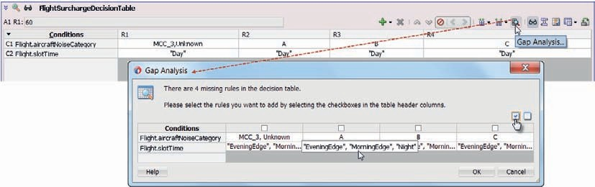

**FIGURE 11-22.** *Gap Analysis indicating the missing rulers for the other slotTime conditions*

*(besides Day)*

The surcharged is elevated with an additional 20 percent during edge hours and 50 percent during the night. For example: in noise category A the surcharge during the day is 40 percent. The additional surcharge during the night is 50 percent over the total fee. That means that the fee is increased by a factor of 1.4 times 1.5 or 2.1, which means the surcharge percentage is 110 percent. The airport means business when it comes to coaxing carriers to fly during the daytime! The surcharge percentages shown in this table are to be applied in the actions for the new rules R5..R12:

|  |  |  |  |  |  |  |  |
| --- | --- | --- | --- | --- | --- | --- | --- |
| **MCC3** | | **A** | | **B** | | **C** | |
| Edge | Night | Edge | Night | Edge | Night | Edge | Night |
| 92 | 140 | 68 | 110 | 20 | 50 | −4 | 20 |

Configure the action column in rules R5-R12 to align with these percentages, as shown in Figure 11-23.

###### NOTE

*In addition to splitting and merging the cells for condition C2, to achieve the situation in Figure 11-14, some rules were moved sideways (to bring all rules with the same noise category closer together) and some cells for condition C1 were merged.*

We now introduce the final piece of business logic. For flights during the night or the edge periods, it depends whether the flight is arriving or departing. The surcharge percentage for flights arriving during the night is set at 25 percent. Night or edge time departures are considered bad form—much worse than arrivals during those hours.

This means we have to add a third condition to the decision table, based on the *Flight* fact property *arrivalOrDeparture*. Nothing changes for day time and night edge flights. That means that for all rule columns with the value day or edge (morning or evening) in their C2 cell, we can set the C3 cell to “I do not care.” For all rule columns with the value *Night* in their C2 cell, we have to split their C3 cell—to create separate columns for arriving and departing flights. Subsequently, we have to lower the surcharge percentage in the arriving flight column, to the following values: MCC3: 100, A: 75, B: 25, C: 0. Figure 11-24 shows the final result for the FightSurchargeDecisionTable.

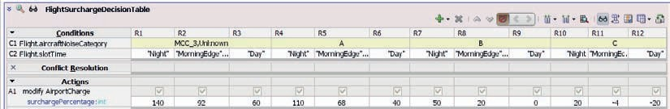

**FIGURE 11-23.** *Twelve rules covering all relevant combinations of noise category and slot time,*

*with the applicable surcharges*

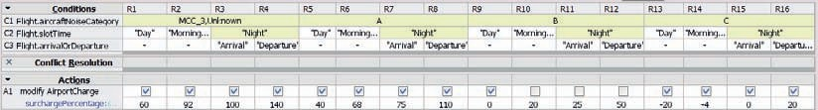

**FIGURE 11-24.** *Decision Table for the derivation of the flight surcharge percentage based on*

*three factors*

##### Analyzing the Decision Table

Note that the order of the rules in the table is not important. The decision table editor will sometimes move the rule columns around, to combine cells where it can do so in order to present a more compact, easier-to-interpret picture. We can also do that manually using the move [column] left and right icons and the drop-down menus for merging and splitting cells, as we have been doing.

Compacting the table can reduce the number of rules we have created by eliminating the rules that are redundant while preserving the no gap, no conflict properties for the decision table. The split operations create additional rules, one for each of the values in the cell that is split.

Splitting a cell that currently matches on [Arrival, Departure] produces two cells, and therefore columns, one for each of the two values. If a cell has the “do not care” value, splitting the cell produces a cell for every value in the value set. The merge operations do the opposite from what split does: They combine various condition values into a single cell.

The decision table editor in JDeveloper has several interesting features. One is the Gap Analysis. This helps us inspect the decision table we have composed to see whether we have forgotten rules, given the combinations of condition values that may occur. We have used the analysis when we added the second condition to the decision table. Note that we can decide to allow gaps, for example, when we know for sure that certain combinations of values from different value sets will never occur—such as MCC_3 aircrafts in the middle of the night—and therefore need not have rules to cater for them. If that situation should occur after all, no rules will match and no value is assigned as an outcome of the business rule.

Another valuable feature is conflict resolution. The decision table editor can find rules that may trigger for the same set of conditions—and that may try to assign different, conflicting result values. It may be intentional or by mistake. In the latter case, this check allows us to correct the oversight. When the rule conflict is intentional, we have to indicate how the conflict should be resolved. Various methods of conflict resolution are available to us, for each conflict detected by the tool. Through Override and OverriddenBy, we can indicate that one rule overrules the other one (the overridden rule is ignored altogether). With RunBefore and RunAfter, both rules may be activated—in the order specified—and both actions may be executed. Finally, using NoConflict we can instruct the business rule engine to ignore what it thinks is a conflict.

We could have a potential conflict in our decision table: say we want to implement a fallback option as a final resort that should trigger when no other rules have triggered. This fallback rule will assign the surcharge percentage value 200. The fallback rule accepts all values for all conditions—and therefore has a conflict with every other rule.

When we double-click the cell that shows the conflicts, the Conflict Resolution window pops up. We can select the resolution for every conflict for this rule. In this way, all other rules will

override this fallback rule—when any other rule has fired, this rule is overridden, which means ignored. Only when no other rule was activated will this rule come in action to assign a 200 surcharge percentage.

##### Use Excel for Editing the Decision Table

The business rule editor in JDeveloper has a little Excel icon in its top bar. Through this icon, we get access to two options, for exporting decision tables to an Excel document and importing an [edited] Excel document with the updated definition of the decision table.

Through Excel it becomes much easier for business representatives and function analysts who are not JDeveloper users, to work on the business logic captured in the decision table. Especially for large tables with many factors and values per factor, the table can become quite big and unwieldy to work on in the business rule editor. Figure 11-25 shows the export dialog. Note that only decision tables are exported, not the regular IF/THEN rules.

The exported Excel document contains the definition of a special Excel plugin with its own ribbon (Figure 11-26). It also has instructions on how to edit the decision table and the value sets.

The value set definitions are included and can be edited, as well as of course the decision table itself.

##### Add Decision Table to Decision Function

To ensure that the decision function leverages the decision table for calculating the surcharge, we have to explicitly add the *FlightSurchargeCalculation* rule set to the list of selected rule sets in the decision function, between the two other rule sets, as shown in Figure 11-27.

#### Update Test Suite

The existing test cases are no longer valid, because they have not been configured with appropriate values for the new fact properties in the Flight fact. To reinstate these test cases, we also have to provide values for the *SlotTime* property, which is of type *XMLGregorianCalendar*. To allow easy configuration of test values for *SlotTime* based on a simple time string, we will create a helper function *getTimeFromString*. Using the function, we can subsequently refine the test cases.

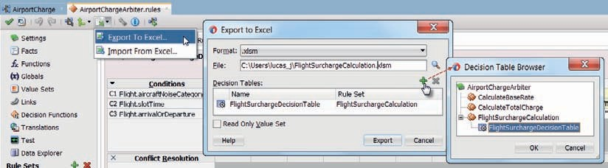

**FIGURE 11-25.** *Exporting a decision table to an Excel document for review and manipulation*

*outside JDeveloper*

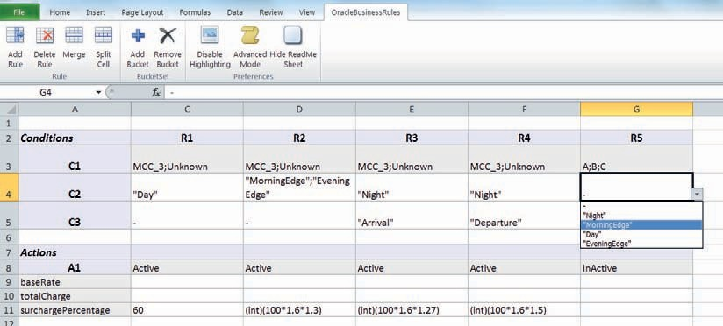

**FIGURE 11-26.** *Editing the decision table in Excel*

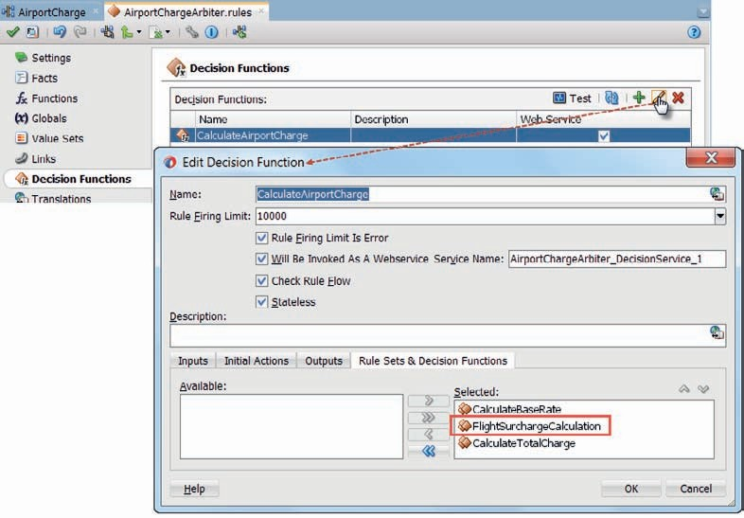

**FIGURE 11-27.** *Add rule set FlightSurchargeCalculation to decision function*

*CalculateAirportCharge*

##### Create Helper Function to Produce XMLGregorianCalendar

Open the tab labeled Functions. Click on the green plus icon to add a new function. Call it *GetTimeFromString*. The return type is *XMLGregorianCalendar*. The function has a single argument, called *timeString* and of type *String,* as shown in Figure 11-28.

The implementation of the function is quite simple:

 return XMLDate.fromstring("2015-12-31T"+ timeString + ":00Z" )

##### Test Helper Function

Functions can be tested in the business rule editor through test functions. A test function is any function with a boolean return type and no input arguments. Such a function can be invoked directly from the Functions tab.

Create a new function called *TestGetTimeFromString*. The function has a boolean return type.

A simple implementation of the function looks like this:

 assign new XMLGregorianCalendar var = GetTimeFromString("15:45") call print (message: var)

return true

Figure 11-29 shows the test function and its output.

##### Update Test Suite with Proper Test Cases

With a function to produce an XMLGregorianCalendar at our disposal, we can now update the Test Cases. Before the Flight input only had properties for *numberOfPassengers* and *aircraftMTOW*. We now need to provide values for *arrivalOrDeparture* (A or D), the *slotTime—*using a call like

GetTimeFromString(“hh24:mi”)*—*and the *aircraftNoiseCategory* (A, B, C, or MCC_3). The output has a new property as well: the *surchargePercentage*. Figure 11-30 shows an example of a test case.

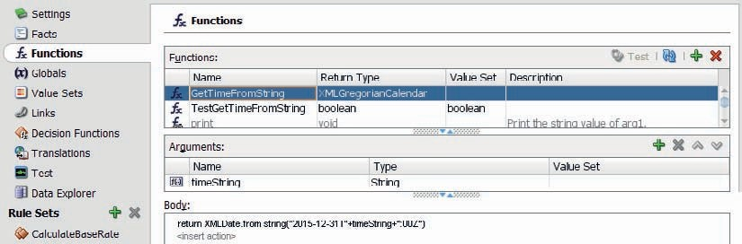

**FIGURE 11-28.** *Create custom function GetTimeFromString*

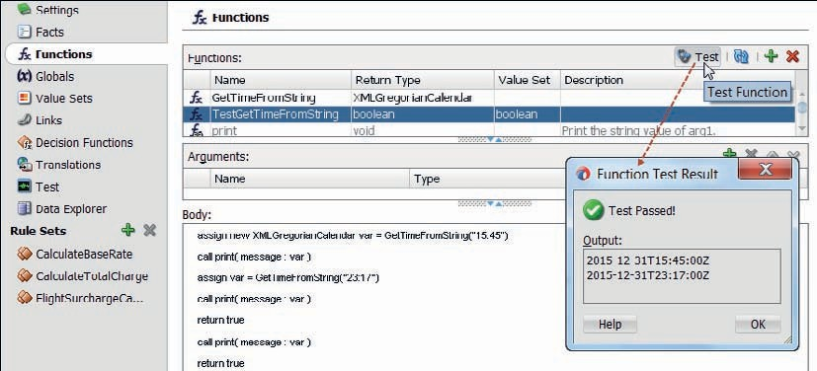

**FIGURE 11-29.** *Using a test function to try out function GetTimeFromString*

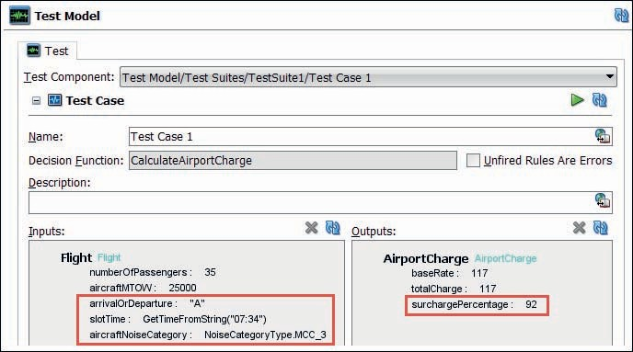

**FIGURE 11-30.** *Test case for decision function CalculateAirportCharge—with the three new*

*properties to derive the surcharge percentage*

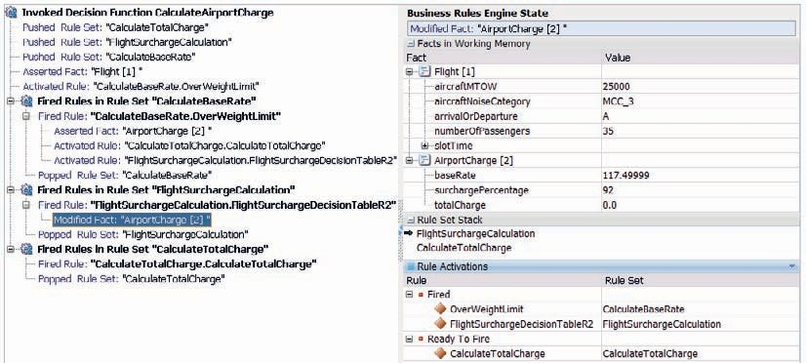

**FIGURE 11-31.** *Trace details for test case execution for decision function CalculateAirportCharge*

After modifying the existing test cases and perhaps adding new ones, we can run the test

suite to witness the added business logic for establishing the surcharge and applying the surcharge in the calculation of the total charge. Figure 11-31 gives an impression of the trace details for

the test case.

#### Deploy and Test

With the introduction of the decision table complete and tested at design time, now is a good time to deploy the SOA composite to the Integrated WLS and to make a few test calls to the *AirportChargeService* for various combinations of input parameters. Airlines considering signing up their services to slots at Saibot Airport can use this service to explore the costs of their various options and scenarios*—*tweaking slot times, aircrafts, and flight schedules.

After the composite has been deployed, you can check in SOA Composer what the decision table looks like in the browser on top of the run-time environment. And like before: the Integrated WLS only supports read only access through SOA Composer. In a full server environment, you can use SOA Composer to edit the decision table at run time and very rapidly implement changes in business policies.

### Summary

Separation of concerns is a crucial element in the SOA Suite. Externalizing business logic out of technical implementations into metadata that can easily be changed and redeployed without changing the code leveraging that logic is a good way to help achieve that separation*—*especially given the different pace of change in the logic (fast) and the services using the logic (much slower).

The Business Rule component in SOA composite applications is the embodiment of that notion. This component can be used to take on the responsibility of performing potentially

complex, reusable calculations, validating data, and making decisions given a certain input based on advanced business logic. A special aspect of Business Rules is their ability to be edited at run time. Through the SOA Composer, developers or business analysts can refine the definition of a business rule. Such modifications take immediate effect and do not require a redeployment of the application.

Business Rules can be leveraged from other components, such as Human Task, BPEL, and BPMN processes, as we will see in future chapters. They can play an important role in assigning tasks, dynamically determining where to route messages or deciding which paths to take in a business process. In adaptive case management, a business rule component is even at the heart of the case, acting as a *state engine* that drives the case from start to finish. Note that business rules can also be invoked from external applications as a web service and from Java applications through a Java-based API.

